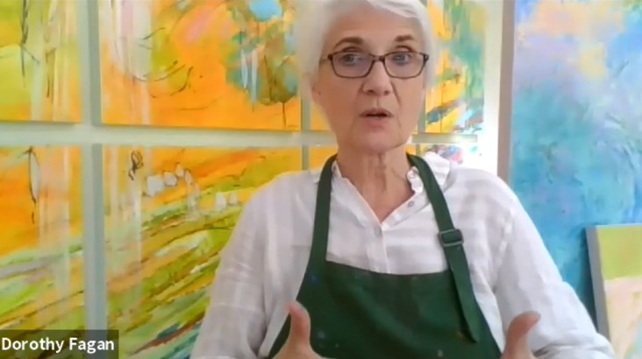
Embody Earth
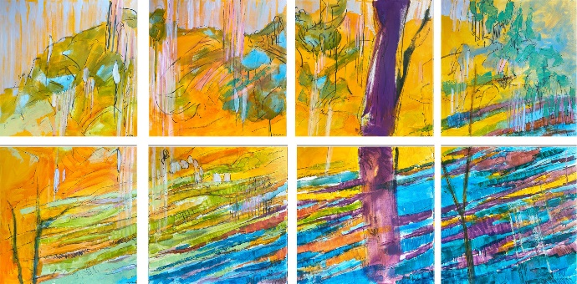
"Dorothy Fagan has the extraordinary sensation of embodying the color she is using. She interprets art as a way of 'wrapping ourselves in colors the light.' This light of which the artist speaks is visible in all her creations." ~ Curator Georgia Massari

Dorothy Fagan envisions a world where people express their hearts, drawing structures to support hearts. Her post-pandemic mural The Crossing, exhibited in Milan Fashion Week’s DressME at M.A.D.S Gallery demonstrates how she expresses emotional color first, then draws into wet paint fusing heart to create structures that support the heart.

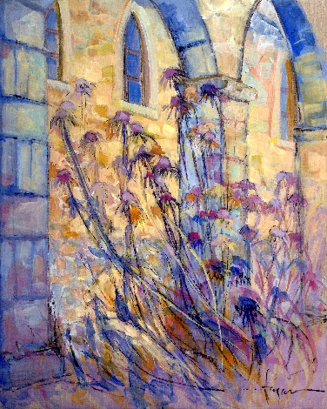
A Freshman art student at East Carolina University in 1971, Fagan painted a triptych pastel landscape, super-imposed over a woman's reclining body ~ thus began her artistry Embody Earth.

In her fusion painting Attiendre, in the permanent collection of Musee de la Grande Vigne, Dinan, France, she uses oil wash on linen with willow charcoal to fuse human and divine with thistle thriving in a 12th Century monastery garden.

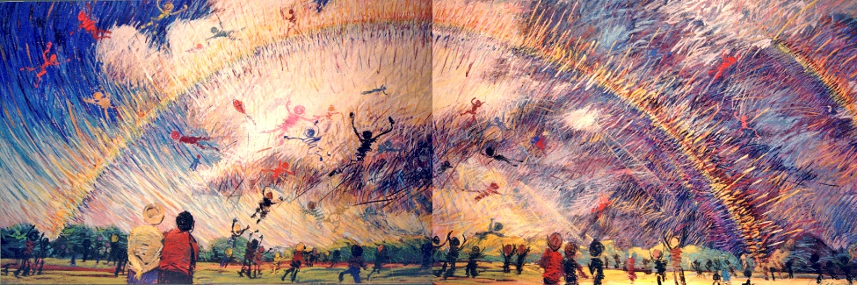
A ten-foot pastel diptych in the permanent collection of Longwood Art Museum, Farmville, Virginia lifts viewers into Rainbow in the Sky transforming a barren landscape.
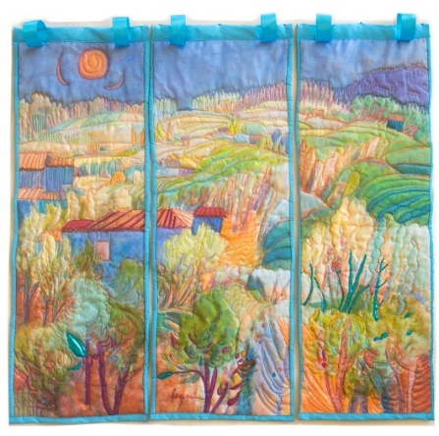

A fiber art triptych, Jardines del Ninos envisions a walled garden from above is housed at Boston Children’s Hospital.

dorothyfagan.com
@dorothyfaganartist YouTube IG FB

PUBLICATIONS
Magic of Color|Coda Magazine Jan 2023, Sarah Muehlbauer
DressME 2020 | Georgia Massari, Exhibition Catalogue, Oct 2020
100 Plein Air Painters of the Mid-Atlantic | Gary Pendleton, 2014

SELECTED EXHIBITIONS
Pastel Society of America, National Juried Exhibition, National Arts Club, New York
Pastel Society of Canada, International Juried Exhibition, Cambrian Rose Gallery, Ottawa
American Artists Professional League, National Juried Exhibition, Salmagundi Club, New York
G.V.W. Smith Art Museum, National Juried Exhibition, Springfield, MA
Virginia Museum of Fine Art, Prints & Drawings ’81 National Juried Exhibition, Richmond, VA
Virginia Contemporary Museum of Art, Virginia Beach, VA
The Copley Society, Pastel Society of America Members’ Exhibition, Boston, MA
Kansas Pastel Society, National Juried Exhibition
Hermitage Museum, Pastel Society of America Members’ Exhibition, Norfolk, VA
New Jersey Institute of Technology, Pastel Society of America Members’ Exhibition, Newark, NJ

EDUCATION
B.F.A. 1974 East Carolina University, Printmaking, Painting
Mentorship 1979 – 1989 American Masters Painting Robert Bowers Mayo
ARTIST RESIDENCY 2013, Musee de La Grande Vigne, Dinan, France

COLLECTIONS
Musee de La Grande Vigne, Dinan, France,
City University of New York
Longwood University Art Museum, Farmville, VA
Emory University
HEALTHCARE COLLECTIONS
U. Mass Memorial Hospital,
Boston Children’s Hospital,
Camp Lejeune Mental Health Facility,
Wellness Center at The Landing
Riverside Cancer Center
Southampton Memorial Hospital
The Village at Woods Edge
Walter Reed Riverside Hospital
FINANCIAL
Monarch Bank
Towne Bank
First National Exchange Bank
Bronco Federal Credit Union
MUNICIPAL & PRESERVATION
Main Street Preservation Trust, Gloucester, VA
Mathews Land Conservancy
Williamsburg Land Conservancy
City of Franklin
City of Virginia Beach
Franklin Main Street Association
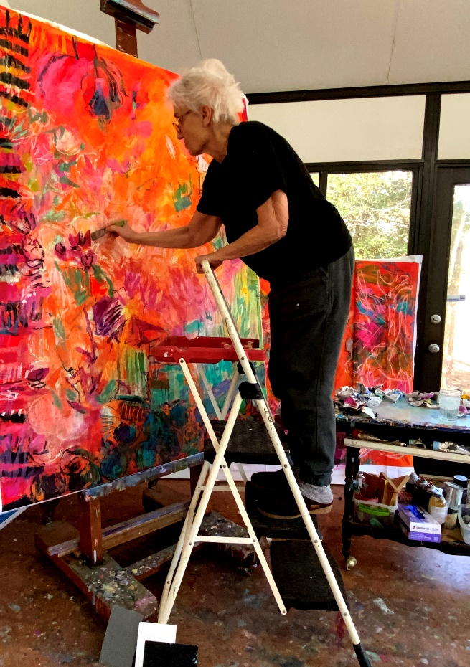
CORPORATE COLLECTIONS
Princess Anne Country Club
Assured Construction
General Electric
International Paper
AAA
Raycom Media
Union Camp Forestry Division
Coldwell Banker

