Stand out with a strong sense of place
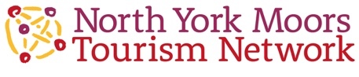
Easy actions to benefit your business

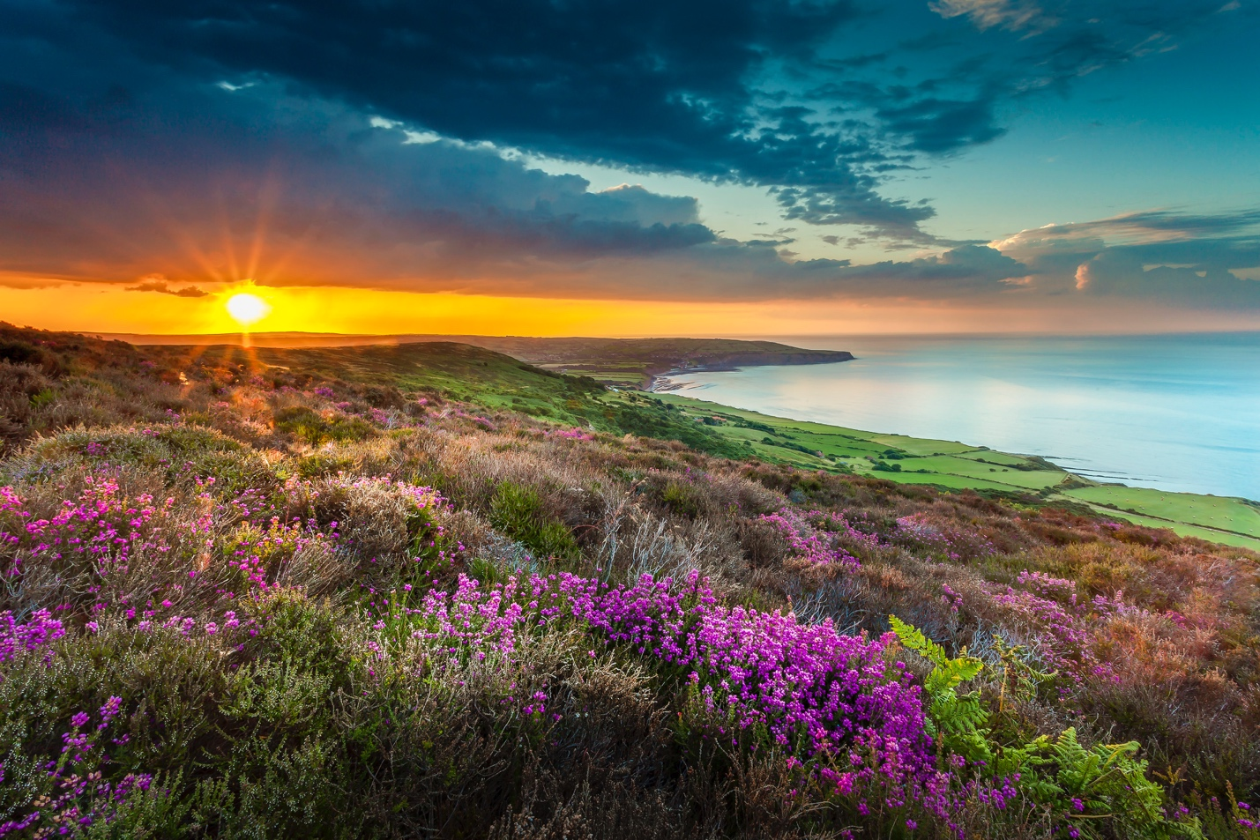
We’d like to help you attract visitors to enjoy the North York Moors National Park.

We’d like to help more visitors to feel better and uplifted after their visit.

We’d love visitors to stay longer, spend more and help care for this beautiful area.

First we have to attract them…

We’re competing with many other destinations.

There’s so much choice. Too much choice can delay or prevent a visit.

We need to make it easier for visitors to choose our destination. We can help you do this.

Our approach is simple:

1: Understand what visitors are looking for – and show them how we can offer it.

2: Stand out, be more memorable and distinctive with a strong ‘sense of place’.

These guidance notes will help you stand out, and use your sense of place.

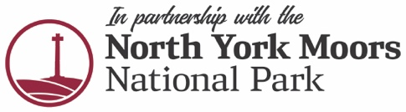
Susan@tourismnetwork.co.uk
NorthYorkMoorsTourism.com
Today’s visitors are looking for something different

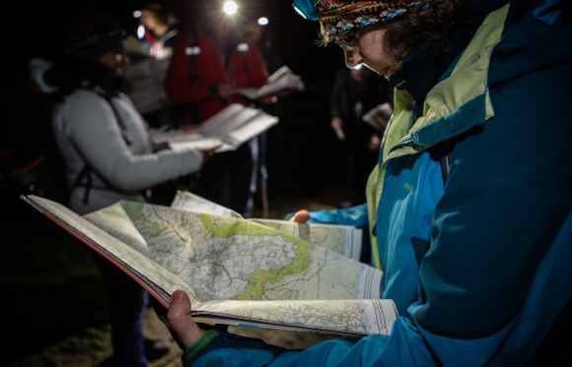
Visitors used to be content with a brew, loo, and view.

Now they increasingly want a local experience, to meet real people, do as well as see.

Visitors like to understand and appreciate the essential character of a place, ideally to learn something they can tell others about when they return home.

This is why local distinctiveness is important. Showing your sense of place makes you and your area more memorable. It can slow visitors down, so they do more in one local area. Visitors are more likely to recommend you to others, because they have more to talk about. They spend more too.

It can be better for the environment, especially if we encourage visitors to walk or cycle instead of dashing around in their car.

Use these guidance notes to be more memorable and attract visitors who care

Your business doesn’t exist in isolation. Its context and your local area are important when you’re trying to stand out and be more memorable.

Using your location in the North York Moors National Park can help you create more interesting content to use on your website, in blogs, mailings and social media posts.

You might use some of the information within your business: for guest information or as part of a display inside your business, for a collaboration with another local business. If you develop new angles and packages for your business, we may be able to help you attract media attention.

What’s special about your area?

We can’t assume knowledge on the part of our visitors. We need to offer clearer reasons to visit and make our destination enticing to them.

Visitors are drawn to places when it’s obvious how that business will serve their needs. Be really specific, with tangible information outlining what’s good to attract visitors to your business.

Too many businesses fail to use their local context. As a result they’re just not memorable. Few visitors want to travel to a place they know nothing about.

Desirable destinations have good accommodation, attractions, activities and places to eat and drink.

Think about when you go away somewhere. Most of us don’t choose a place to stay just because of the accommodation. We want to know what there is to do and if it’s worth the journey.

We’ve done some of the work for you

The North York Moors National Park marketing and communications’ team have worked hard to raise the profile of this area.

Visitor research now shows strong recognition of the North York Moors National Park.

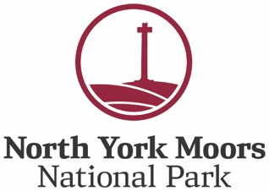
Action!

It pays to talk about this special location in your marketing. Please remember to get the name right: it’s the North York Moors National Park.

Use the Special Qualities

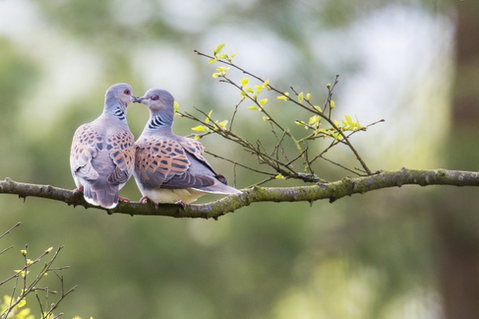
The Special Qualities are the aspects of the North York Moors National Park that make this area worthy of protection and promotion.

The Special Qualities are what makes the North York Moors National Park distinctive.

We might take some of these for granted, but they’re really special for many visitors!

A quick summary of the North York Moors National Park Special Qualities:

- Towering forests, ancient trees, meandering rivers, Jurassic coastline, heather moorland

- Rich variety of wildlife —curlews, turtle doves, nightjars, freshwater pearl mussels, Duke of Burgundy butterfly

- Strong links to cultural heritage — Roman fortifications, medieval castles, abbey ruins, ancient moorland crosses, early industrial sites

- Distinctive places and communities — coastal villages, sandstone buildings, rural settlements, remote farmsteads

- A place of escape from towns and cities — International Dark Sky Reserve, tranquil becks, secluded waterfalls

- Walk, wheel, cycle, horse-ride —thousands of miles of public bridleways, footpaths, country lanes and forest tracks to explore

Action!

Consider the Special Qualities - more information about them here.

Which are most relevant to your local area? What can you tell your visitors about them?

What places can you recommend they visit or see?

Remember to be specific. Don’t just say ‘lovely views’ – tell your visitors which view, where and what they can see. Perhaps there’s a good café or pub nearby too?
Describe your business and local area so it stands out

Your location offers an important context for your business. You can use this information on your website, in guest information, as part of blogs or social media posts.

Action!

You might find it helpful to try to answer these questions:

Anything distinctive about your local landscape? Any important or unusual landmarks?
What are the key features?
Is it hillier, wilder, softer, or more tree-clad than others? Any remarkable trees or plants?

What are the local buildings like?
From a particular time period? Building material? Anything quirky, or beautiful?
Any important or interesting buildings for visitors to look out for or visit nearby?

Any local events that are worth talking about? They could be big festivals or small local events that visitors might like to know about, especially if they give an insight into your area

What natural highlights or wildlife can visitors look out for?
Is there anything that happens at a particular time of year, or time of the day or night?

Where are your favourite places to go locally? To eat, drink or shop?
To stop and gaze at the view?
Any local craftspeople or artists you admire?

Are there are local traditions, stories, words or sayings, local characters?

Could you create an experience for your visitors?
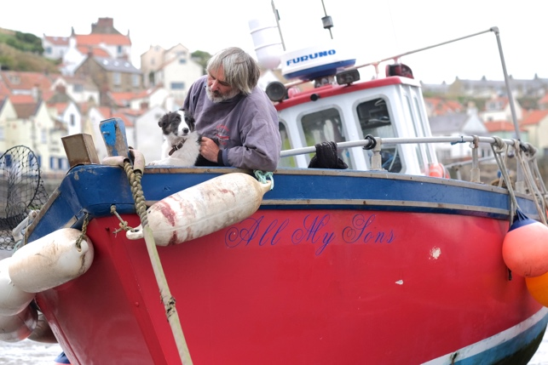
Visitors particularly enjoy experiences they can remember and talk about, showing their photo memories. Insider tips are very welcome.

What experiences can you offer? It might be something you can offer directly, or something you can facilitate or recommend. It doesn't have to be complicated. It could be as simple as recommending a short walk to see something different or beautiful.

Action!

Consider the kind of experience you could offer or promote. You might find this information useful.

Or you might want to simply make some recommendations for experiences offered by others?

Is there an opportunity for visitors to learn something?

Offer a talk trigger or some personalised information

Perhaps you can give visitors something to take home to remind them to recommend you to others? It could be a story, a talk trigger, an insider tip or something made locally.

Some businesses use a customised map to show their local highlights or create information about their favourite walks. You could create your own local treasures map, with recommendations for must-see places, or your favourite places to eat and drink. It’s easier than ever to create your own local mini-guide.

This all helps to build loyalty and position you as a local ‘expert’. Visitors really value this kind of insider knowhow, and are more likely to recommend you to others.

Action!
What information or talk triggers do you need to create? When will you offer them to your visitors?

Use images with impact

Use photos that intrigue, tell a story, explain something, show something specific or distinctive.

Think of photos as ‘evidence’. They should help to show the key selling points of your business, your local area.

It’s good to include photos of the kind of people you want to attract. For example, if you say you’re dog-friendly but don’t include any photos of dogs, will visitors really believe you?

If you use images that show beauty spots, explain what visitors can actually do, and give information about other activities such as places to eat.
Local food, artists and makers
Visitors enjoy tasting local food and seeing or buying work by local artists and makers. We need to make it easier for them to do this, with more direct recommendations and examples.
Many businesses talk about local food. But so do many others. We need to go a step further.
More details make the food seem more special, and you’ll sound more credible!
E.g. “the blue cheese made by Mrs. Wotsit, on Thingy Farm near Where, made from her own goat’s milk”.
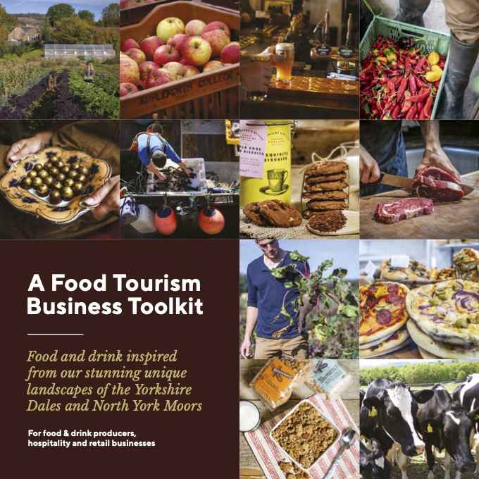
It’s even better to provide a taste of Mrs. Wotsit’s cheese, or say where visitors can buy or sample it. And to suggest the cheese goes really well with Mr. Whatsit’s apple juice made from the special apples in his orchard…

Action!

Take a look at the ideas in this Food Tourism Business Toolkit

Add awe and wonder with nature

Many of our visitors come from urban areas, where natural delights might not always be easy to find. You might be used to seeing flocks of sheep wandering across the fields yet for some people that’s quite special. You might be used to hearing morning bird-song and being able to recognise the sounds. Many visitors can’t do that, but are interested when you point it out.

Action!
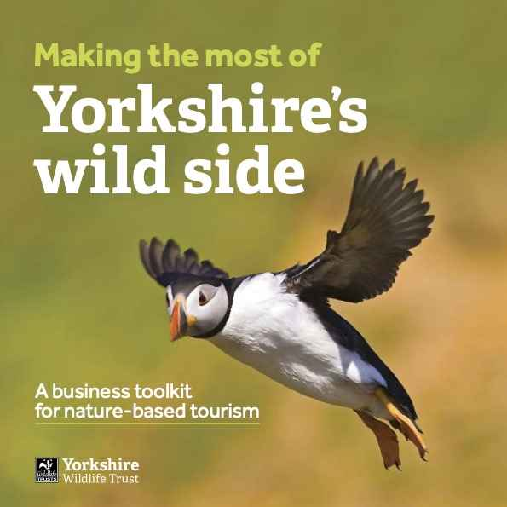
What wildlife or natural sights can you tell visitors about?
Is there anywhere you can recommend they go?
How can you make it easier for them to enjoy nature, for example with identification guides or binoculars?

Is your business nature friendly? You might like to apply to be part of the North York Moors National Park’s Nature Friendly scheme.

More information: Making the Most of Yorkshire’s Wild Side

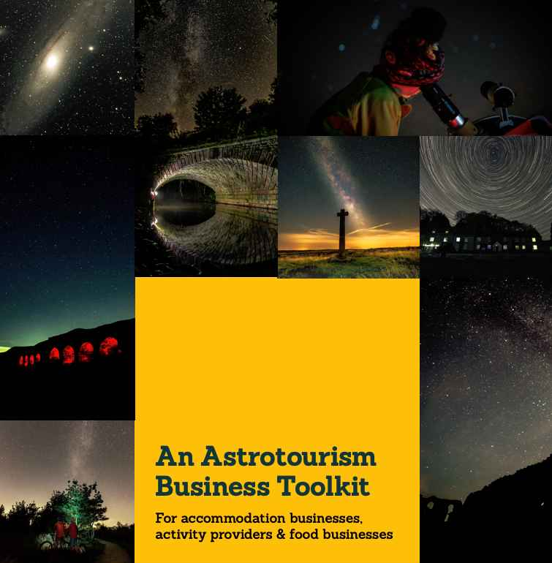
You can enhance the information on your website and social media posts, and offer your visitors more insights using this Nature Calendar

Benefit from the North York Moors National Park’s Dark Sky Reserve status by becoming a Dark Skies Friendly business.

More information: An Astrotourism Business Toolkit

Slow and active travel
We’d like to help more of our visitors enjoy walking and cycling when they’re in the North York Moors National Park. Our Activity Friendly schemes are designed to help visitors recognise which businesses can help them. Dom Barry, our Cycling Development Manager is happy to come to speak to businesses to discuss how you can become more cycling-friendly.
Many of our visitors arrive by car. Once they’re here we’d love them to give their car a holiday and help the environment by walking, cycling or taking public transport. We recognise that it isn’t always easy to take a train or bus, but we do have some excellent routes. Some of them offer fantastic views.
Action!
Could you add more information about public transport to your website and mention in your social media? More information to help visitors plan their visit here
More ways to enhance your business, help your visitors and encourage visitors to look after the North York Moors National Park
Action!
Sustainability
More information about ways to make your business more sustainable

Accessibility
See here for the benefits of making your business more access to more visitors and what to do next

Share with care
We’d love you to share some of these messages from the North York Moors National Park with your visitors.

Image credits:

Night skies navigation – Polly Baldwin/NYMNPA
Turtle Doves – Richard Bennett/NYMNPA
All My Sons/Sean – Tony Bartholomew/NYMNPA

