Case 1
A 36-year-old long-term patient who usually attends maintenance treatment once a month.
Recently, he has been attending more frequently due to a fracture of the first toe on his left foot. He was treated for this condition with auriculotherapy and chromotherapy. However, during this visit, he appeared somewhat foggy and unfocused. When I asked what had happened, he explained that two days earlier a dermatologist had removed a suspicious lesion from his chest, around the level of the 6th–7th ribs on the right side, very close to the Stomach line (from a TCM perspective). In order to perform the procedure, the area had been locally anesthetized, and from that moment onward he had experienced a persistent sense of mental fogginess. We decided to address this issue.
The patient takes no medication and is generally healthy.
We began by investigating the entry point using Green 53, light only (without frequency), at maximum intensity.
A 50 VAS response was elicited.
To select the appropriate colors, I relied on two presentations: Presentation No. 7 (When should colors be used) and Presentation No. 8 (The use of colors in photonic medicine).
The principal treatment objective was to eliminate the mental fogginess. Although I had a strong inclination to work directly on the head, I considered it to be a secondary manifestation rather than the root cause of the problem, and therefore decided against doing so. In retrospect, it may have been worthwhile to investigate this area at the end of the treatment.
An additional objective was to stimulate the lesion site and promote the local redistribution and absorption of the anesthetic agent
I selected colors associated with muscular stimulation:
- Blue 47
- Orange 21 (which produced very little VAS response and was therefore not used)
- Yellow 12
In addition, I wanted to create sensory neural stimulation. However, Yellow 16 did not produce as strong a response as Yellow 12 and was therefore excluded.
Consequently, Yellow 12 became the primary choice.
Furthermore, I considered that stimulating the motor nervous system might indirectly activate the sensory system as well, and these colors appeared to correspond to that objective.
I also incorporated Indigo 98. Although this color is known primarily for its neurovegetative effects, "It also has a muscular tropism and is stimulating and ergogenic, strengthening work and action" (Modul II presentation 8 slid 15).
Although the lesion itself was superficial and removed from the skin, the local anesthetic injection had been administered into the underlying muscle tissue.
Because the patient presented a highly specific complaint, I did not perform a comprehensive auricular examination. Instead, I focused on the auricular representation of the lesion site, specifically the sixth and seventh rib region and its corresponding sagittal projection extending toward the relevant dermatome.
Another area that produced a therapeutic VAS response was located between the shoulder and the hand. It is possible that this represented another structure, perhaps Lung Phase 3. Since the purpose of Phase 3 is to prevent deeper penetration of pathology, it is conceivable that the anesthetic injection into the muscle temporarily affected the external musculature and consequently altered the function of the right lung. However, the strongest responses were observed primarily around the C2–C3 vertebral level, as well as along the spinal representation extending from the first cervical vertebra down to approximately T6–T8.
The treatment sequence was as follows:
- Opening point – Green 53
- Auricular projection area corresponding to the lesion
- Blue 47
- Indigo 98
- Yellow 12
Yellow 12 proved to be particularly active, not only at the primary treatment point but also in the additional areas described above, producing a stronger response than any of the other colors.
In addition to addressing the relevant auricular projection areas, the lesion site itself was treated locally using the same color sequence. Once again, Yellow 12 demonstrated particularly strong activity, producing a more pronounced response than the other selected colors.
At the conclusion of the session, the patient reported an approximately 85% reduction in the sensation of fogginess.
The following morning, he reported a 95% improvement.
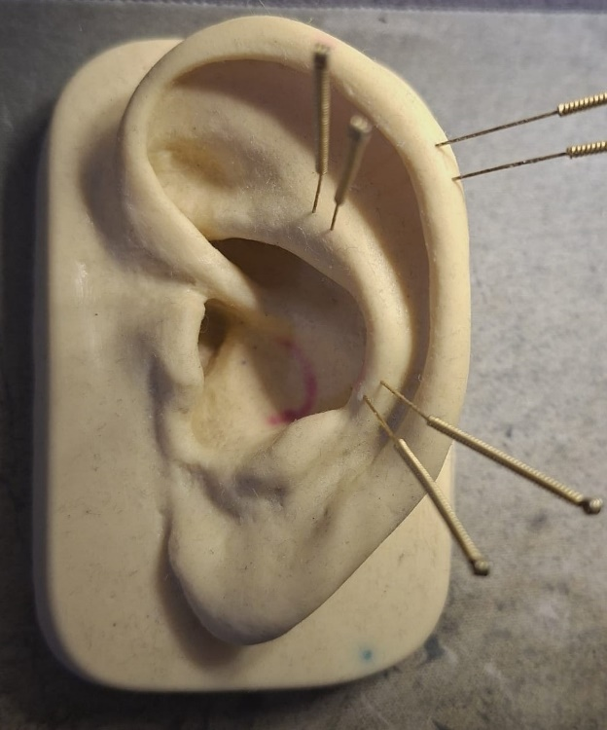

Case 2
A 50-year-old long-term patient suffering from multiple chronic conditions, the most significant being enlargement and irritation of nerves in the lower limbs, primarily along the Spleen meridian pathway.
Several years ago, he underwent a neurolysis procedure to address the condition. However, the pain eventually returned, and on 17 May 2026 he underwent another surgery consisting of:
- Neurolysis of the left saphenous nerve at the thigh level (a purely sensory nerve)
- Neurolysis of the left tibial nerve at the lower leg level (a mixed motor and sensory nerve)
- Neurolysis of the saphenous nerve at the ankle level (the distal continuation of the same sensory nerve, running along the medial aspect of the first metatarsal)
In addition, he suffers from left-sided sciatica, which further complicates the clinical picture.
The patient serves as Deputy CEO of an investment firm, and his work is predominantly sedentary, a factor that does not contribute positively to his physical condition.
Following surgery, he received both antibiotics and corticosteroids.
Unfortunately, I did not take photographs before and after treatment. As this is not part of my routine practice, I neglected to do so in this case as well.

First Treatment Session
The first session took place at the patient's home, 11 days after surgery.
The patient was ambulating with considerable difficulty.
Investigation of the entry points using Green 53 produced a 65 VAS response.
Because the surgical site was well defined and highly specific, I did not perform a complete auricular examination. Instead, I followed the auricular projection of the leg and foot on the left ear (Triangular fossa) and subsequently treated along the actual neural pathways involved in the surgery.
The treatment was divided into two parts with a 10-minute interval between them.
As in the previous case, I relied on Presentations No. 7 and No. 8 to guide color selection and treatment planning.
Only light was used, without any frequencies.
Part One
The objective of this phase of treatment was to promote fluid mobilization and reduce postoperative inflammation, and provide pain relief. I selected colors associated with antibacterial activity, as the patient was receiving antibiotic therapy following surgery and I wished to support and potentially accelerate the recovery process
- Green 53
- Red 25
- Turquoise 44
Red 25 is primarily anti-inflammatory and serves to drain away excess water, such as swelling caused by a sprain. It is both an attack and a supply of formed elements and the water drainage. Red 25 expels water, while applications of Turquoise 44 and/or 38 distribute it. (Presentation 8 slid 34). Turquoise 44 showed a stronger VAS response than Turquoise 38 and was therefore selected.
- Green 53
- Green 58
It is advisable to systematically apply this filter after any antibacterial, antiviral and/or anti-inflammatory action. (Presentation 8 slid 42).
- Green 54
Green 54 corrects and normalizes bacterial aggression. (Presentation 8 slid 40)
- Violet 35
Violet 35 is particularly applicable to the brain and nervous system. (Presentation 8 slid 75)
- Indigo 98
Indigo relaxes muscles and tendons. It has a major anticontracture effect (Presentation 8 slid 16)

Part Two (presentation 7 slid 4 "Muscle soothing")
- Turquoise 38
- Blue 47
- Cyan 80B

Second Treatment Session
One week later, another treatment was performed at the patient's home.
The leg appeared improved, with reduced swelling. Pain was still present but somewhat diminished.
The same treatment sequence was repeated; however, this time Frequency C was applied.
Green 54 was particularly prominent in its response.
Second Treatment During the Same Visit
- Green 53
- Red 24
- Red 25
- Turquoise 44
- Cyan 80B
- Green 58
This treatment sequence was proposed by Pascal as a pain-management protocol during Module 1. It has become a regular part of my clinical practice, and I have consistently observed significant therapeutic benefits across a wide range of cases.

Third Treatment Session
A third session was performed one week later, again at the patient's home.
At this stage, there was a visible improvement in the appearance of the leg and the surgically treated areas. Pain was now confined exclusively to the surgical region of the foot.
Auricular treatment focused primarily on the foot representation area, and body treatment was directed mainly to the foot itself, with only limited work performed along the surgically treated nerve pathway.
Investigation of the entry points using Green 53 produced a 56 VAS response.
The treatment protocol from the first session was repeated.
Unfortunately, toward the end of the treatment, the patient reported an increase in pain in the foot.
I applied kinesiology tape to the area, which reduced the pain almost completely, bringing it close to zero.
Later that evening, the patient removed the tape because it caused itching. The pain returned, but the following day he reported that the pain level had remained significantly lower than before.

A fourth treatment session has not yet been performed. However, I met the patient today (while treating his son), and his leg appears to be in significantly better condition than at the start of treatment. The patient now reports only mild residual pain at the ankle level.

Additionally, an image is attached showing the nerve pathway along the leg, with the surgical sites marked.

