CASE STUDY
44 FEMALE CERVICAL RADICULOPATHY

Reason for Consultation:
Consultation was sought to help with chronic muscle tension/pain around the cervical spine and right shoulder, neurological symptoms including referral along median and radial nerve distribution presenting as numbness and tingling all the way down to her fingers. Reduced cervical ROM in EXTENSION, LATERAL FLEXION BILATERALLY AND ROTATION TO THE LEFT.

Medical history:
2 years ago K.N. hit her thoracic spine in the interscapular area on a towel bar upon rising from a crouched position. This resulted in an extremely severe bout of neck pain that lasted 11 days and continued for the next 1 year with paresthesia in the thumb and first finger on the LEFT side. A chiropractor she consulted thought she was experiencing a pinched nerve.

Six weeks ago the patient started experiencing pain in thoracic spine in the same area that was originally hit with the towel bar. Then pain in the sternum area. Then the pain went to her neck and she lost motor control in her tricep and started experiencing severe deep bone pain in her upper RIGHT arm. Also deep pain deep under her right scapula. THIS EPISODE WAS UNPROVOKED and was possibly from her job as massage therapist and associated postural issues. Severe muscle spasms were experienced in area of R subscapularis, R serratus anterior and serratus posterior superior and triceps. NOTE HOW THE NEUROLOGICAL SYMPTOMS AND PAIN ARE NOW ON THE RIGHT SIDE OF THE BODY UNLIKE THE ORIGINAL EVENT.

The patient scores 7/9 on the BEIGHTON test for hypermobility, has a positive ANA indicating a non-specific connective tissue disease somewhat simiar to Lupus.

MRI imaging revealed degenerative disc disease and bulge at C5/C6 causing bilateral severe foraminal stenosis with encroachment of exiting nerve roots with resulting spinal nerve root impingement. Also mild spinal canal stenosis at this level. Also moderate stenosis in the left foramen at C6/C7.

An X-ray showed reduced lordodic curve of cervical spine and moderate to severely reduced intervertebral disc space.
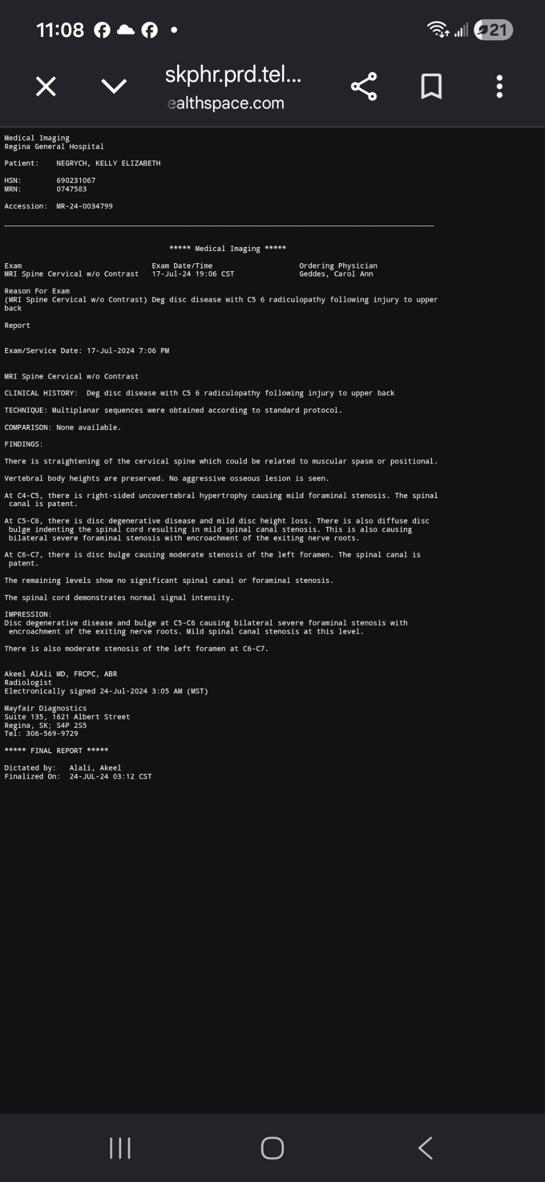

It should be noted that the patient experiences difficulty in emotional regulation, extremes in mood/mental states and generally struggles with mental health.

Current Treatments:
The patient has worked with naturopath care including homeopathic remedies, physiotherapy, TCM/acupuncture, osteopathy and occasional use of Advil.

FIRST PHOTONIC MEDICINE ASSESSMENT:

Laterality:
18 VAS on L Hemi, 67 VAS on R Hemi
- Treated with Green 53 on interhemispheric neurons and after rechecked hemispheres and found 8 VAS on each side.
- Patient felt much more relaxed.

Entry Point:
- The VAS on the entry point was more bouncy, pushy, maybe a bit faster.
- Upon assessing entry point multiple times, I perceived a different VAS count on multiple tries.
- I settled on 23 VAS

Exploration of Pinna:
- Revealed at least 4 significant points on R and L ear including ares which I think are possiblY THALAMUS(OR HYPOTHALMUS), SPINAL CORD, R ZONE, CERVICAL SPINE, AND LATERALITY POINT

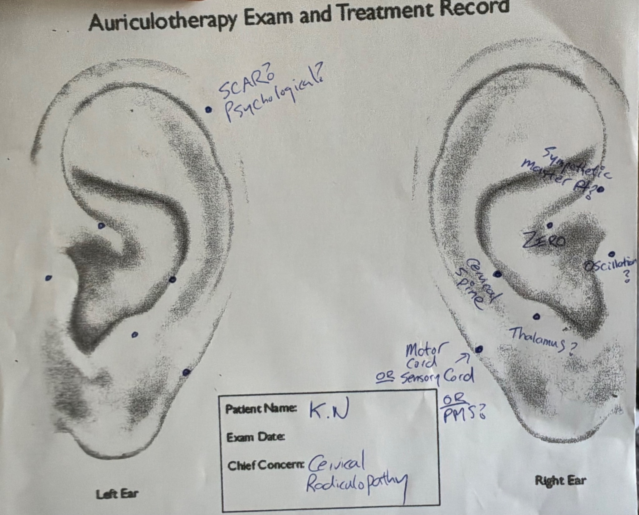

TREATMENT #1: June 1/26

I decided to focus photonic treatment on the cervical spine and muscles of the neck.

On the pinna, the cervical spine produced VAS from Green 53 (30V), Red 24 (63 strong V), 44 (40V), 38 (24V), 80B (25V), 58 (40V), 16 (40V), 47, 21(23V), 98 (80V)
The order I chose was as follows:
53, 24, 44, 80B, 58, 16, 47, 58, 21, 98
I did not use Red 25 as this is contraindicated on neck (and brain)

Rational for filter order:
After 53, I first treated the symptoms (24 and 44 for inflammation, 80B for pain) then cleaned the terrain with 58, then applied 16 to address nerve innervation/nerve fibres and then followed with 47 to address the neuromuscular chronaxis. Then cleaned up with 58 again follow by 21 (augment cellular metabolism) and ended with 98. I would have like to assess VAS with Yellow 3 due to its use in nerve reactivation.

The most notable reactions during the treatment on the pinna was with 44 (she felt cool sensation), 58 (STRONG sensation of energy going down to feet and necked cracked) 47 (felt like a soft hug), 21 (felt intense, her body started jerking a bit)

I then treated the neck muscle zone on the mastoid surface with the same colours/sequence all of which triggered VAS.

Finally, I treated the whole neck area with the same order of colours.
She felt MUCH more pronounced reactions during in situ treatment. A lot of moving around and some jerking. She felt really calm.

TREATMENT 2: June 4/26

The patients neck felt REALLY good the first day of the treatment. The following few days post treatment she also felt good but not as pain/restriction free.

The same areas were treated on the ear followed by the treatment of the neck. The most notable reactions were again, a lot of jerking around when being treated in situ on the neck. She felt very compelled to extend the neck during treatment. She really like the way Blue 47 feels.

TREATMENT 3: June 8/26

She reported good days following the last treatment. She notices she is not thinking about her neck so much as usual.

All the same areas were treated.

During this treatment on the cervical spine zone on the pinna, She had a lot of jerking of the neck with 44, 80b, 16, 47 and 21.

The most notable and interesting observations she expressed today is how she is not scared to extend her neck and how some feeling of tension can build with the application of the colours and whenever 58 is applied, this tension releases.

TREATMENT 4: June 11/26

COMMENTS ON CASE MANAGEMENT GOING FORWARD:

For this case - due to time/expertise limitations - I would like in the future to focus on exploring and treating other prominent points found on K.N’s ear. For now, I chose to focus on the area of chief concern, the cervical spine and muscles of the neck. I am especially interested in that point found at the
- TAIL OF THE HELIX which I suspect is the motor/sensory cord or a psychological projection site.
- The point on the ANTI-TRAGUS which is likely the thalamus site
- Corpus callosum/oscillation zones (especially considering her disturbed laterality findings
- The point on the ANTERIOR LOBULE likely representing her prefrontal cortex, hippocampus or hypothalamus

I am also VERY interested in exploring that VULNERABLE AREA mentioned in the lectures in the interscapular area that is a zone of energy leakage that is assessed/treated with Yellow 3, 9 or 12. I do not have these colours but this is the EXACT area that she originally slammed against the towel bar.

In the future I also need to localize the ENTRY POINT SIGNATURE on the pinna. I have not yet managed to do this with certainty.

