Photonic Medicine, Case 1. Presentation by Eva d. 27/6-26.

Case 1: stomach ache, heartburn and reflux.

Anamnesis: A 64 year old woman, retired.

For about 8 or 9 years, the patient has suffered from heartburn, reflux and stomach ache, which we will try to treat with photonic medicine over four sessions.
Her health is overall good, although she also suffers from pollen allergy, and has a small tendency to asthma. In general her digestion is good, without any diarrhea or constipation. She has an active lifestyle and does a lot of exercise, comparing to most people her age.

The condition, you could say, is under control, so far as the patient takes a lot of consideration about what to eat and drink.
The doctor has advised her to take acid reducers, as the medicine you get as “over the counter purchase”. She eats 6 tablets a day.

Still the condition affects her life quality a lot – always must make a lot of restrictions on her diet, and social events and eating out is not easy. And even with all the restrictions the stomach can still be a little reactive.
Her diet must be very fat reduced. Acidic food and even raw food like oatmeal is a problem. Drinking sparkling water, wine or alcohol is not possible without stomach pain and reflux. A glass of red wine can result in vomiting.

The normal picture is that the symptoms start in the afternoon, and if she is eating or drinking something provoking, the symptoms will be pain in the stomach, reflux and even vomiting in the evening and during the night. When she has pain, she assesses it to about 8 on the SUD pain scale.

Considerations and general perspective on the condition before treatment.
The condition is also called gastroesophageal reflux disease (GERD), and happens when stomach acid or backwash of food flows back up into the esophagus, with the already mentioned symptoms following. When the condition has become permanent, there is a malfunction of the lower sphincter of the esophageal, which has gotten too relaxed,

I was wondering if treating the digestive canal and esophagus would have any effect, because sometimes the condition is caused by a hernia, where the top of the stomach is bulging up above the diaphragm, and sometimes it is caused by changes in hormones in womens menopause, which can make the esophageal lower sphincter more relaxed. The first we do not know, and the second could be possible, since the condition started in that time of the patients life.

So I did not make any promises to my patient, but we made the agreement of trying four treatments.

This is the short overview over the treatments. For further explanation, you can read below.

Date | Right ear | Left ear | Affected area | Patients experiences
10/4-26 | 53/24/25/44/58/80B  Exam. 54 and 47 but no reaction  Then 21/98 (shortly) | 53/24/25/44/58/80B  --“-- | Esophagus, stomach, small intestines/duodenum  lung | Under control but if not cautious, pain 8 (SUD)
27/4-26 | 53/24/25/44/80B/58  21/98 (shortly) | 53/24/25/44/80B/58  21/98 | Esophagus/ stomach, small intestines/duodenum | More calm stomach,  Pain from 6 to 8 (SUD)
4/5-26 | 53/25/44/80B/58/47(diagphragm)/58  21/98 | 53/25/44/80B/58/47(diagphragm)/58  21/98 | Esophagus, stomach, small intestines/duodenum – now also bladder/bronchi  Finding less VAS | less stomach pain after eating (SUD 4), no pain at night.
20/5-26 | 53/25/44/80B/58  47 diaphragm/58  21/98 | 53/25/44/80B/58  47 diaphragm/58  21/98 | Esophagus, stomach, small intestines/duodenum – now also bladder/bronchi  Finding less VAS | Still better.  Acid reducers: before 6 tabl/day to now 2 tabl/day

NB: The findings on the right and left ear is always similar, although the VAS is more easily felt on the left ear every time.

Picture 1: Findings of VAS on the pinna during the first two treatments. The pink area corresponds, I would say, to the small intestine, duodenum, stomach and esophagus on the front of ear, as shown in Pascal’s ppt 6, slide 27 and 29. The blue line is the diaphragm as showed in Pascal’s ppt 6, slide 38. It also shows the bladder and colon is corresponding to the upper dot and esophagus and stomach with the lower dot on the back of the ear.
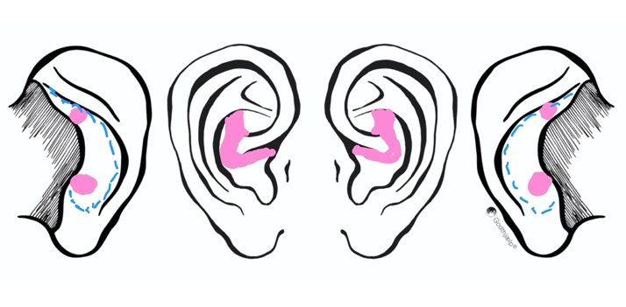
- Treatment.
I treat laterality.
Entry point 13-14, clearly not accurate, because there is more VAS on stomach/esophagus.
I search the whole ear with green 53 and find a very distinctive and coherent area, which corresponds with the small intestines, duodenum, stomach to the esophagus, with increasing VAS from intestines to esophagus. (VAS from 7-8 to 23-25)

There is small reaction on hypothalamus and on the lungs, but the main VAS reaction is on the digestive tract, and I am surprised how clear the picture shows.
I suspect this is because she in general has a good health condition, so there is nothing that points to other issues.

Selection of color sequence:
I remembered that Pascal did a treatment on stomach and intestines on the first module, so I decided to copy the suggestion of colors, and the affected area did respond to that color sequence.

Searching and treating the pinna:
The area responded on both red 24 and red 25, still increasing towards esophagus. I tried 54 for bacteria and 47 for virus, and there was no reaction.
Therefore my conclusion so far is, that the patient has an inflammation in the area, and no traces of infection or virus.
That is why I treat with 24 first, to be cautious not provoke pain, then 25 shortly, 44, 58 to clean after the treatment, and 80B to calm and soothe.
Finishing with orange 21 and 98 very shortly, because I wonder if it is too early because of the inflammation with orange and don’t want to constipate with 98.

I also found two areas on the back of the ear, and according to Pascals ear chart p. 38 on the back of the ear, it could refer to bladder/colon maybe duodenum on the upper part, and stomach and esophagus/stomach on the lower part.

I find it difficult to be precise on the back of the ear, so there can be more uncertainty.

Treatment on the body, starting on the stomach going up to esophagus, and then on the small intestines. I use the same sequence of colors in same order as on the pinna, but the directions on the body is not that consistent, I admit, and I will later found out that the right way is to start at the esophagus following down to stomach and intestines.

- Treatment 27/4-26

Patients condition.
Really positive statement from the patient. She has already gotten better: the first 10 days she was much better, pain was on a 3 (SUD), but then the stomach got more sensitive again, so now on a 6. So a clear improvement, but because of the long period between the first two treatments it was worsening, but still better than the starting point. But we are both surprised an eager to go on.

Color sequence: the same. Again checking with 54 and 47 but no reaction. A little more orange and violet 98, as it went well after the first time.
Entry point: I counted 22, but found 25 on the esophagus, so again, I need to practice counting the VAS.
Reacting area: I find the same picture as the first time: Number of VAS when applying 24/25 on the small intestines/duodenum, increasing all the way to stomach and esophagus (25 VAS). I notice that I find the same two areas on the back of the ears, corresponding to stomach/esophagus in the low and bladder/colon in the upper part – reacting to green 53 and red 24/25.
Other things: A little VAS in the allergy point, bronchi and hypothalamus, the two first just get green 53 during the search, and bronchi gets same treatment as the rest.

I repeat the same treatment on the body, same way as the last time, so I still get the directions wrong
I am aware that I must treat the diaphragm at some point, but for now we don’t, because of long treatment and exhaustion of both client and practitioner.

- Treatment d. 4/5-26
Patients condition: She is very happy to tell me that the stomach feels calm, it is not often she gets the pain in the solar plexus anymore, but when she does it is only on a 4 (SUD) and it lasts for a shorter time. No discomfort in the evening, she can even lie on the right side when she goes to bed, she can eat oatmeal in the morning now without pain afterwards. And she always starts to feel better immediately after treatment.

Color sequence: Almost the same, this time I leave out red 24. I wonder if I should try other colors, but as it is going all right, I do not. Today I also include working on the diaphragm on the back of the pinna with blue 47 because of its relaxing properties.

This time I have in the meantime been told by Pascal to start at the most reacting place and go backwards from that, because then much of the VAS will already be solved, when I go back. So the right direction to work, is to start on the esophagus, the stomach, duodenum/small intestine/bladder, which I do.
And then also following the line of the diaphragm at the back of the ear, as shown on Pascals slide ppt 6, slide 38, the thin brown line, with green 53 and blue 47.
And still also the two places on the upper and lower part with bladder/colon and esophagus/stomach.

Picture 2: you can notice the little dot added, corresponding to the bladder.
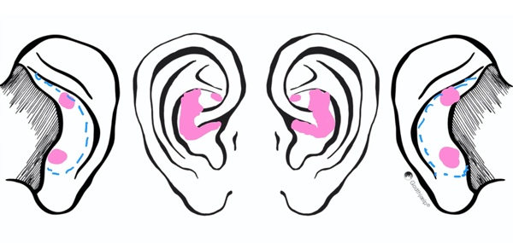

Entry point: 15-17.
Reacting area: Today the picture is changing a little. Still VAS on the esophagus, stomach, small intestines and duodenum, but now also spreading out to bladder, reacting with 53 and 25. At the same time the number of VAS is decreasing: the VAS with green 53 is most places about only 5-8, on the esophagus I count 14-15, and when applying the red 25 the VAS disappears very fast.
It feels like a very calm situation, and as if we have reached another level, why new things appear. The patient confirms, that she has had problems with an irritated bladder and urethra since very young. So I also treat the bladder and urethra with the same color sequence.

On the body: Same treatment, now starting out from above on the esophagus and going down, ending at the level of colon and the bladder, still the same picture with VAS quickly ending.

This time I also tried to follow the right and left dome of the diaphragm in soft curves from the lower ribs to where the sternum ends with blue 47, following the fibers as good as possible according to the pictures of the diaphragm, that Pascal has shown us.

After the photonic session, I introduced the breathing exercises, we learned during Module 2, and the patient also performed them very well on her own.

Because of the esophagus passing through the diaphragm, it seems like a good idea to make all tension in the diaphragm go away – apart from all the other advantages of the diaphragm massaging the intestines in the whole area. (look at Pascals 2 posted pictures on whatsapp)

- Treatment 20/5-26.
Patients condition still improving. The stomach pain is now more rare, she only take two tablets of acid reducers before going to sleep, and just to be sure.
Though she is still cautious with her diet, she drank a little wine and ate differently during a holiday, even forgetting medicine one night, without feeling any discomfort.

Treatment on the pinna: same color sequence as last time, now finding fewer VAS, and treating with red 25 VAS disappears after 4-6 VAS.
Treatment on the body: Same as last time.

So this is where we are now. I found that the patient had an inflammation in her small intestines, duodenum, stomach and esophagus, and later on I also found a little inflammation on her bladder. It could look like a general inflammation of the mucous membranes – I do not know if it is a known condition? We can ask Pascal. And the
treatment seems to have had a very good impact on the condition of the client.
I wonder if I should have worked with other colors too, or perhaps treated other places?
The patient wants to continue the treatments. We will see if it worsens over the summer holiday, and then find out the right amount of time between treatments.

My ability of counting the VAS on the entry point is not good. I have to practice! But in the searching and treating on the pinna I never doubted my findings, because the picture was very clear, and moving around I find it much easier to feel the differences.

