Tinnitus

Client is a sixty-four year old male who in 2012 was thrown from a horse and landed hard on his left occipital bone. Saw stars for a short time after the impact and a noise like a freight train passing through his head persisted for some days, By the end of the first ten days, this noise had diminished to a ceaseless low roar (3 on a scale of 10) which has continued unabated till now.
He is left ear dominant and likely was before the incident.
Hearing tests have been done, and no functional loss has been noted.
An MRI was performed some years ago, date uncertain, no abnormalities reported. The MRI is not available to us for inclusion.
When lying on the table, his feet fall outwards, indicating longstanding yin deficiency in the Yin Qiao Mai Vessel.

The protocol followed throughout the course of treatments has been that set out by Professor Pierre Magnin on p129 of “De la chromothérapie à la médecine photonique”, The points are shown below.

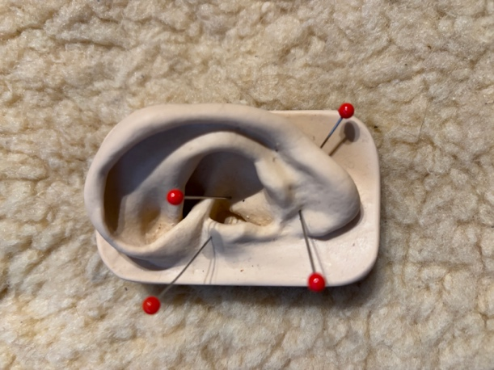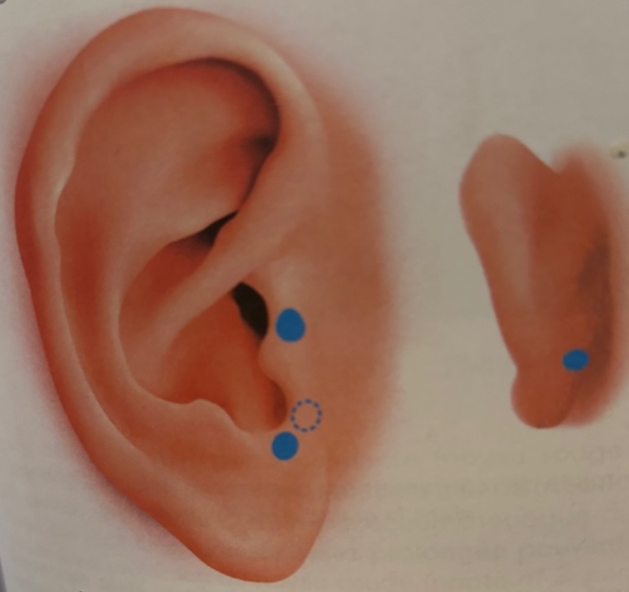

Date | Left | Right | Treated | Patient’s experience | Practitioner’s Observations
30.04.2026 | 53,54,25,44,21,98,32 | Little response | Explored with 53, 25,44 then treated Master cerebral point  Supratragic notch (ear point)/vagus point.  Auricular nerve point on back of ear. | Sensed colours | Followed the sequence of colours outlined on p129 of “De la chromothérapie à la medicine photonique”, Dr. Pierre Magnin.
08.05.2026 | 53,54,25,44,21,98,32 | 0 | Explored with 53, 25,44 then treated Master cerebral point  Supratragic notch (ear point)/vagus point.  Auricular nerve point on back of ear. | Sensed colours and started to be aware of his own pulse | Tested client to ascertain which of the five types of tinnitus he has – vascular, muscular, senso-neural, psychogenic or lesional. Apparently, none of these.  He went to sleep as soon as I started working
13.05.2026 | 53,54,25,44,21,98,32 | 0 | Master cerebral point  Supratragic notch (ear point)/vagus point.  Auricular nerve point on back of ear. |  | Slept through much of the procedure.
20.05.2026 | 53,54,25,44,21,98,32 | 0 | Master cerebral point  Supratragic notch (ear point)/vagus point.  Auricular nerve point on back of ear.  In situ on left cranium. Most response above lambdoid suture on parietal, in the area of GB17.No response from right side of head. | Was aware of different colours on his head which he felt as a light pressure. | On the theory that the impact from being thrown by the horse could have pushed the L occipital up in to the parietal area, I decided to use the colours in situ on the lambdoid suture. Almost as soon as I started, the client admitted to having downloaded an app of white noise to counter the tinnitus. This use compromises the purity of light therapy alone.  Client suddenly remembered a second incident of being thrown, from another horse, landing on the exact same spot on the head and breaking his pelvis.
27.05.2026 | 53,54,25,44,21,98,32 |  | Master cerebral point  Supratragic notch (ear point)/vagus point.  Auricular nerve point on back of ear.  In situ on left cranium. VAS more generalised over the area. | Was aware of different colours on his head. A light pressure. | Because client had already compromised light alone by adding some “white noise, and because the second fall from the horse had affected both the left occipital and a broken pelvis, thus involving cranio-sacral aspects, I gave him the MindAlive David Premier device to use. This has a 22-minute program of sound and light projected at 12Hz at 15-second intervals alternating activity and silence. This pumps cerebrospinal fluid up and into the glymphatic system thereby clearing accumulated debris from the system. The broken pelvis may explain the feet falling out when supine.
03.06.2026 | 53,54,25,44,21,98,32 |  | Master cerebral point  Supratragic notch (ear point)/vagus point.  Aurcular nerve point on baick of ear.  In situ cranium, reaction from right side for the first time. |  | After one week of using the AV CSF pumping device nightly, the ear points became very much more responsive and in situ on cranium extended for the first time to the right side, with strong VAS above the parietals to 44 and 35. Strong response at the oropharyngeal point on the L ear and client constantly swallowed.
10.06.2026 | 53,54,25,44,21,98,32 | 0 | Master cerebral point  Supratragic notch (ear point)/vagus point.  Auricular nerve point on back of ear.  Oropharyngeal point  Cranium and in situ over the left pinna. | With 21 in situ over pinna he said the quality of the tone changed. | Strong response to 21 and 98 on all ear points and pinna in situ. Reaction to 54  On various areas of the cranium both sides.
17.06.2026 | 53,54,25,44,21,98,32 |  | Usual points, plus two on the back of the ear in the hollow zones at the level of the insertion of the ear. | Sound remains unchanged, but there are times when he pays it no attention. This is new. | 203 VAS on auricular nerve point with 53, and high readings with 25 44, and 21  In situ on cranium and over ear strong reaction. On a parietal area 5 cun from the midline and 2 cun back from the hairline strong response to 21 and 98

Tinnitus types.

Type 1 Vascular

Whooshing urbulence, can hear heartbeat

Test
Lower shoulder, turn head to right, press right hand against ear. C drop chin. If sound increases, then vascular. Repeat on Left. raise head to look at ceiling, and lower chin. Does the sound change? Neck and vestibular artery syndrome, trapped trigger point.

Type 2 muscular

Clicking popping, resembling bullets, extremely rapid tapping on occasion. Intermittent.
This is the stapedius or the tensor tympanum under stress.
Low in magnesium. Twitching in ear. Could be facial muscle issue.

Test open mouth as wide as possible, hold for five seconds. Clench jaw and hold while pushing jaw forward.
If worse, then muscular

Type 3 sensoro-neural.

High frequency whine, whistle, buzzing
Damage to hair cells of cochlear. Electrical software issue
Insulin resistance. Glycation

For this type, Caffeine on an empty stomach is bad news as it raises cortisol levels.
Pillow. Head should be in straight line with the spine. Cotton buds, ear buds create a vacuum which worsens the situation.
Dehydration!! Warm water first thing in the morning, well before coffee is advised.
Magnesium glycinate supplements suggested if sleep is also an issue, magnesium citrate if there is constipation .
Take in the evening. Vitamins B1, B6 and B12, methylcobalimin. Rebuild myelin sheath so nerve signals travel clearly and cleanly.
Fatty acids good.
Massage SCM with a pinching movement. Press ting gong SI19 circular massage, 20 clockwise, 10 anticlockwise.
Then do 12 to 24 clicks, index off middle on the occipital bone. ALL EXERCISES ON LONG SLOW EXHALE.EXHALE LASTING TWICE ITHE TIME OF THE NHALE.

Type 4 psychogenic

Constant change. Deepens when emotion is strong. Drones.
When client is absorbed, in an activity, the sound disappears. limbic.issue. Chronic anxiety.

Type 5

One ear only, possible neuroma on auditory nerve. Dizzy, nauseous, face droop, double vision slurred speech.

***************

Link to Dave Siever’s lecture on Cerebro-spinal pumping. The video, on YouTube is entitled AVE and Dementia

https://youtu.be/jycexnNnUH8

