

Instructions:
- Go to “File” → “Make a Copy”
- Retitle it and save it somewhere in your Google Drive folder where you can find it easily.
- This is your COURSE LAUNCH CALENDAR (COURSE BLUEPRINT).
- After you make a copy, paste the URL of this document onto your COURSE BLUEPRINT next to “Course Launch Calendar.”

LAUNCH CALENDAR

Example:

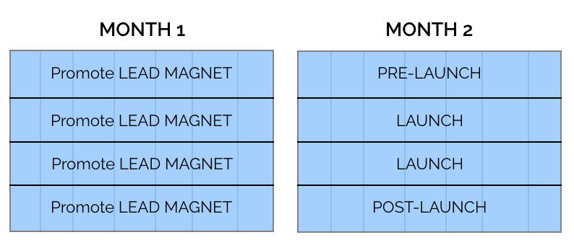

Month 1

Month 2

Month 3 (optional)

Example of my recent launch:

Month 1
AFFILIATE PROMO ALL WEEK | -----> | SOCIAL MEDIA TAKEOVER | -----> | TWITTER, IG, FB POSTS | -----> | ----->
AFFILIATE PROMO CONT’D | -----> | -----> | PRE-SALE WEBINAR |  | ENCORE PRE-SALE WEBINAR
 |  | SENT SURVEY

Month 2
FB ADS |  |  |  | WAITING LIST WEBINAR
FB ADS
FB ADS
FB ADS | PRE-  LAUNCH PROMO STARTS

Month 3
FB ADS |  | PRE-  LAUNCH CONTENT DROPS
FB ADS | LAUNCH WEBINAR |  | ENCORE LAUNCH WEBINAR |  | “WATCH THE REPLAY” | “DOUBTS?”
FB ADS | “PERSONAL QUESTION?” |  | “FIRST STEP?”
FB ADS | AFFILIATE WEBINAR |  | WEBINAR |  | CART CLOSE

