Learning from Home

A Handbook for Parents
This handbook is not intended to create a contract. The school reserves the right to modify, at any time, any of the policies described or privileges granted.

[Montessori School] admits students of any race, color, gender, national or ethnic origin, religion, family structure, sexual orientation or gender identity to all the rights, privileges, programs and activities of the school. It does not discriminate on the basis of race, color, gender, national or ethnic origin, religion, family structure, sexual orientation or gender identity in the administration of its educational policies, admissions policies, scholarship and loan programs and athletic and other school-administered programs.

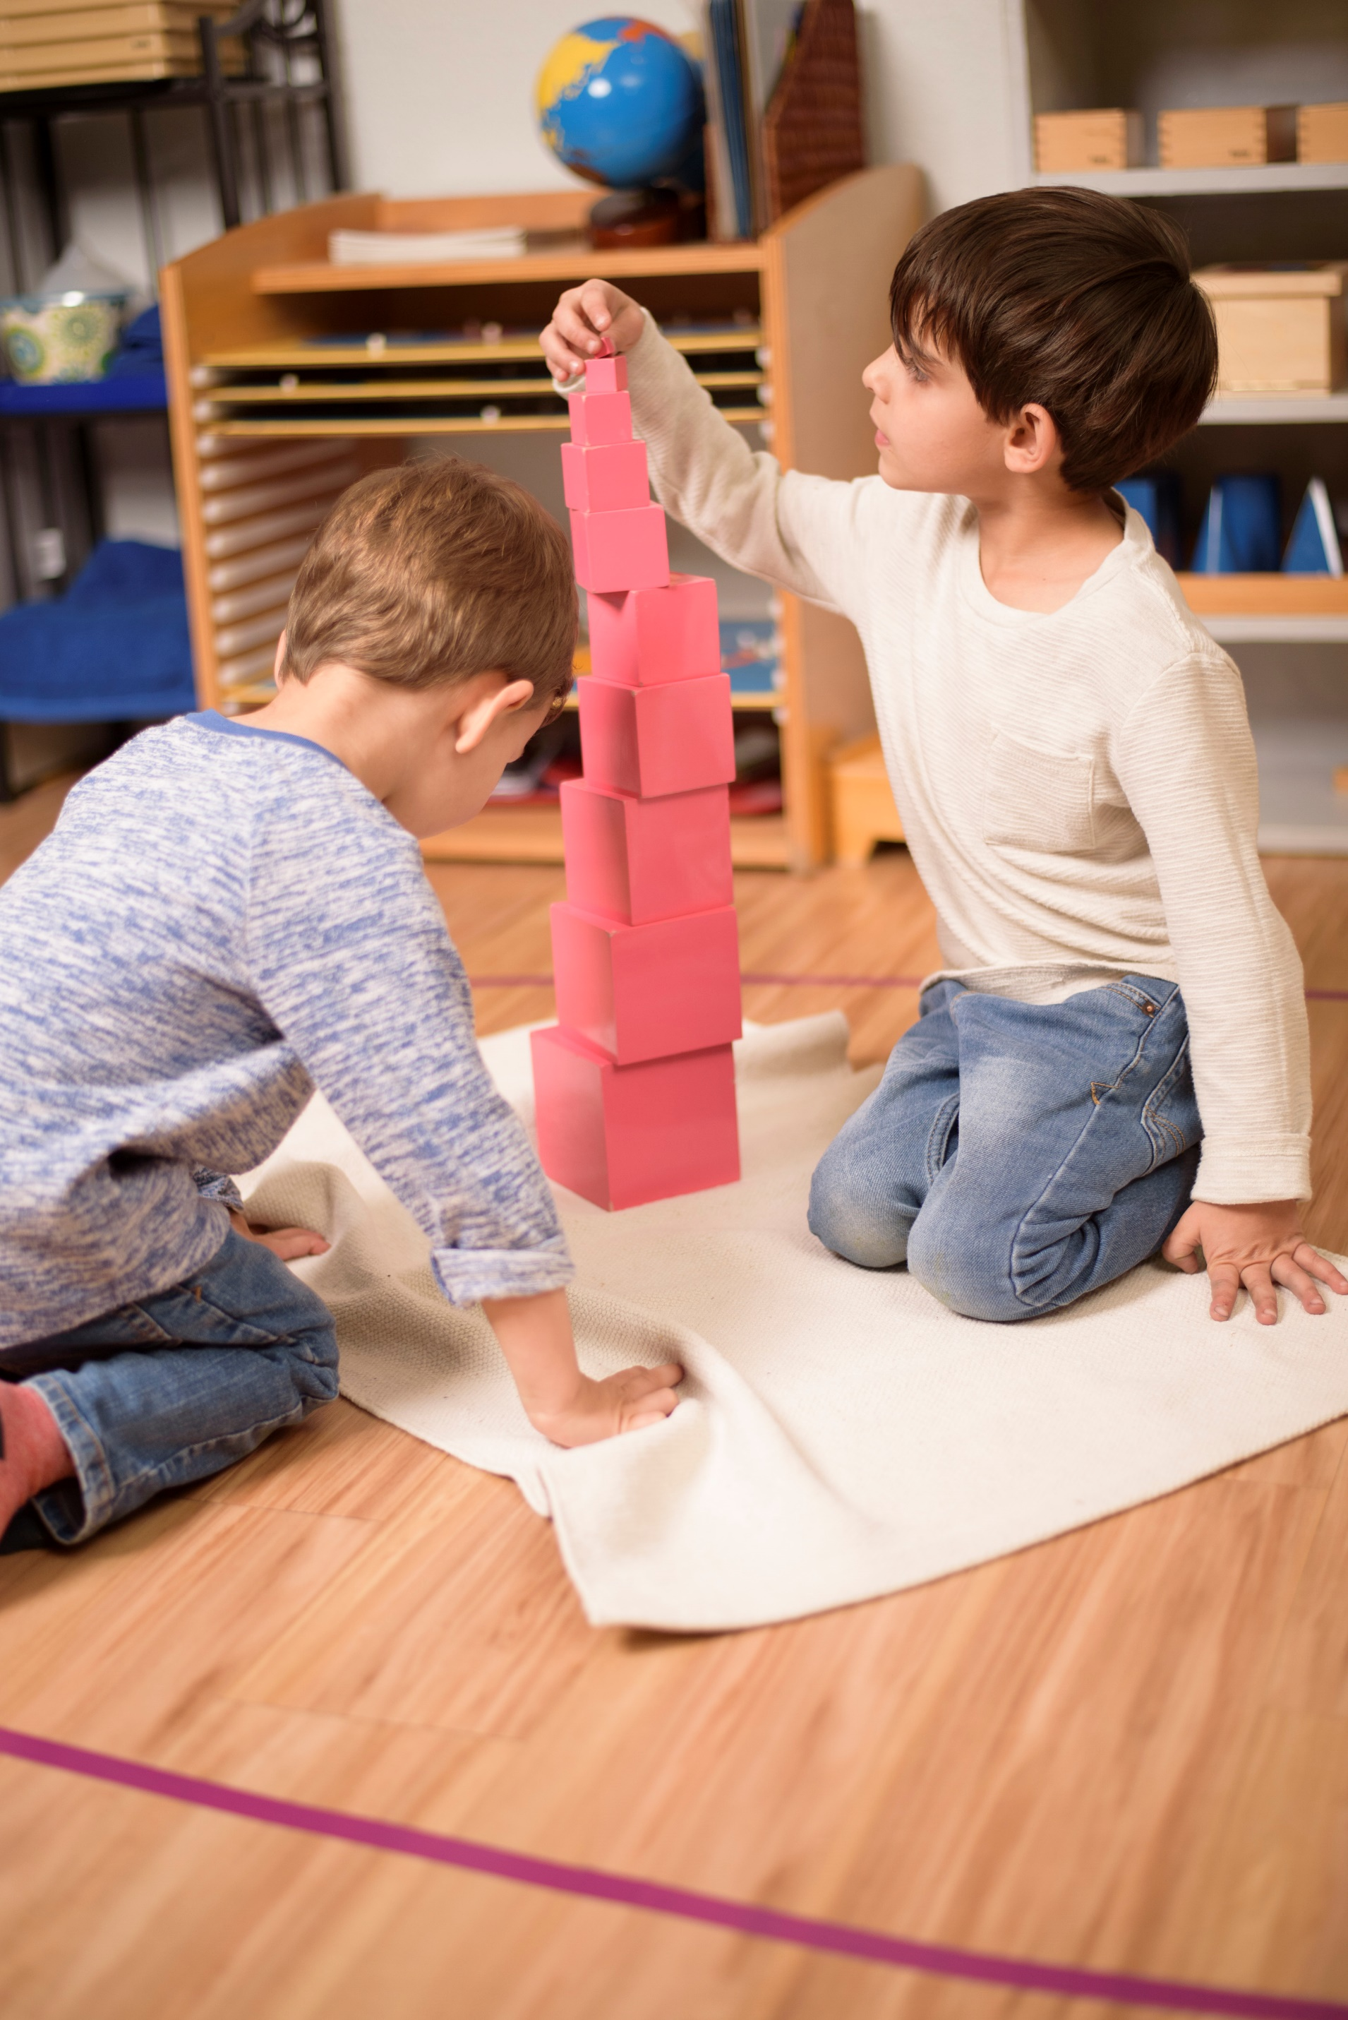

Table of Contents

3 Learning from A Montessori Perspective
4 The Prepared Environment
5 Practical Life
6 The Uninterrupted Work Cycle
6 Ownership of Tasks and Sharing in Learning
7 Responsibility and Contribution to Community
8 Toddlers
12 Primary
16 Lower Elementary
18 Upper Elementary
21 Adolescent Program
24 Specialty Classes
24 Resources for Families
25 Frequently Asked Questions
Many Thanks to the Montessori School of Tokyo for their support in the creation of this school resource.

Learning from A Montessori Perspective

When embarking on a time of learning from home, our aim is to create a Montessori-based framework that serves our students while supporting parents as we all adapt to a different daily routine. It is important to us that the children’s activity during this time be enjoyable, thoughtful, challenging, and rewarding.

Replicating what happens in our classrooms is not something we can achieve during this period. Our goal is to work in collaboration with families to keep alive the culture of learning that is unique to Montessori and provide families with support and activities that match the developmental needs and characteristics of each child in our community.

HOW DO WE ESTABLISH THIS AT HOME?

The Montessori method is all about the process. While completion of work is important, it is our approach that makes all the difference. Learning is most effective when it is within a greater context. When we connect subjects and concepts, we establish meaning which fuels motivation in students. Above all, we want children to feel connected to their learning, not simply “complete assignments” while at home.

Learning together with a sense of exploration, curiosity and discovery results in deeper and more meaningful experiences for children. This instils a great sense of ownership and responsibility for the child.

It is important to us that we maintain a feeling of connectedness through this process. We will be in regular contact in a variety of ways and continued communication between teachers and families throughout the period of closure is assured. The guidelines in this Handbook outline how [Montessori School]’s faculty, administration, and staff will support all our families throughout this period.
The Prepared Environment
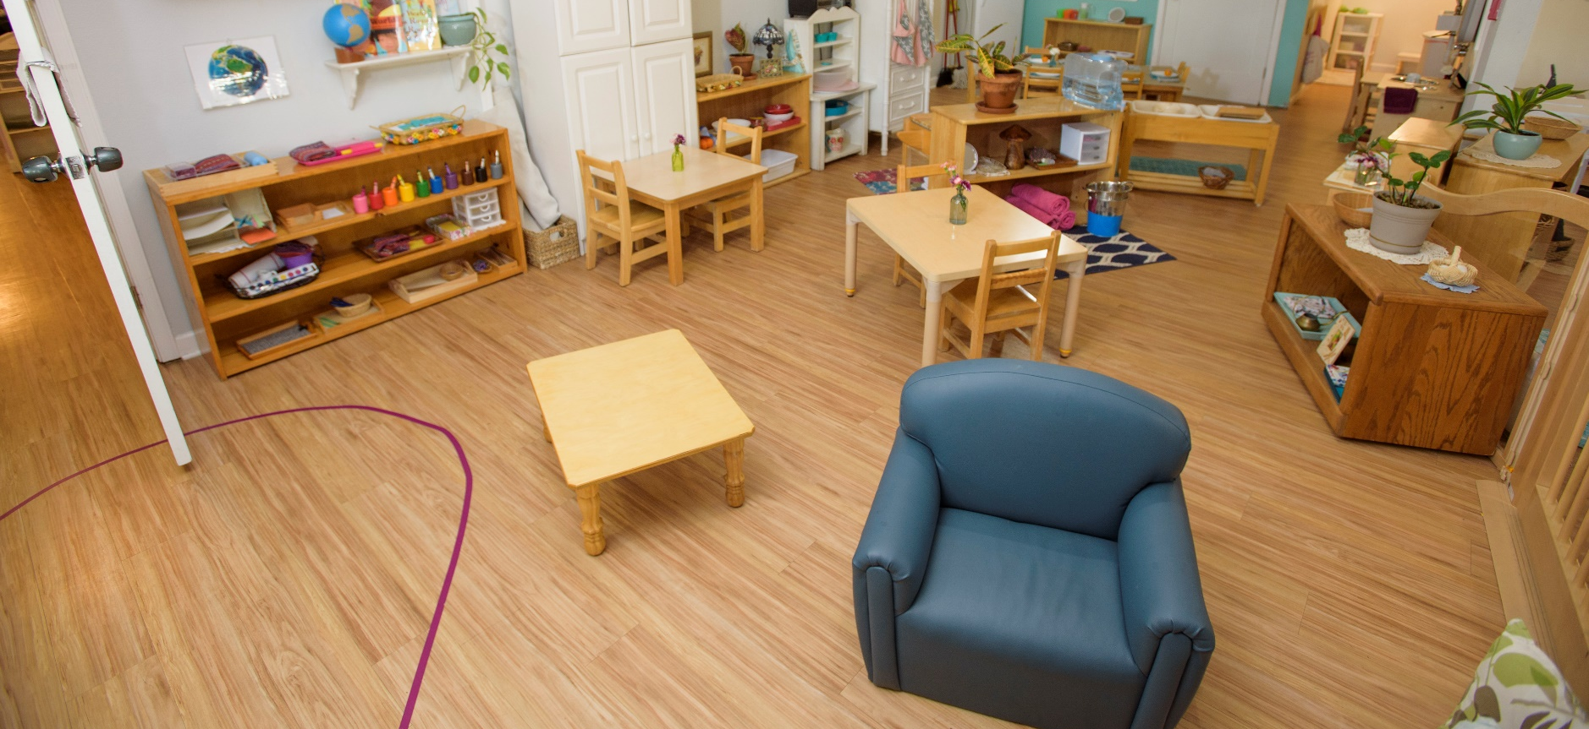

For our younger students, the learning environment is your home and surroundings. This means finding ways to support independence, engage in meaningful tasks and supplement learning through various activities suggested by teachers.

For our Upper Elementary and Adolescent Program students, this will mean all of the above, plus establishing a quiet space, expectations and routines for any specific assignments shared by teachers.
Where age-appropriate you might like to discuss learning from home with your child and include them in some decision-making processes:

• Ask them where to set up their space (if applicable)
• Make a schedule together that works for your family (when to take breaks / have time outdoors etc)
• Gather ideas for activities and projects
• Organize materials

For our older students, it will be important for them to maintain their routine of handing in work and
receiving feedback from their teachers. Overall, we can approach this as an opportunity to be creative and collaborative—we are here to support you through this process.

Practical Life

Practical life is an important part of experiential learning. It is part of every Montessori classroom and can be mirrored at home. These activities assist students in developing purposeful life skills for their
continued growth and development. This includes refining fine motor and movement skills and practicing coordination, planning and problem solving. Practical life activities:

• foster order and sequence;
• develop concentration;
• foster physical independence;
• foster the development of fine motor control; and
• provide opportunities for planning and carrying out tasks.

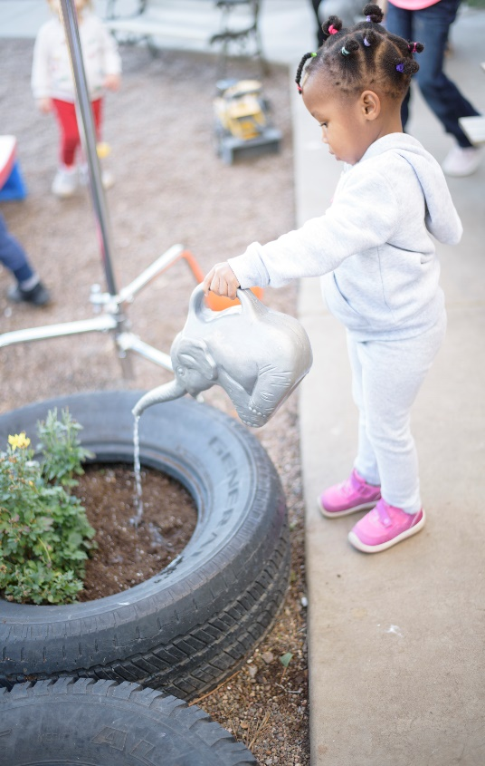
The Practical Life area also provides children with opportunities
to contribute to family life. Inherent in these activities is the
development of key executive functions: decision making,
organization, problem-solving, impulse control, collaboration
and communication. These skills form the foundation of a
child’s academic learning. For example, sequencing a task is
a pre-reading skill.

Examples of practical life might include:
• setting the table;
• watering plants;
• tidying and organizing rooms;
• planning an outing;
• taking care of pets;
• preparing a snack/meal;
• helping with shopping lists/budgeting; or
• planting a small urban garden.

Practical life is engaging for children at all stages of development and tasks are designed according to their level of coordination and independence. You can organize a job chart or list of family projects as a way to help guide your child’s interests. Planning and gathering resources to complete the tasks is purposeful work. These ideas foster a sense of contribution, responsibility, shared experiences and satisfaction.

As our children get older, these activities lead naturally to volunteer experiences and beginnings of
community work. For our oldest adolescents, many of these practical life experiences are the foundation of their sense of belonging and personal vision.
The Uninterrupted Work Cycle

Establishing a routine that works for your family is an essential first step to creating a successful learning environment at home. Children are very familiar with this framework from school. In a Montessori classroom, children are given large blocks of time in order to explore their work deeply. This contributes directly to the development of concentration and provides opportunities to collaborate and problem-solve. It is the framework that fosters child- centered as opposed to teacher-directed learning.

OWNERSHIP OF TASKS AND SHARING IN LEARNING

Montessori learning environments are often referred to as “optimal learning environments” because of the inherent skills and outcomes that result from being in a rich and interesting classroom, coupled with the dynamic of interactions amongst peers and teachers.

In order to foster a deep sense of ownership in their learning, we focus on two things: the developmental needs and characteristics of the child and their interests. Here are a few key points that aid in cultivating a child’s self-direction and attention to their work:
• Choice
• Participation in planning and organizing tasks
• Conversation
• Finding good resources
• Sharing of knowledge

You will be receiving regular communications from your child’s classroom teachers in the coming weeks. We encourage parents to follow teacher suggestions and guidance when completing work at home. The more children are involved in developing and detailing their activities, the more they can achieve.

A note regarding sharing and presenting work:
It is a regular occurrence in an Elementary (or older) classroom for children to present their work or projects to one another. This can be replicated at home. Planning a presentation or sharing time at the end of a project is very exciting for young children and gives our older students an opportunity to use their voice. It is an essential part of the learning process as it requires synthesis of learning to describe, explain and express yourself clearly. It feels celebratory as well!

Responsibility and Contribution to Community

Being in a Montessori school is often described by students as being part of a big family. All of the aspects detailed above result in a feeling of belonging to a community and with that, we learn that there is a responsibility to ourselves, others and the environment. It is our commitment to each child at [Montessori School] that they reach their fullest potential and feel that they are a valued part of our community.
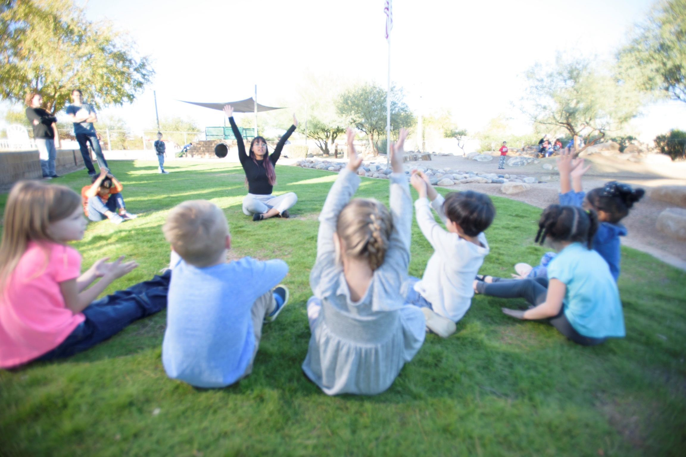

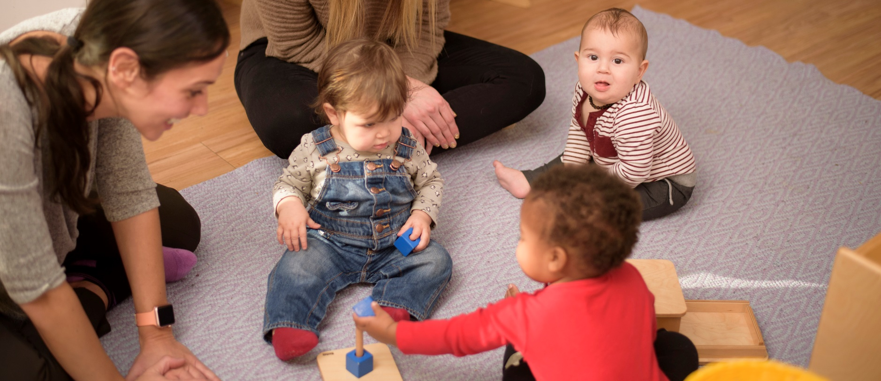

Toddlers

OWNERSHIP OF TASKS AND SHARING IN LEARNING
Routine and consistency are very important for your toddler.

Morning | Wake up and assist in making bed. Use the bathroom, brush teeth. Make breakfast with your child, eat and clean up.  Rotate through activities one at a time for an hour and a half. Have a few choices of activities for children to choose from. Remember to make time for a bathroom break.
Mid-Morning | Snack Break: children can set the table, eat, and clean up.
Late Morning | Work time (indoor or outdoor) for an hour.  Read stories, sing songs, listen to music and singalong.
Lunch | Set up for lunch and have lunch. Clean up and use the bathroom. Outside play time if the weather is appropriate, for at least 30 minutes.
Afternoon | Use the bathroom and take a nap for 2 hours. Wake up and use the bathroom.  Listen to music and look at books.

It is important to continue toilet independence during this time at home. The teachers will be in touch with you to help guide you with each child’s toileting pattern.

Toddler Program Expectations

STUDENTS MAY BE EXPECTED TO:
• Enjoy family life with developmentally appropriate contributions.
PARENTS ARE INVITED TO:
• Remain mindful and respectful about the growing self-esteem and sense of independence that your child is developing.
• Help your child with the hardest part of a task (not the whole task).
• Initiate verbal communication frequently, ask question, share concerns and observations.
• Be consistent; follow routines and clear sequences for each activity.
• Limit screen time.
• Include your child in household chores.
• Provide opportunities for outdoor activities (gross motor skill development).
• Let go of perfection. What you are experiencing now is not the final goal, it is foundational.
• Enjoy and appreciate time with your child.
TODDLER TEACHERS WILL:
• Initiate individual support and communications based on each child’s needs.
• Provide detailed updates and consultation (as required) regarding toilet learning, sleeping habits, and activities (fine or gross motor).
• Share current class routines and suggest guidance in setting up daily routines at home.
• Share guidelines and suggestions for screen time.
• Share general and individual suggestions for activities for fine and gross motor skills, providing pictures, videos, and materials for parent viewing as appropriate.
• Provide suggestions for books and songs to support language acquisition.
• Provide videos of teachers singing and performing hand actions to well-loved class songs.
• Share suggestions for practical life activities at home such as recipes, food prep, house chores, clothing tips, etc.
• Be responsive to parent questions and available to offer guidance and tips for activities or any other element of support for your child’s development.

Toddler Program Expectations

“A place for everything and everything in its place” is one of the critical principles of Montessori at home. Having a place for everything, on a child-friendly scale, means that children know where to find what they need, and have a place to put things when they’re done. This is an essential tool in teaching them to be responsible for their belongings. External order gives the children internal order and security. An ordered environment also has fewer distractions, allowing children to focus on the task at hand.

Have a place in each room for your child’s carefully chosen belongings: by the front door have a stool to sit on and a place to hang coats and keep shoes. In the living room have a place for your child’s books and toys – neatly and attractively organized. Think out the activities and materials for all living spaces and arrange the environment to include your child’s activities.

• Store clothing in low drawers or baskets, as well as move the rod in the closet down to eye-level so your child can reach their clothing.
• Place step stools in both the kitchen and bathroom to enable them to wash their hands and, in the case of the kitchen, help with meal preparation.
• Place toys, games and art supplies on low shelves where your child can easily access them, then separate these toys into various baskets, bins or shelves, so the items stay separate and are easy to find without sifting through piles of other toys.
• Store healthy snacks down low in your refrigerator or pantry so your child can help themselves.
• Keep beverages in small pitchers located on the lower shelf in the fridge, with child-friendly cups nearby. When your child is thirsty, allow them to help themselves — just be sure to keep a sponge/ some rags nearby, so they can clean up any messes they make.
• Don’t put out too many toys and books at one time. Those being used by your child at the moment are sufficient. Rotating is a good idea – taking out those books and toys that have not been chosen lately and removing them to storage for a time. Children grow and change and they need help to keep their environment uncluttered and peaceful.

Activities for Toddlers at Home

PRACTICAL LIFE
• Food Preparation
• Preparing their own snack: cutting half of an apple (cut horizontally) using an apple slicer, squeezing orange juice, spreading cream cheese or jam on half of a bagel or bread.
• Slicing vegetables and fruit for snack and dinner.
• Baking: have ingredients pre-measured and in jars.

• Care of Self
• Dressing and Undressing: give your child enough time to practice dressing and undressing by themself.
• Toileting: It’s important to continue with the toilet learning process.

• Care of Environment
• Mopping, sweeping, or use of a dustpan and dust brush.
• Helping with laundry.
• Watering plants and leaf washing.
• Window washing, dusting, and wood polishing of large furniture in the home.
• Taking care of pets.
• Loading and unloading dishwasher, dishwashing by hand.

ART WORK
• Coloring, painting, collage, playdough, sidewalk chalk.

OUTDOOR ACTIVITIES
• It is always fun for children to spend time with their parents in nature. So take some time out of your busy schedule to explore outdoors with your child. I guarantee, you’d enjoy the experience as well as your children would. Here are a few ideas for connecting your child with nature:
• If you have 15 minutes:
• Watch the clouds and see what animals you can make out of them.
• Hug some trees and try to find one that your arms fit perfectly around.
• Turn over a rock and see what is hiding underneath.

• If you have 30 minutes:
• Do a backyard/nature treasure hunt.
• Try your hand at rock stacking.
• Grab some leaves or pieces of bark and race them down a creek.
• If you have an hour:
• Go for a walk and make note of all the sounds you hear.
• Find a nature trail and help children make up a game or collect bugs or leaves.
• Pack some food and have a picnic.

LANGUAGE
• Naming things in both indoor and outdoor environments.
• Read together: let your child choose the books, talk about how the characters might be feeling and wonder together what will happen next. Reading with your child teaches more than literacy and language skills. He is learning that you value his interests and choices, and that you love him and enjoy being close to him. Studies show that lifelong readers are those who, as children, simply found reading a pleasurable experience.
• Singing songs and do finger- plays
• Narrate what you do as you go through your daily routines.
• This helps your child connect words with objects and actions. “I’m washing the dishes. I’m squeezing the yellow dish soap into the warm water.”

All these activities will help limit screen time.

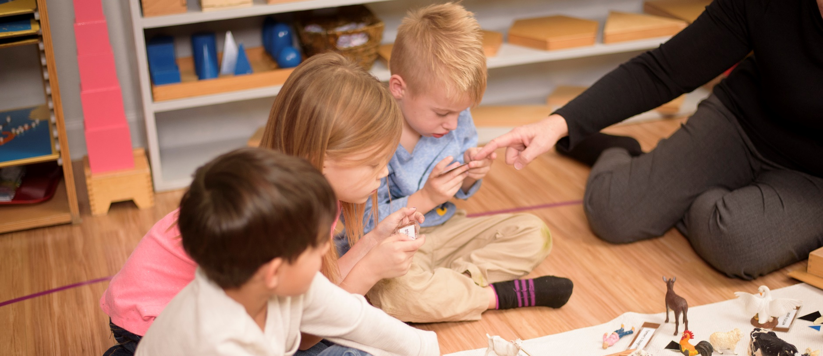

Primary

SUGGESTED DAILY SCHEDULE FOR PRIMARY

Early Morning | Set up and clean up breakfast, load dishwasher.  Basic chores: collect dirty clothes, sort laundry, help load washing machine. Prepare morning snack (place in accessible area to be eaten later), clean up.
Mid-Morning | Uninterrupted work cycle. Children should engage in activities to practice skills for practical life, sensorial work, language, or math.
Lunch | Prepare (set up, clean up) lunch.  Quiet Time: this may include nap, reading books, handwork, reflective time. No screen time.
Afternoon | Afternoon work time. Include time for care of the environment and preparation for the next day’s work.

Preparations for the next day and chores can be performed throughout the day.
Activities can be modified according to child’s readiness and developmental needs.

Primary Program Expectations

STUDENTS MAY BE EXPECTED TO:
• Enjoy family life with developmentally appropriate contributions.
PARENTS ARE INVITED TO:
• Remain mindful about your child’s stress or worries during this time of change.
• Monitor communication about your child from your teachers.
• Initiate communication with teachers about questions, ideas, concerns, or feedback.
• Support your child’s independence in daily life activities.
• Be mindful of and allow children to continue periods of concentration.
• Establish daily routines and expectations.
• Limit screen time.
• Provide opportunities for daily physical activity.
PRIMARY TEACHERS WILL:
• Initiate individual communications based on student needs.
• Give guidance in setting up a daily routine.
• Make suggestions for appropriate house chores.
• Offer guidelines and suggestions for screen time.
• Provide both general and individual suggestions for activities developing fine motor skills, gross motor skills, language, and math.
• Be prompt in replying to your emails if you need additional guidance and support.
PROGRAM-SPECIFIC NEEDS AND CHARACTERISTICS
• Children aged 3 to 6 thrive in environments that promote repetition, routine and the mastery of purposeful movement.
• Allow your child to choose activities and give the opportunity for periods of time without distractions.
• The key to a successful learning environment is order, access to tactile resources, space to explore and meaningful activity. For the Primary child, work and play should be interchangeable—a natural, fun and exciting part of life.
PRACTICAL LIFE
• Ages 3 to 4:
• Meal or Snack Preparation: slicing vegetables, fruit, cheese, etc.
• Baking: measuring and mixing ingredients.
• Kitchen Care: loading and unloading the dishwasher, washing dishes by hand, sweeping floors.
• Pet Care: walking, playing with, and grooming.

• Dusting: the leafs of plants with a soft cloth or furniture around the house.
• Nature walks in the yard or about the neighborhood with a list of things to find.
• Walking on the Line: make a masking tape line throughout the house and walk carefully on the line.
• Art: coloring, painting, collage, sidewalk chalk.
• Cutting and gluing - for example find and cut all of the plants in a magazine; glue into a collage.
• Sewing shapes/pictures onto napkins, hand/kitchen towels, etc.
• Ages 5 to 6 — Any of the above plus:
• Cutting (advance searches: mammals, birds, amphibians, etc.)
• Baking: reading, measuring and mixing simple recipes.
• Handwork: crocheting, finger knitting, or sewing words, initials, or pictures on napkins, hand towels, etc.
• Origami
SENSORIAL
• Ages 3 to 4:
• Exploring the home for 2 dimensional shapes (rectangles, squares, circles, etc.).
• Exploring the home for 3 dimensional shapes (spheres, cylinders, cones, cubes, prisms).
• Explore the home for textures that are rough or smooth.
• Exploring sound by tapping on different objects (pot, glass, wooden cutting board, etc) with different objects as well (tap with a metal spoon, then a wooden spoon).
• Ages 5 to 6:
• Exploring spices and attempting to recognize them by scent.
• Comparing the various shapes of leaves found amongst the house plants.
• Drawing a picture that includes certain shapes i.e., 1 circle and 3 rectangles, or 1 square and 4 triangles).
LANGUAGE
• Ages 3 to 4:
• Sound Games/I-spy: Something that begins with the sound /s/.
• Question Game: Have a conversation using who/what/when/where/why questions.
• Singing new songs (different languages).
• Tracing shapes, letters in flour (pour flour in a cookie sheet).
• Ages 5 to 6:
• Write a letter to a friend or family member to mail.
• Assist in writing list of things to do for a day or a week.
• Write a story or a play and read aloud or act out when finished.

MATHEMATICS
• Ages 3 to 4:
• Scavenger hunt/counting objects collected.
• Counting objects (beans, pennies, etc.).
• Sorting laundry.
• Sorting silverware.
• Ages 5 to 6:
• Hopscotch math—all operations can be done, just make your hopscotch go higher than 10.
• Math facts with dice.

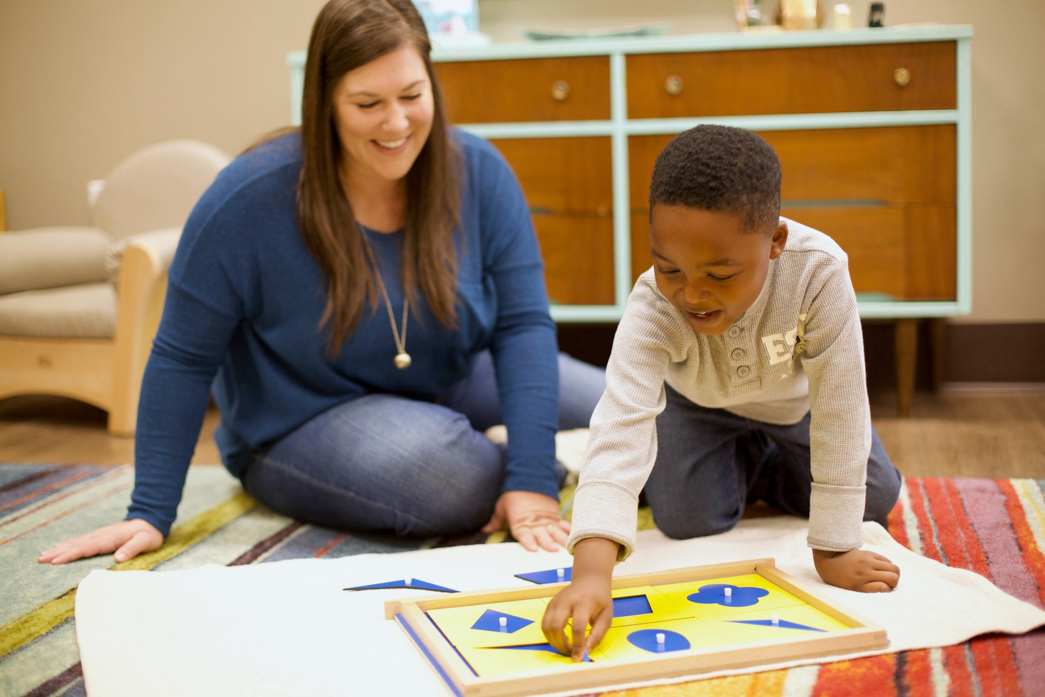

Lower Elementary

SUGGESTED DAILY SCHEDULE FOR LOWER ELEMENTARY

Early Morning | Make breakfast and clean up.  Complete chores (i.e. pet care, care of self, make bed, laundry, etc.)
Mid-Morning | Uninterrupted work cycle. Children should engage in activities to practice skills for math, language, geometry, and geography. Teachers will send specific instruction. Make sure to make time for snack and movement.
Lunch | Make lunch and clean up.
Afternoon | Afternoon uninterrupted work cycle. Children should engage in activities for biology and research. Make time for at least 30 minutes of silent reading.

Preparations for the next day and chores can be performed throughout the day.
Activities can be modified according to child’s readiness and developmental needs.

Lower Elementary Program Expectations

STUDENTS ARE EXPECTED TO:
• Plan and organize work with guidance from parents.
• Follow teachers’ guidelines and academic expectations.
• Work with integrity on assigned tasks—do your best!
PARENTS ARE INVITED TO:
• Guide your child to set up a prepared environment at home.
• Establish a consistent routine and work schedule together.
• Follow along with the teachers’ suggested activities to maintain skills and concepts.
• Provide opportunities for your child to share and present work to you.
LOWER ELEMENTARY TEACHERS WILL:
• Prepare a variety of appropriate tasks and activities for children to complete at home in order to maintain and move their learning forward.
• Communicate in a consistent fashion with parents, replying to emails within 24 hours.
• Share a daily “Morning Greeting” via email.
PROGRAM-SPECIFIC NEEDS AND CHARACTERISTICS
• Respect the stage of development—many Lower Elementary students are at a “concrete level” and require the Montessori materials to complete certain tasks. Teachers will guide you regarding what works makes sense for your child.
• Develop ideas that allow the opportunity for Lower Elementary students to build from their interests. Examples may include projects, journals, creative writing, geometry constructions, Practical Life at home.

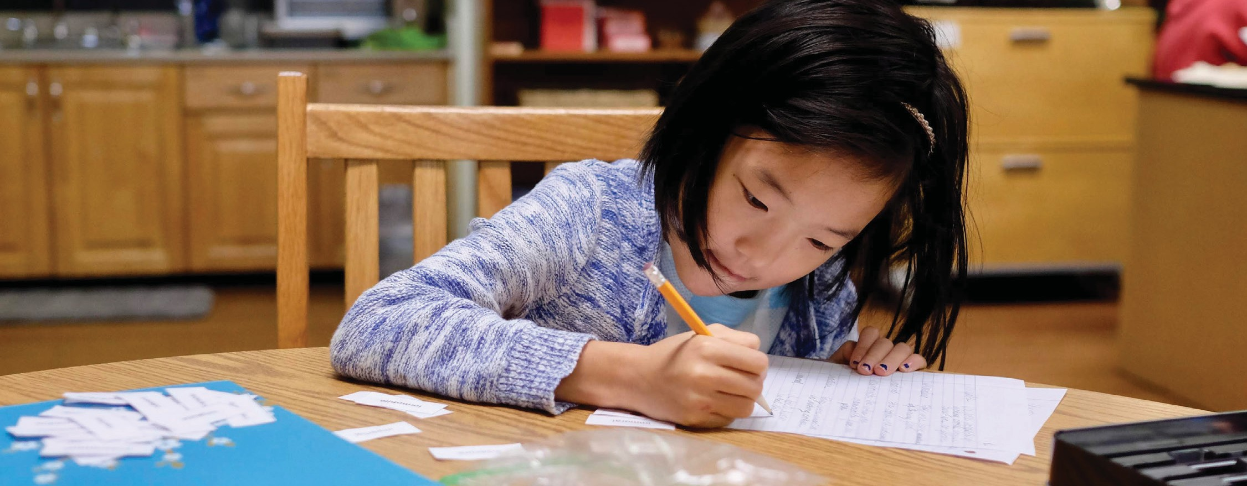

Upper Elementary

SUGGESTED DAILY SCHEDULE FOR UPPER ELEMENTARY

Early Morning | Make breakfast and clean up.  Complete chores (i.e. pet care, care of self, make bed, laundry, etc.)
Mid-Morning | Uninterrupted work cycle. Children should engage in activities to practice skills for math, language, geometry, and geography. Teachers will send specific instruction. Make sure to make time for snack and movement.
Lunch | Make lunch and clean up.
Afternoon | Afternoon uninterrupted work cycle. Children should engage in activities for biology and research. Make time for at least 30 minutes of silent reading.

Upper Elementary Program Expectations

STUDENTS ARE EXPECTED TO:
• Plan and organize work as independently as possible.
• Follow teachers’ guidelines and academic expectations.
• Be own advocate when assistance or further clarification is required.
PARENTS ARE INVITED TO:
• Guide your child to set up a prepared environment at home.
• Establish a consistent routine and work schedule.
• Follow along with the teacher’s suggested activities to maintain skills and concepts.
• Meet and review your child’s assignments; provide opportunities at home for work presentations.
UPPER ELEMENTARY TEACHERS WILL:
• Prepare a variety of appropriate tasks and activities for children to complete at home in order to maintain and move their learning forward.
• Communicate in a consistent fashion with parents, replying to emails within 24 hours.
• Share a daily “Morning Greeting” via email.
PROGRAM-SPECIFIC NEEDS AND CHARACTERISTICS
• Respect the stage of development - some students may still be at a “concrete level” and require the Montessori materials to complete certain tasks. Avoid “teaching” shortcuts for subjects such as Mathematics.
• Develop ideas that allow the opportunity for Upper Elementary students to build from their interests. Examples may include projects, journals, creative writing, geometry constructions, Practical Life at home.
• Upper Elementary students are extremely social. At this time, not being able to be directly with their friends can feel challenging. We strongly encourage parent monitoring of texts, emails, and group chats to ensure that the students are using grace and courtesy towards themselves and others.

Activities for Elementary at Home
MATH FACTS (LIMIT TO 10 MINUTES AT A TIME)
• Create flashcards of multiplication math facts 0-9.
• List all the factors of 18, 24, 36, and 54.
• Dice Rolling
• Jump rope while skip counting.
FRACTIONS
• Follow a recipe.
• Construct something using measurements less than one inch.
• Order fractions on a number line from least to greatest.
• Divide figures into fractional amounts and label them.
DECIMALS
• Have your own “Showcase” and price household items, then add them together.
• Look for advertisements in the mail and add prices together.
• Create a shopping list and add items together.
LANGUAGE
• Make a poem book.
• Try to write a poem in an author’s style.
• Memorize a poem.
• Go on a word hunt in a novel: make a list of adjectives on a page and write an antonym and synonym for each one.
• Find sentences in your current book, identify the subject and predicate.
GEOMETRY
• Identify shapes around the house.
• Identify angles as either: right, acute, obtuse, or straight.
• Look for congruent and similar figures.
• Measure things in one and two dimensions.
• Find the perimeter of things.
• Find the area of rectangular figures.
BIOLOGY
• Spend 15 silent minutes a day in nature and record your observations.
• Sketch plants inside or outside.
• Research an endangered animal. Why is it endangered?
GEOGRAPHY
• Teachers will be sending home map assignments and country/state researches.
HISTORY
• Make a timeline of your life.
• Make a timeline of your day and include it in your work journal.
• Interview a family member in your house or over the phone about their life.
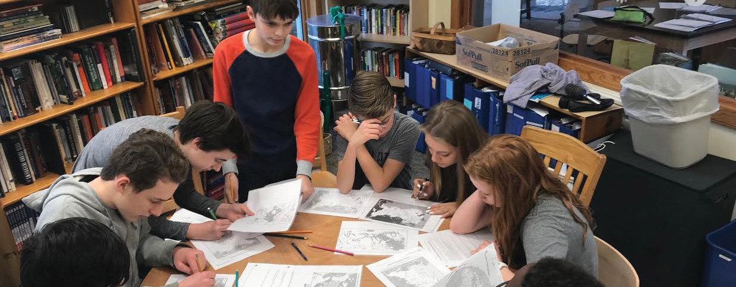

Suggested Daily Schedule for Adolescents

SUGGESTED DAILY SCHEDULE FOR ADOLESCENT

8:00am - 9:00am | Get up and help with household chores, including making breakfast for family.
9:00am - 10:30am | Math work: problem sets, IMs, math seminars, etc.
10:30am - 12:00pm | Language work: reading or writing.
12:00pm - 1:00pm | Lunch and break.
1:00pm-1:30pm | Spanish review: reading, vocab, conjugation practice.
1:30pm - 3:00pm | Humanities work: readings, discussion groups, individual research.
3:00pm - 3:30pm | Additional cleaning and organizational tasks.

Adolescent Program Expectations

STUDENTS ARE EXPECTED TO:
• Schedule their own time for work
• Review lessons and readings
• Keep up with their planner
• Check both email and discussion boards each school day for updates
• Work solidly for roughly 4-6 hours a day (see attached sample schedule)
• Submit or review assigned work according to guidelines
• Curate work to be submitted upon return to school
PARENTS ARE INVITED TO:
• Check in with your child each morning to plan school work time and work space
• Maintain daily conversations about work progress
• Invite your child to prepare a meal for the family once per week
• Invite your child to contribute more than usual to household chores
• View and discuss suggested movies/web inquiries with your child when possible
• Share news items especially related to coronavirus
MIDDLE SCHOOL TEACHERS WILL:
• Provide unit guidelines by each Wednesday morning
• Review assignments due each Wednesday morning
• Provide “office hours” availability times at least twice a week
• Answer student or parent emails within 24 hours
• Advisors will schedule a weekly check-in with each student via email or phone
PROGRAM SPECIFIC NEEDS AND EXPECTATIONS
• In general, we expect Middle School students to take responsibility for completing their work within the timelines provided. Students will hear from AP teachers within 48 hours of a decision to move to online-learning for a general schedule of classes.
• There is an opportunity for parents and students to discuss topics of inquiry from their studies. Watching or reading the news together, and otherwise having adult-style conversations is very important. While we don’t expect parents to review assignments, please do support work completion.
• Adolescents crave and require social interaction. Please facilitate ways your child can meet with other classmates or friends outside of school as appropriate.
Possible Coursework for Home Learning

MATH:
• Students will receive updates on individual math work from their math guide. As math is individually paced, students will have the ability to continue in their math work unhindered. IMs and other practice materials will be made available to students.
LANGUAGE:
• Students will receive updates on current or upcoming language work from their language guide. Formal seminars will not take place, but book groups and previously assigned writing will move forward. Students may be asked to participate in discussions on online forums.
PROJECT WORK:
• If a project is in-progress: work will be finished according to the due dates set out at the start of the project. Additional readings or assignments may be assigned to replace in-class activities.
PROJECT WORK:
• If no project is in progress: students will be given the chance to study one of two topics as a mini- project. Guidelines will come from the leading guides. Students will follow the normal rhythm of project work with readings, research, and discussion groups.
PRACTICAL LIFE
• Adolescent Program students are encouraged to be active participants in their home, just as they would be in the classroom. This includes activities like cooking, cleaning, and care of younger siblings (if applicable). Students will be expected to set their own schedules and keep up with all work. Students are asked to reach out to their advisor should they find themselves struggling to schedule their time effectively.

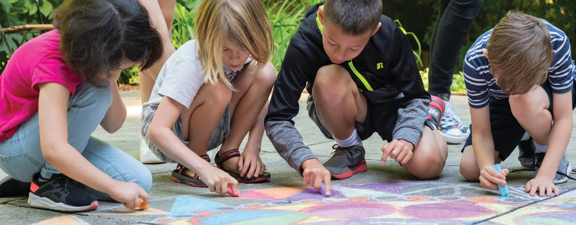

Specialty Classwork
[Montessori School] Specialty Classes include art, Spanish, and music. Lessons for these classes and examples for incorporating daily movement will be shared by teachers.

Resources for Families

Arts and Craft Activities
• Easy Peasy and Fun
• Left Brain Craft Brain

Podcasts for Children
• The Big Life Kids Podcast
• Wow in the World
• Forever Ago
• But Why: A podcast for curious kids
• Pants on Fire
• Tumble
• Circle Round
• Reading Bug Adventures
• Good Night Stories for Rebel Girls
• The Purple Rocket Podcast
• Fierce Girls
• The Past and The Curious: A History Podcast for Kids and Families

• Sparkle Stories
• Earth Rangers
• Myths and Legends
• Peace Out
• Story Time
• What if World
• Brains On!
• Short & Curly
• Classic Kids
• The Alien Adventures of Finn Caspian
• The Unexplainable Disappearance of Mars Patel
• News Time

Frequently Asked Questions

When and how can I reach my child’s teacher?
Email remains the best way to contact a teacher. If you wish to speak to a teacher, please use email to set up a time for a phone call. Be aware that teachers calling from their personal cell phones have been asked to
block their number for privacy.
When can I expect a response?
In most cases, you can expect a response to emails within 24 hours, excluding weekends and planned school breaks.
How much communication can I expect from the school?
The administration office will communicate with you directly should there be any updates on the COVID-19 situation that might have a direct impact on school operations. The frequency of communication from your child’s teacher will vary depending on each program.
Can teachers tutor students individually online?
In most cases, no. Teachers will be connecting with families on a class level, and also sharing suggestions, feedback, and expectations on an individualized or small group level where necessary. Some video conferencing may be utilized for our older students.
How much technology will be used?
This will vary greatly depending on the age of the students. Teachers will share information with families via email and adolescents will use Google applications to submit work assignments. Staff may utilize online video conferencing in certain circumstances. Your classroom teachers will share more information with you in due course.
I don’t have access to a printer. What should I do?
[Montessori School] is happy to provide printing assistance and our office will be open daily between 10am and 3pm. Please forward any school work for printing to info@[Montessori School].com with the subject line: PRINT REQUEST - CHILD’S FULL NAME. All printing tasks will be completed by 3pm the next business day and placed at the Lavista front entrance for pick up.
How will the school keep me informed on the closure?
All closure updates and plans to reopen will be communicated via email (Mailchimp) and text (Renweb Parent Alert).
Will we get a reimbursement of tuition fees?
[Montessori School] is operating in accordance with recommendations made by government officials given these exceptional circumstances. As such, there will be no reimbursement of tuition fees offered. Teachers continue to work both onsite and remotely to support families and offer the best education services we can under these challenging circumstances.
What support will be provided to children whose parents both work full-time?
It would be unrealistic and counter-productive in the circumstances for [Montessori School] to provide childcare for all working families. We understand that a sudden school closure is an inconvenience for all. If any [Montessori School] family finds themselves in an emergency or in truly exceptional circumstances, please contact
us. We may be able to help or connect you with other families who would be willing to do so.

“We discovered that education is not something which the TEACHER does, but that it is A natural process which develops spontaneously in the HUMAN being.”
- Dr Maria Montessori

[Montessori School]
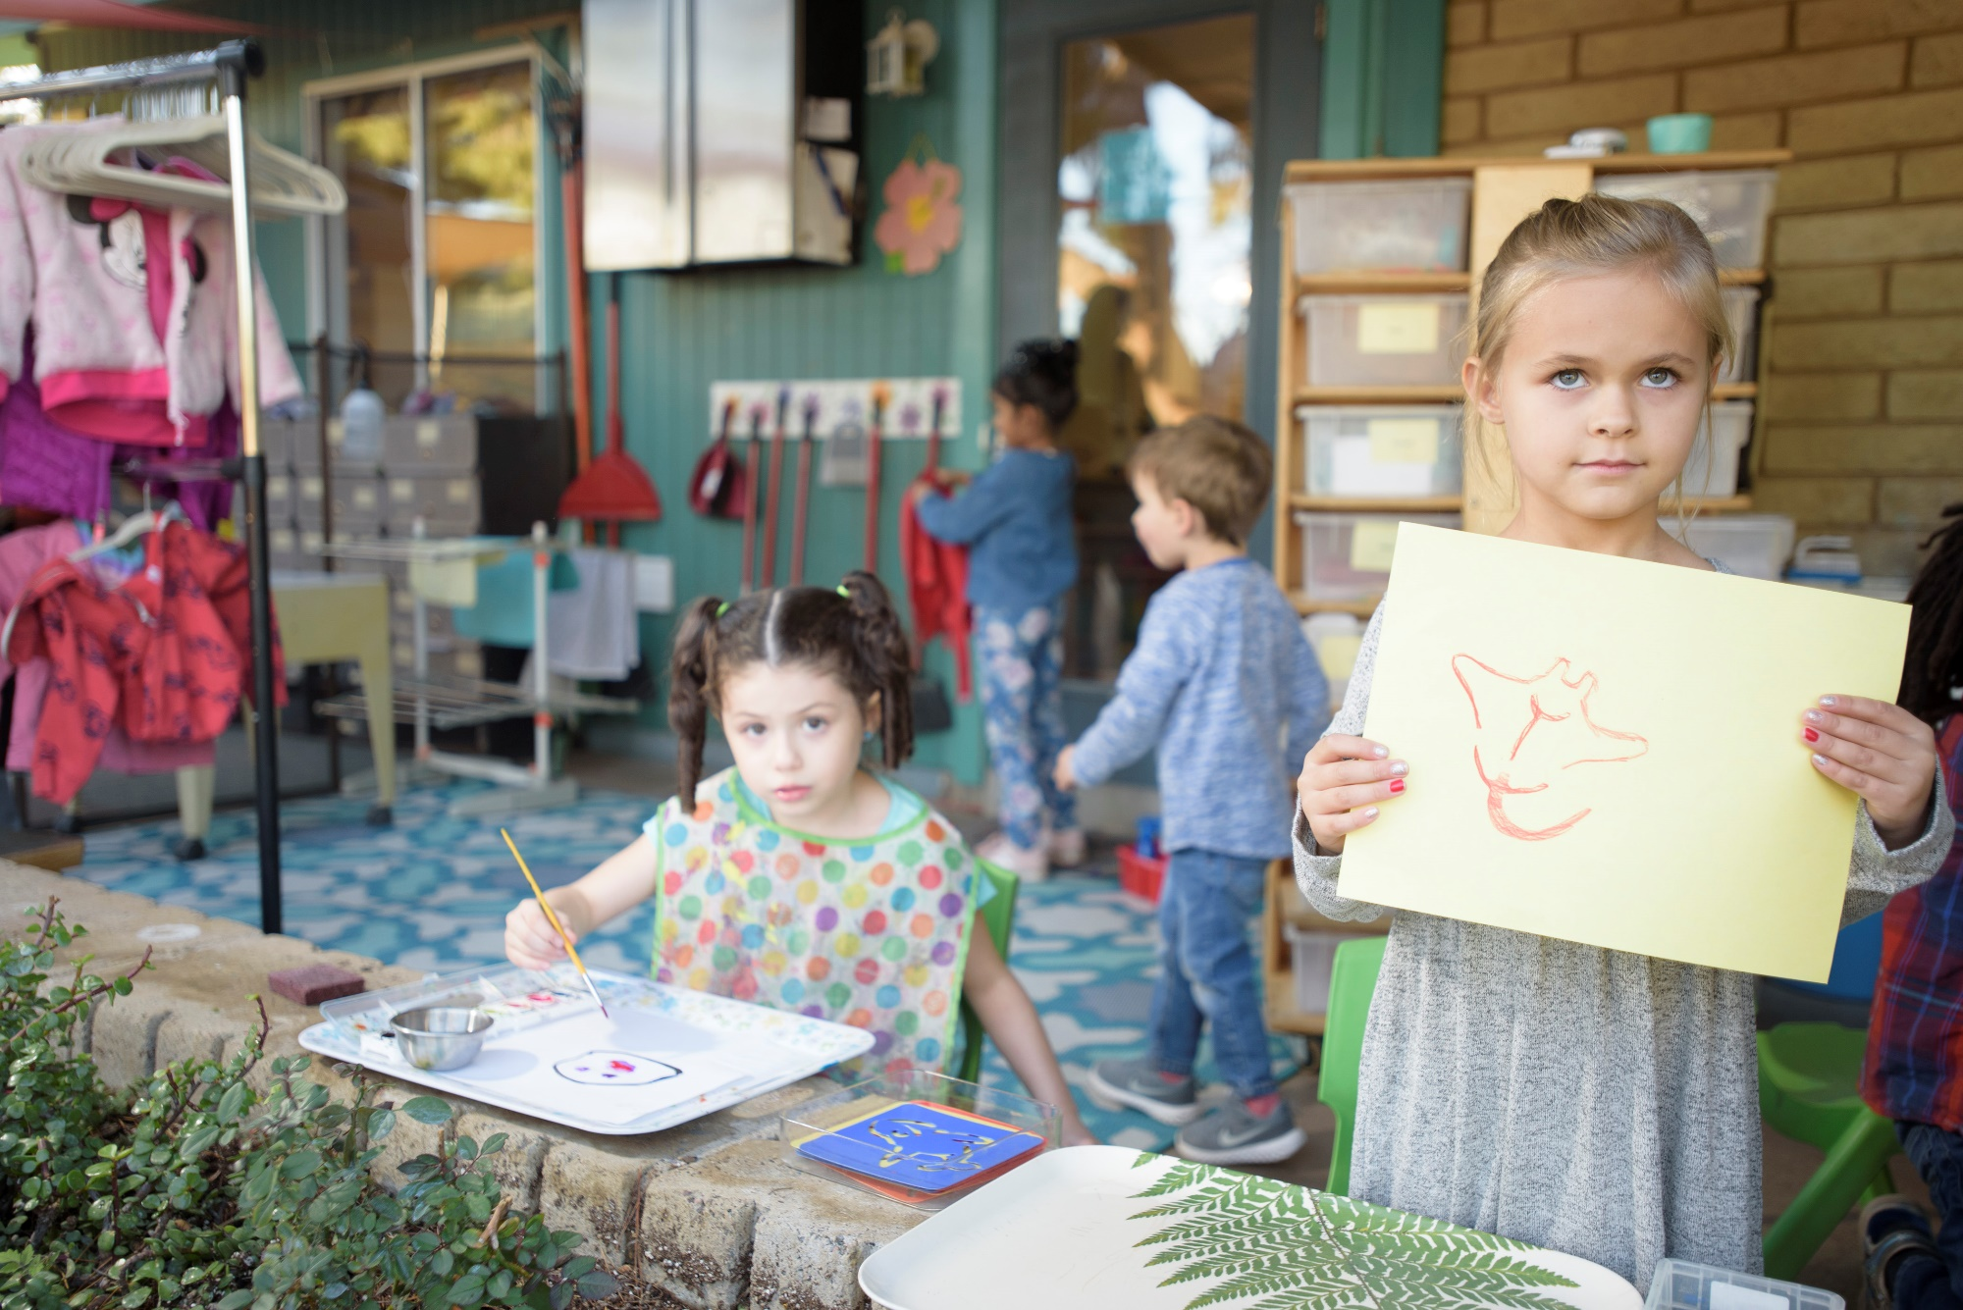
[Montessori School Address, Website, Contact info HERE]

