We should spend time creating the right home environment to enable us to feel how we want to feel in order that we can be our Highest Potential Self and achieve more success for less stress. This means taking stock of your home, what you have around you and the influence it has. Our minds can only focus on so much at once. We have control over our home environment. We can make our home environment help us to focus on things that are aligned to how we want to feel, which increases the chance of us feeling those feelings.

Clutter is a distraction. Visually, there’s always something to take your focus away from the task at hand. Practically speaking, you’ll spend valuable time looking for items that you need (rather than completing the tasks on your plate). Clutter can also increase stress. It can be mentally exhausting accounting for the emotional baggage all your various belongings bring with them. Look up more on this in this article:
https://www.nytimes.com/2019/01/03/well/mind/clutter-stress-procrastination-psychology.html

Activity
Here are a few things for you to consider and action:
What will prompt you to relax more effectively? For example: move your phone out of the bedroom at night and charge it in elsewhere. Keep work related computer, books and files away in a cupboard when not working.

What will keep you focused on your Vision and Purpose? For example: Create a Vision Board and put it on the wall. Declutter and removed the ‘old me’ from the house. Look for new things to help you stay focused on the ‘new me’. Go through kitchen cupboards and throw out unhealthy food and pop alcohol in the garage (Out of sight, out of mind).

What will help you to feel more true to yourself? For example: Decorate and furnish to reflect your personality and not the latest trends.

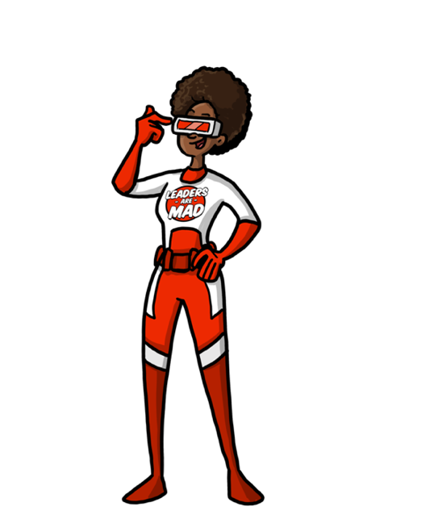

"A house is not a home unless it contains food and fire for the mind as well as the body." Benjamin Franklin

I am Calm, Compassionate, Curious, Clear, Connected , Creative, Courageous, Confident.
I choose how I respond!

