(Print off this page)
- Write below the things take away your Superpowers to determine what might be limiting you showing up as your Highest Potential Self. If you think of more than 10 items, just add them on the page.
- Examples: own or other people's beliefs or behaviour, unmet needs, crossed or blurred boundaries, unresolved issues, guilt or regret, eating habits, relationships, lack of sleep

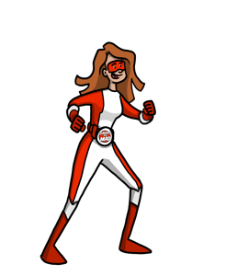
1. ________________________
2. ________________________
3. ________________________
4. ________________________
5. ________________________
6. ________________________

7. ________________________
8. ________________________
9. ________________________

If there was ONE THING that
TOTALLY ZAPPED your energy it would be:

10. _______________________

Finally, pick ONE action to take right away (now or in the next day or so):
Now that you've brought your Superpower Zappers into your awareness, you can start to resolve them. (Check Resources on the website for ideas.

Action _________________________________________________________ By When ______________
As we begin to clear the things that Zap us (whatever they may be) we free up more of our Superpowers to be our HPS!

