Looking to help your students navigate UCAS? Follow this simple timeline, and you'll give your students the best possible start. The goal is to help them all complete their UCAS application forms and write decent drafts of their personal statements before the summer vacation, which will make your life much easier in September.
Teacher Road Map
UCAS Applications

Get Them Researching

Throughout May, keep chivying your students to research courses. They'll need a shortlist by June.
The Complete University Guide: https:// www.thecompleteuniversityguide.co.uk/ courses/search

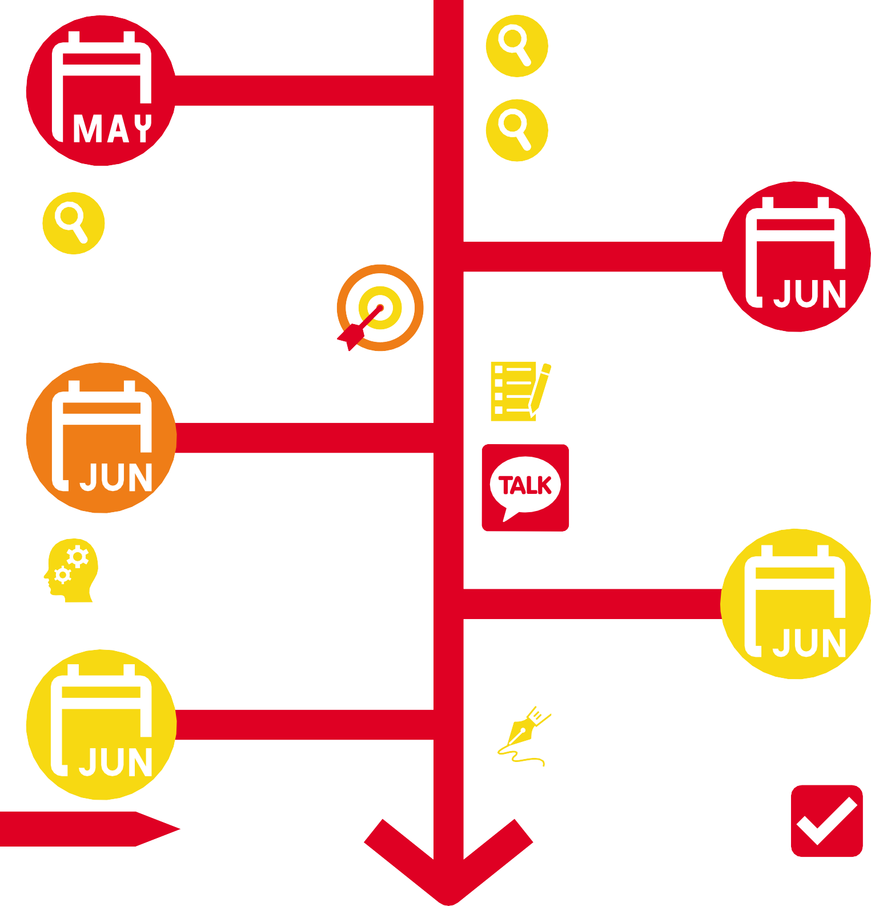The Student Room: https://www.the studentroom.co.uk/wiki/a-_of_university_ courses

UCAS: https://digital.ucas.com/search

Many students know what they want to study after school, but those that don't need to be identified early and targeted with extra time to discuss their options.

Get Them Form-Filling

In the first week of June, tell your students to fully complete their UCAS application form.

1-7

8-14

Get Them Planning

Throughout May, keep chivying your students to research courses. They'll need a shortlist by June.

George Teaches: https://ucas- applications.simplerosites.com/courses
/21425-personal-statement

Get Writing Yourself
UCAS: https://www.ucas.com/

Keep communicating closely with your students. The personal statement phase is when many of them become lost and need additional support.

Get Them Drafting

15-21
In the second week of June, get your students to draft their personal statement

22-28

Don't forget!

In the last week of June, write a paragraph on all the students in your year 12 classes, to support the teachers in charge of writing their references.

georgeteaches.co.uk george@georgeteaches.co.uk
© George Teaches Limited (2021)
George Teaches: https://ucas- applications.simplerosites.com/ courses/21515-reference

Well done! If your students are this far along, then they're in a great spot. Congratulations!

