Tools for SMALL Businesses
Level 1 Question 14: Do we have frequent and efficient follow-up meetings?

Title | Effective meeetings
Why | Meeting management tends to be a set of skills often overlooked by leaders and managers Keep in mind that meetings are very expensive activities when one considers the cost of labor for the meeting and how much can or cannot get done in them. So take meeting management very seriously.
What | The process used in a meeting depends on the kind of meeting you plan to have,  e.g., staff meeting, planning meeting, problem solving meeting, etc. However,  there are certain basics that are common to various types of meetings. These  basics are described below.
How | Sections of This Topic Include:  - Selecting Participants  - Developing Agendas  - Opening the Meeting  - Establishing Ground Rules  - Time Management in Meetings  - Evaluating the Meeting Process  - Evaluating the Overall Meeting  - Closing the Meeting  Selecting Participants  The decision about who is to attend depends on what you want to accomplish in the meeting. This may seem too obvious to state, but it's surprising how many meetings occur without the right people there. · Don't depend on your own judgment about who should come. Ask several other people for their opinion as well. · If possible, call each person to tell them about the meeting, it's overall purpose and why their attendance is important. · Follow-up your call with a meeting notice, including the purpose of the meeting, where it will be held and when, the list of participants and whom to contact if they have questions. · Send out a copy of the proposed agenda along with the meeting notice. · Have someone designated to record important actions, assignments and due dates during the meeting. This person should ensure that this information is distributed to all participants shortly after the meeting.  Developing Agendas  Develop the agenda together with key participants in the meeting. Think of what overall outcome you want from the meeting and what activities need to occur to reach that outcome. The agenda should be organized so that these activities are conducted during the meeting. In the agenda, state the overall outcome that you want from the meeting · Design the agenda so that participants get involved early by having something for them to do right away and so they come on time. · Next to each major topic, include the type of action needed, the type of output expected (decision, vote, action assigned to someone), and time estimates for addressing each topic · Ask participants if they'll commit to the agenda. · Keep the agenda posted at all times. · Don't overly design meetings; be willing to adapt the meeting agenda if members are making progress in the planning process. · Think about how you label an event, so people come in with that mindset; it may pay to have a short dialogue around the label to develop a common mindset among attendees, particularly if they include representatives from various cultures.  Opening Meetings ·  Always start on time; this respects those who showed up on time and reminds late-comers that the scheduling is serious. · Welcome attendees and thank them for their time. · Review the agenda at the beginning of each meeting, giving participants a chance to understand all proposed major topics, change them and accept them. · Note that a meeting recorder if used will take minutes and provide them back to each participant shortly after the meeting. · Model the kind of energy and participant needed by meeting participants. · Clarify your role(s) in the meeting.  Establishing Ground Rules for Meetings  You don't need to develop new ground rules each time you have a meeting, surely. However, it pays to have a few basic ground rules that can be used for most of your meetings. These ground rules cultivate the basic ingredients needed for a successful meeting. ·  Four powerful ground rules are:  - participate,  - get focus,  - maintain momentum and  - reach closure.  List your primary ground rules on the agenda. · If you have new attendees who are not used to your meetings, you might review each ground rule. · Keep the ground rules posted at all times.  Time Management  One of the most difficult facilitation tasks is time management -- time seems to run out before tasks are completed. Therefore, the biggest challenge is keeping momentum to keep the process moving. · You might ask attendees to help you keep track of the time. · If the planned time on the agenda is getting out of hand, present it to the group and ask for their input as to a resolution. (Also see Time Management.)  Evaluations of Meeting Process  ·It's amazing how often people will complain about a meeting being a complete waste of time -- but they only say so after the meeting. Get their feedback during the meeting when you can improve the meeting process right away. Evaluating a meeting only at the end of the meeting is usually too late to do anything about participants' feedback. · Every couple of hours, conduct 5-10 minutes "satisfaction checks". · In a round-table approach, quickly have each participant indicate how they think the meeting is going.  Evaluating the Overall Meeting  Leave 5-10 minutes at the end of the meeting to evaluate the meeting; don't skip this portion of the meeting. · Have each member rank the meeting from 1-5, with 5 as the highest, and have each member explain their ranking · Have the chief executive rank the meeting last.  Closing Meetings ·  Always end meetings on time and attempt to end on a positive note. · At the end of a meeting, review actions and assignments, and set the time for the next meeting and ask each person if they can make it or not (to get their commitment) · Clarify that meeting minutes and/or actions will be reported back to members in at most a week (this helps to keep momentum going).
Examples | 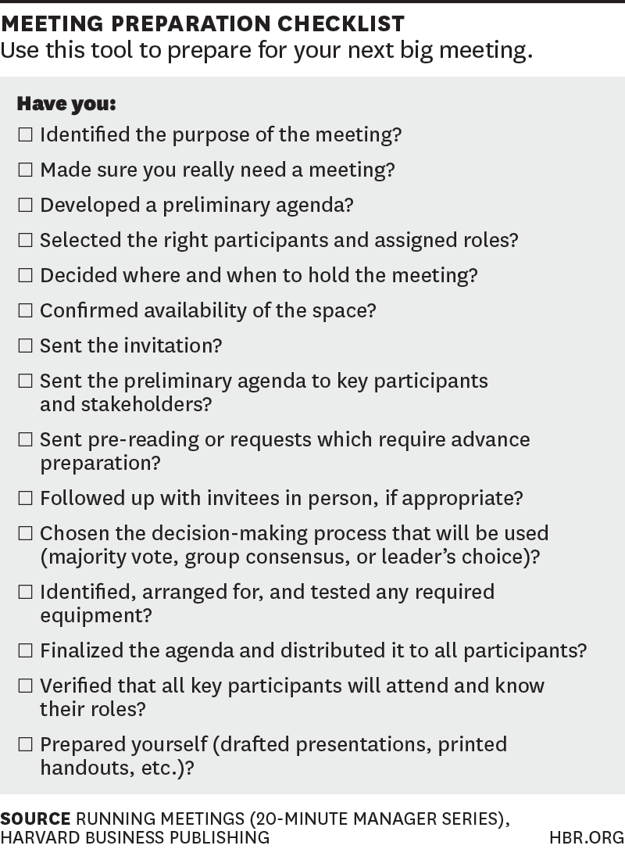
Template | 