EDE Final Report Template

EDE Damanhur 2021
Dates: August 7 – September 5, 2021
Host site: Damanhur

- Course Overview: (150 - 300 words)
Brief explanation of the background of the organisation, host site. Diversity of participants and facilitators. Main highlights, key success factors and other relevant information that would describe what happened during the EDE. This text will appear at Gaia Education´s website to describe your programme.

It took us two years to be able to run the 10th edition of the EDE at Damanhur, organized by the NGO Damanhur Education APS, in partnership with Gaia Education. the Global Ecovillage Network and Arca Tentyris APS, as in 2020 we had to cancel the course because of the Covid situation. So we are even more happy that this year the EDE took place.
Founded in 1975 in northern Italy, Damanhur is a resilient Federation of Communities with its own constitution, culture, art, music, currency, schools and utilization of science and technology. It has about 600 full-time residents, plus 500 citizens in the world.
Damanhur is based on the vision of a new model for society based on solidarity, sharing, love and respect for the environment. For over 44 years, Damanhur has developed into a well organized eco-society in continuous change, though staying true to its foundational principles.
Damanhur also became well known in the world because of building the Temples of Humankind, an underground construction, a unique work of art dedicated to universal spirituality.
Holding the EDE at Damanhur allows the course to look at the many concrete examples and experiences in all four dimensions present in the 47- year old community.
Our EDE starts with the Social Dimension in the first week, because it is really important to first of all create the learning community through the exercises and processes that strenghtens the group experiences. It is so important, because it creates a red thread and the fundaments on which the other dimensions can unfold at their best. Many powerful exercises bring awareness about yourself also, through getting in touch with the Life stories of the other participants. This actually creates the basis to becoming a life changing experience for many. Some of the highlights of this dimension this year as well as in the former years were the sessions around conflict and leadership.
Visiting and meditating in the Temples of Humankind, hands-on straw-bale building, art sessions and a community building experiment in the woods are just some of the highlights of the other dimensions.
The Economic Dimension uses the example of Damanhur, the hosting community, to demonstrate different economic models, to show aspects of a new economy, as well as how a more just economy can be created. Concrete examples also show the challenges a community has to face and how they can be tackled.
This year the group was not as international as other years, because of the Visa situation due to Covid which did not allow a many possible participants to arrive, especially a big group from different countries from Africa, so we had mainly participants who were based in Europe. There were 11 people from 7 different countries in the core group. People were coming from Holland, Latvia, Italy, Usa, Portugal, France and Switzerland in the core group, but this year there was a new situation, because we opened the possibility to the many participants from the Online EDE, that Taisa Mattos and Macaco Tamerice had held in the months before, to do an immersive week in the Damanhur EDE.
11 students from the Online EDE took this chance and it made the course very vivid. It was great to see how the spirit of the EDE is something perceivable and permeating and it allowed the groups to melt. The ages ranged from 21 to 62, and many participants were under 30 or between 30 and 40 years of age.
We are living in years of general awakening, so we have observed that every year the participants start already with quite a high level of information and knowledge in the four dimensions of sustainability before hand. There was an urge to engage, learn and transform themselves and this allowed to go really deep, creating the life changing processes, that continue to nourish the participants also after the course when they go back to their everyday life.
Most of the facilitators were from Damanhur, and all were experienced EDE teachers with many years of expertise.

- Participants: (50 - 150 words)
(Basic stats including numbers of participants, age range, gender ratio, countries, ethnicities and backgrounds)
This year the group was not as international as other years, because of the Visa situation due to Covid which did not allow a many possible participants to arrive, especially a big group from different countries from Africa, so we had mainly participants who were based in Europe. There were 11 people from 7 different countries in the core group. There were people from Holland, Latvia, Italy, Usa, Portugal, France and Switzerland in the core group, but this year there was a new situation, because we opened the possibility to the many participants from the Online EDE, that Taisa Mattos and Macaco Tamerice had held in the months before, to do an immersive week in the Damanhur EDE.
11 students from the Online EDE took this chance and it made the course very vivid. It was great to see how the spirit of the EDE is something perceivable and permeating and it allowed the groups to melt. The ages ranged from 21 to 62, and many participants were under 30 or between 30 and 40 years of age.
We are living in years of general awakening, so we have observed that every year the participants start already with quite a high level of information and knowledge in the four dimensions of sustainability before hand. There was an urge to engage, learn and transform themselves and this allowed to go really deep, creating the life changing processes, that continue to nourish the participants also after the course when they go back to their everyday life.

- Course rhythms: (50 - 150 words):
(A description of the times of daily activities, sessions, free time, social time, interaction with hosts, rest; how many hours in lectures & practical sessions,etc.)
In the morning before breakfast, yoga and meditation sessions were offered by the participants, followed by breakfast from 8:00 - 9:00.
The morning session was from 9.15 - 12:30, lunch at 13:00, break until 15:00.
The afternoon session was from 15:00 - 18:00, dinner at 18:30, break until 20:00. The evening program was from 20:00 - 21:30.
The program varies a lot, but there are some basic patterns. Usually the morning begins with some kind of sharing, followed by a theoretical part. After the theoretical part, there is often the design part, which continues throughout the entire course. The weeks of the four dimensions are different, as the ecological part also has hands-on sessions. There is art in the worldview dimension, and a community building experiment for the social dimension. There are several moments to contact the hosting community, in addition to the initial visit, such as dinners in a Damanhurian nucleo community and hanging out the Damanhur Crea, the central point where the community members meet. There are several free evenings, every week at least one free afternoon and one completely free day.

- Highlights & challenges of each dimension:

Social (150 - 250 words): What happened in this dimension? What were the highlights? What subjects were covered? 1-2 participant quotes from the Gaia Education Evaluations or other sources. A sentence on each core faculty/facilitator.
The Social Dimension takes place in the first week of our EDE. The first week creates community and a very high frequency for the whole course. Through the many exercises and processes experienced in this week a really strong community feeling is created since the beginning. Most participants had life changing experiences during the Social Dimension. The highlights were similar to the previous years: the sessions about leadership presence, conflict resolution, governance and decision making and most of all the community building experiment in the woods. These intensive processes mixed with lot’s of fun helped the participants to learn so much about themselves and how they are part of creating the group.
The community building experience in the woods was particularly intensive and allowed the participants to experience leadership and decision making, to work on personal growth, and to understand what it means to think as a group even in a different environment.
The contact with the hosting community is also very important, because the participants get a taste of community life. The participants are invited to have dinner in different nucleos (smaller communities from 12-25 people) and to hang out at the Damanhur Crea to meet with the Damanhurian community.
Macaco Tamerice facilitated the Social and Worldview Dimensions, and she co-facilitated the Ecological and Economic Dimensions. She has 28 years of expertise in community living and her ability to guiding groups and group processes lead the group through intense personal and group processes and games.
Formica Coriandolo co-facilitated the Worldview Dimension using art as a tool to self-exploration and bringing energy and warmth. Formica has 38 years of community expertise and is one of Damanhur’s artists.
Quotes: “It was such an amazing and inspirational experience to learn about community, while living in a community that has been alive for more than 40 years! Exploring the different aspects, while building a group cohesion at the same time, working together while learning: how to handle yourself, each other, how to deal with conflict or apply the appropriate kind of leadership...there is no more profound way to become really immersed into what it means to be part of a community!”

“Leadership, deep listening and conflict resolution were important topics that I learned about in the social dimension. And not through passively listening! We were put to work and it felt like ‘we were put in the fire’. Challenging but broadening, taking place in a safe group. “
” Macaco is the true master of this pillar. What influenced me dearly was learning leadership presence and giving myself persimmon to be a leader and to be part of something bigger than just myself. This week was truly intense and we were transformed from a group of strangers into a group of friends and teammates. Great ideas sparked here.”

“I've learned so much from the social part. Amazing to see how close such a diverse group of people can get in such a short period in time! The leadership training was full with insights and practical tools. 'Giving yourself the right to be a leader' stayed with me even as the power of your intention when I communicate.”

Include 2-3 pictures. 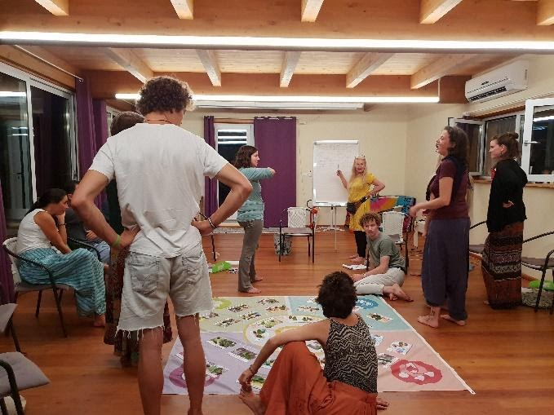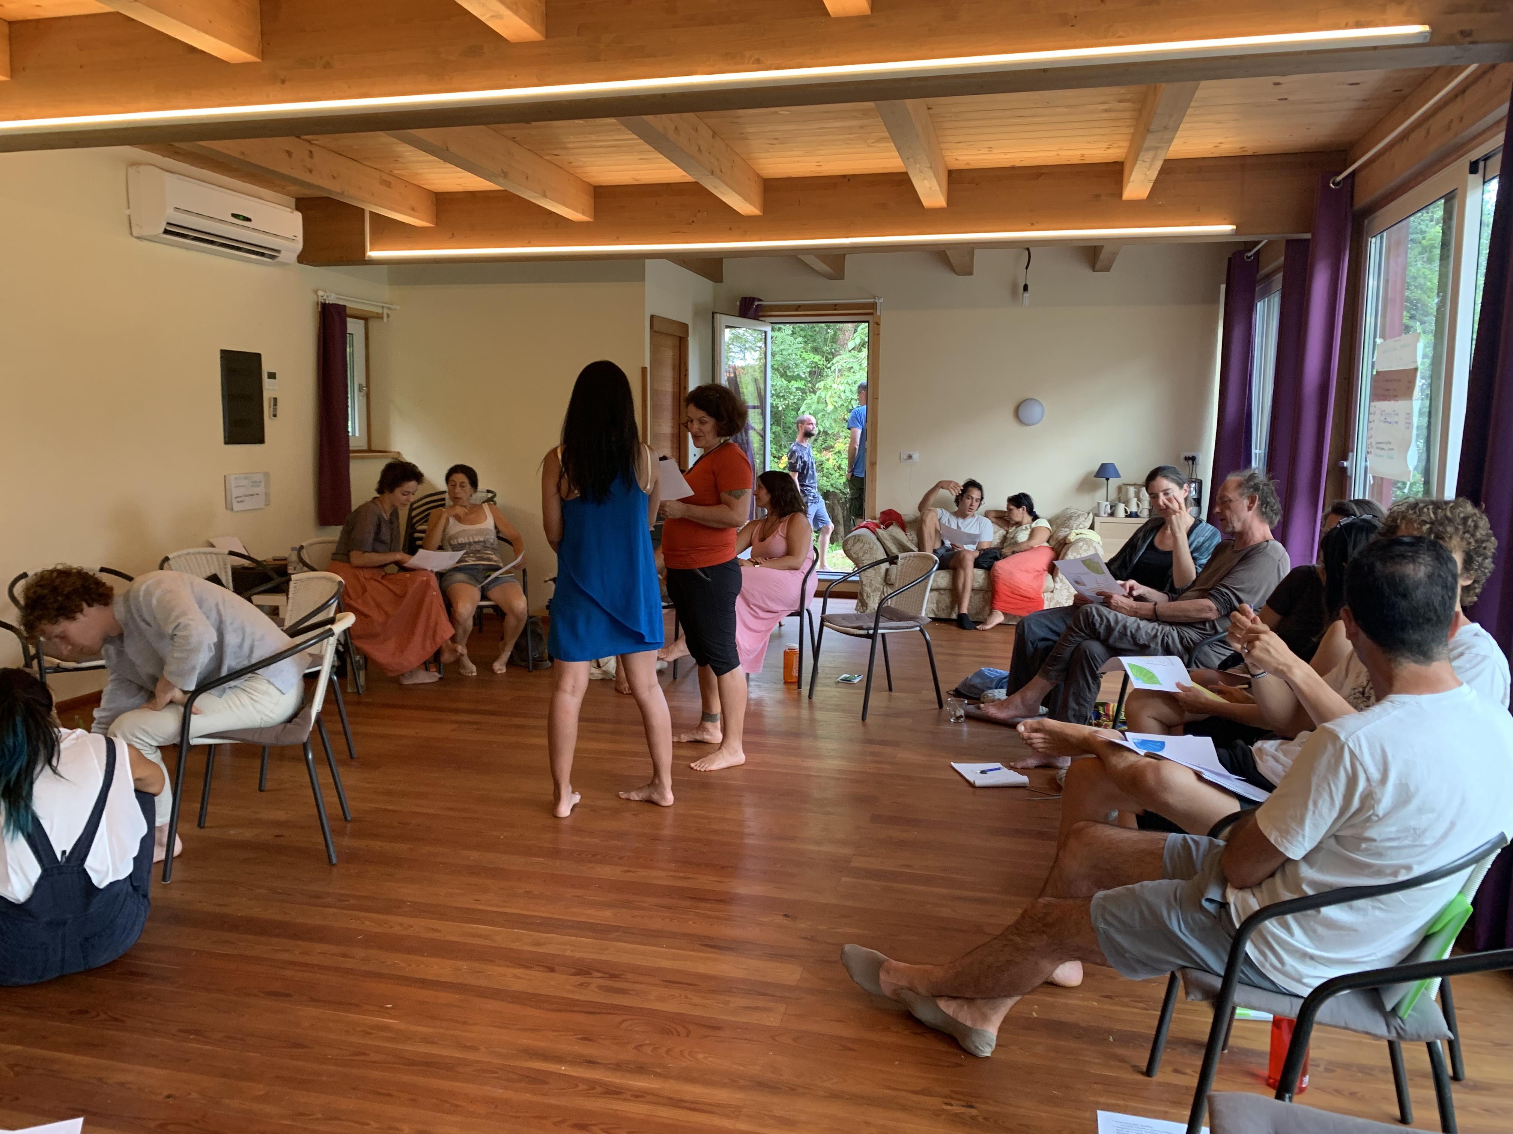

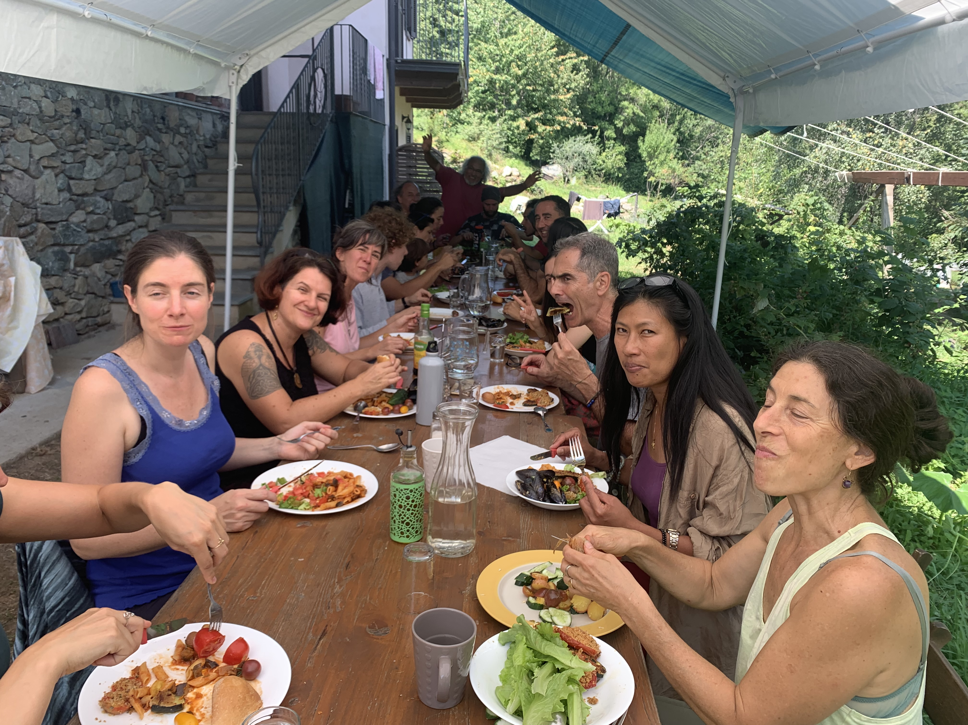

Economic (150 - 250 words): What happened in this dimension? What were the highlights? What topics were covered? What practical activities were performed? 2-3 participant quotes from the Gaia Education Evaluations or other sources. A sentence on each core faculty/facilitator. Any other information that you consider relevant.
The Economic Dimension explained about the ownership of money, macro-micro economy and helped the participants explore possible alternatives to an unfair economic system. It also looked at new models through concrete examples. This Dimension explored complementary currencies and local economy and looked at how these aspects are related to a new way of looking at economy. Solidarity as one of the key elements for a regenerative future helped understanding, that if you want to measure richness there are many more forms of richness than just money.
Damanhur, as the hosting community, demonstrated concrete alternatives and many different aspects of a new economy, and how a more just economy can be created in a community inspired by solidarity. Some very concrete economic tools like the balance point and a business plan were explored too.
Lemming Cactus was the main facilitator of the Economic Dimension which he lead with professional expertise and know-how.
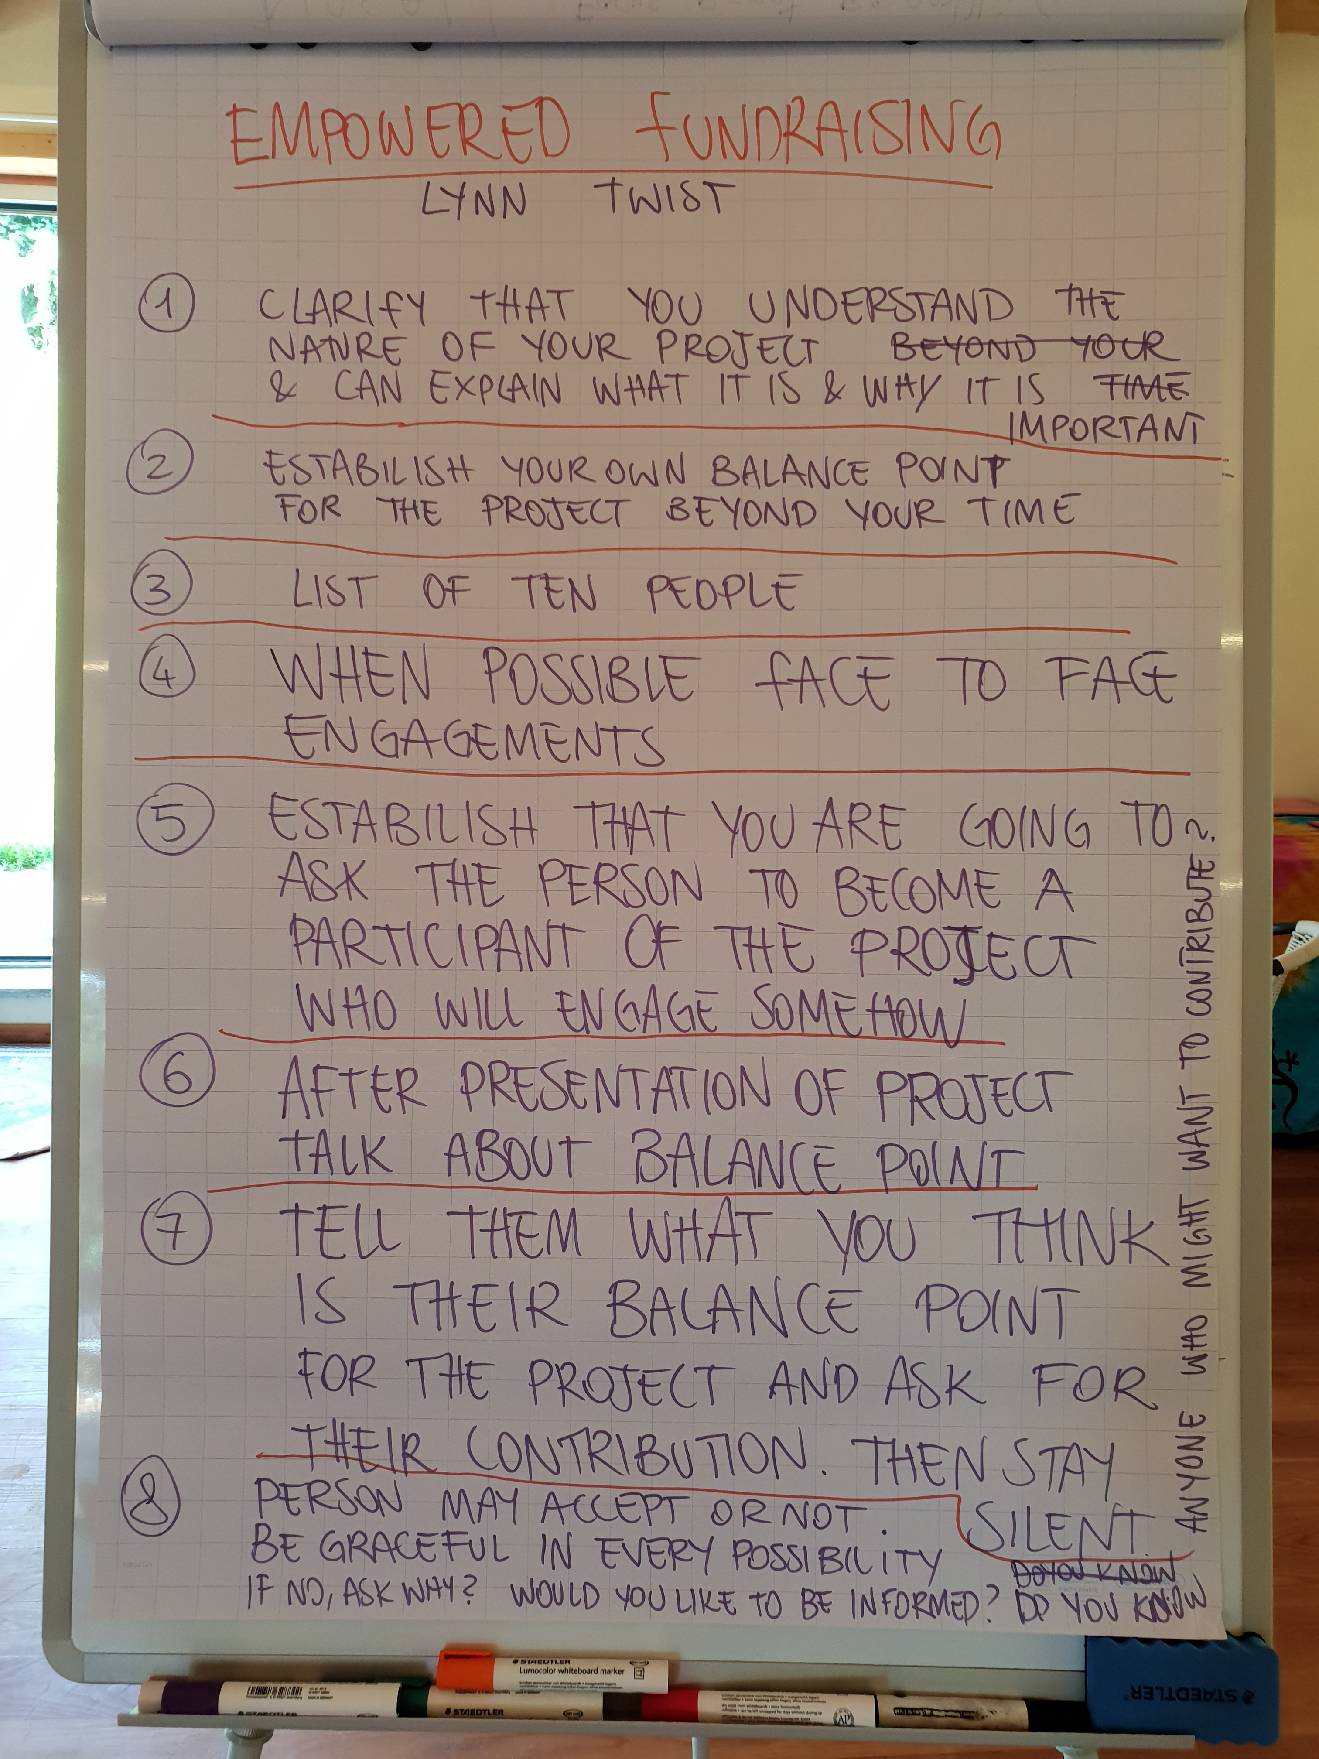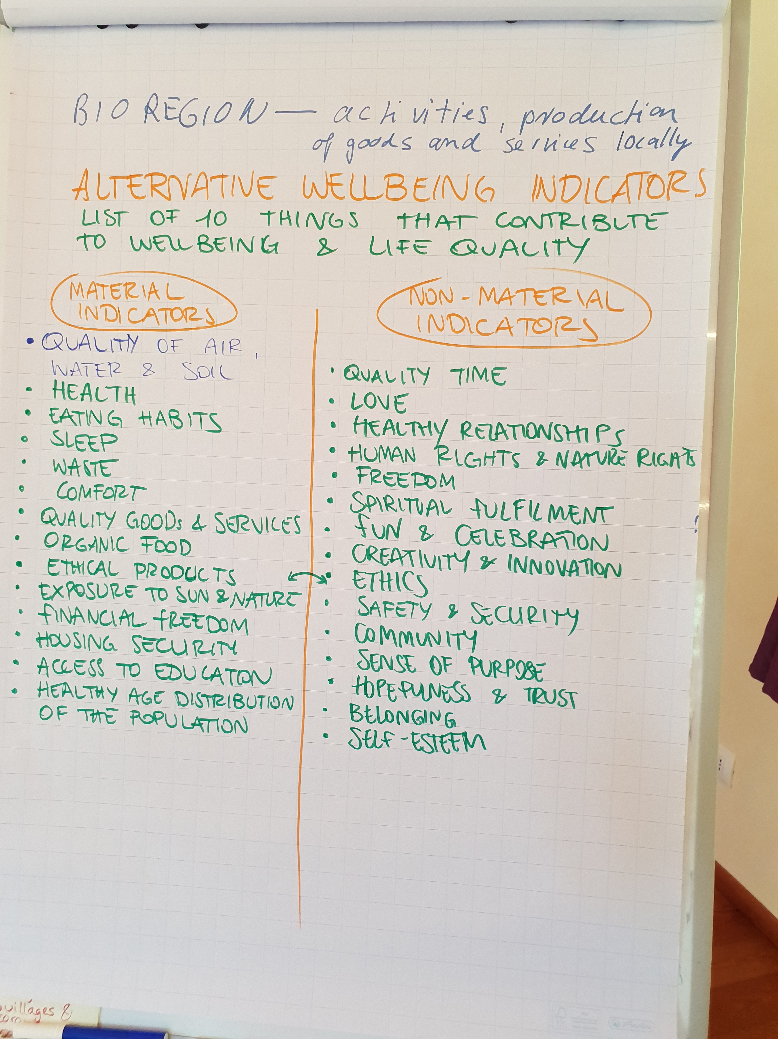
Quotes:
“We are children of competition” is the quote that sticked with me from the economic course. It showed me, how as an individual and as a society at large, we have grown up in competition. This dimension offered alternatives outlooks and practical tools in order to work towards a healthy economic system.”
“In economy we learned about the right systems at the right moment and practiced some fundraising skills. Personally my favorite was economy in permaculture. I learned eight forms of capital and how I can implement it in my everyday life. It helped me to perceive my very own economy in a more holistic way.”

“This for me economy is still a complex part of a sustainable eco village where I don't see the 'right' way to go. As the current system is unsustainable we have to find an other solution to do business in a field of trust. It's I guess one of the biggest challenges and during the course we dove into some great examples and possibilities.”

Include 2-3 pictures.

Ecological (150 - 250 words): What happened in this dimension? What were the highlights? What topics were covered? What practical activities were performed? 2-3 participant quotes from the Gaia Education Evaluations or other sources. A sentence on each core faculty/facilitator. Any other information that you consider relevant.
In the Ecological Dimension, the participants had several sessions to get to know permaculture design. They also learned about growing organic food, water and wastewater treatments, green building and retrofitting, alternative energy and about appropriate technology.
Our Ecology Dimension has a big part of hand’s-on and the highlight of this session was the experience of straw-bale building and the creating a warm bed in a permaculture farm. The introduction to permaculture and designing with permaculture principles gave good insights to different design methods. Also, visiting places in the hosting community where various technologies had already been successfully implemented showed the practical application of the theory.
The participants had lots of fun with strawbale building and enjoyed applying the permaculture principles directly. Also, the visit to the damanhurian organic farm that produces food for the whole community and the community’s organic shop was highly appreciated.
Nicola Savio facilitated the permaculture program, awakening an interest in permaculture design and best practices.
Inti China led the sessions about alternative building and the hands-on straw-bale building, showing how to use different tools and methods.
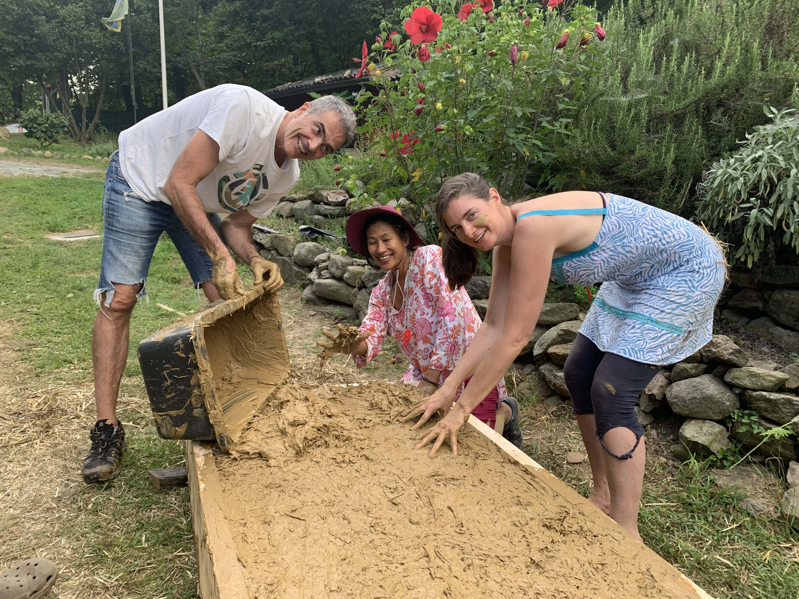

Quotes:
“ Learning about the ecological dimension was a very interactive experience. We were put to work ourselves and got lectures from experts in the field. The host of the course, Damanhur, is itself a pioneer regarding ecological design. They know what they talk about and we were shown many of the applications.”
“It's one thing to learn about all the different approaches, the available technologies, and the possible interactions/connections, it is another thing to go and try to make them, to apply the knowledge, to experience what it feels like to have your hands in the clay, the soil, and to build something, renew something, or design something based on observations and taking many variables into account... It helped me to understand deeply how much effort and care is needed to build beautiful ecological solutions and that we do it together!”
“This was a fun week filled with hands-on experiences. This is a very complex topic that is hard to learn in depth in one week. What I appreciated about this particular experience was actual ideas that I could implement. For example building a hugelkultur garden bed. I can’t wait to have one in my home.”

.”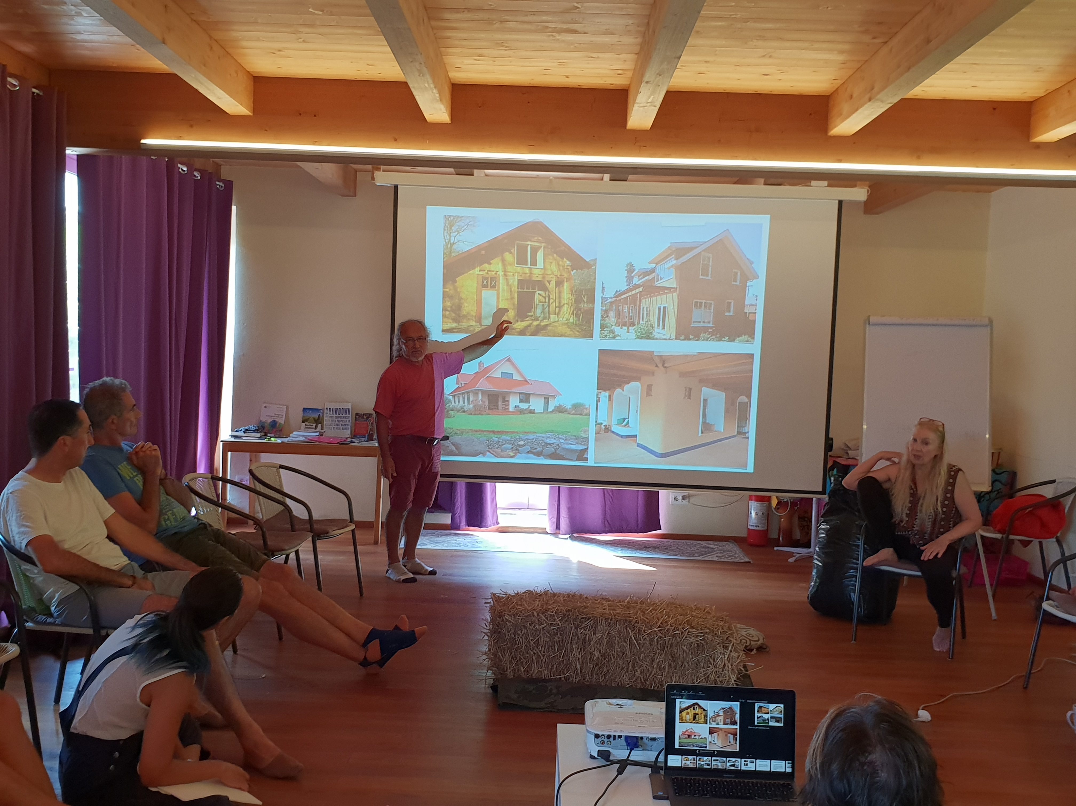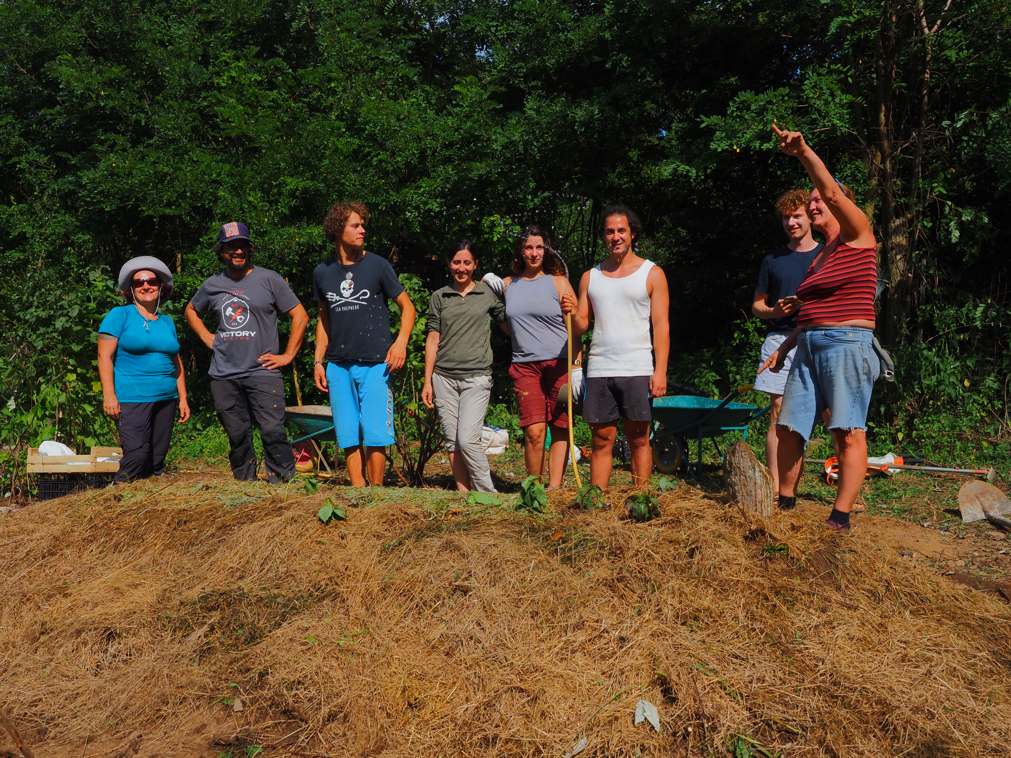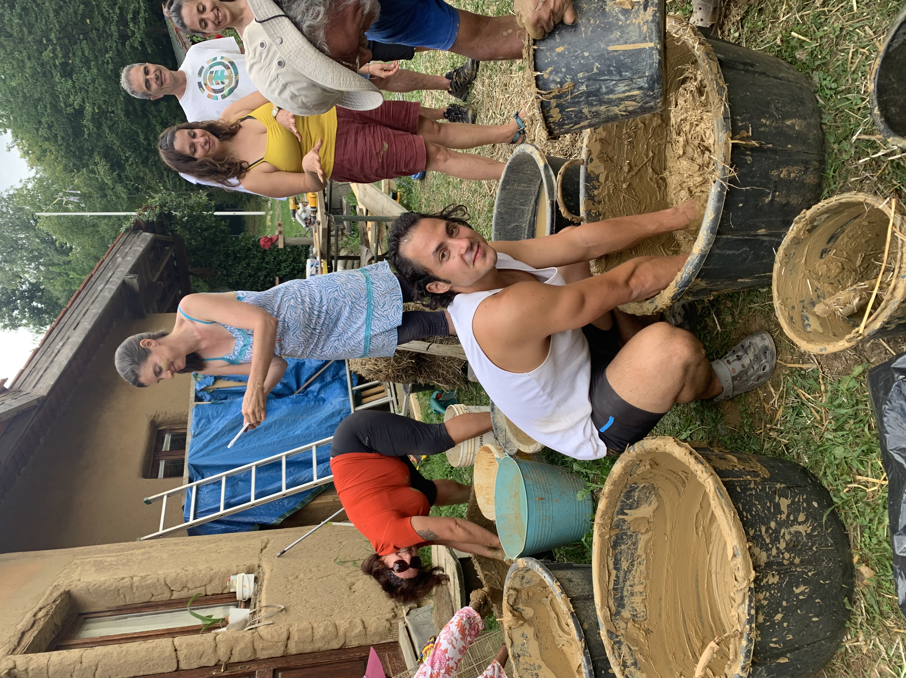

Include 2-3 pictures.

Worldview (150 - 250 words): What happened in this dimension? What were the highlights? What topics were covered? What practical activities were performed? 2-3 participant quotes from the Gaia Education Evaluations or other sources. A sentence on each core faculty/facilitator. Any other information that you consider relevant.
The Worldview Dimension is another really touching part of the EDE. It allowed the participants to experience their artistic and expressive abilities, to connect deeply to nature and to visit the Temples of Humankind. They also participated in a meditation in the Temples, which was a highlight of this Dimension. The participants had an introduction to Spiral Dynamics with some exercises, to understand about human evolutionary steps inside ourselves and as a society. A beautiful sharing about worldviews was enriching for all. Especially appreciated was the hands-on part linked to sculpturing with clay, which allowed the participants to bring out the artist that lies in every person. A detailed introduction to Sociocracy with some exercises gave inputs about more inclusive ways of governance.
A session about health helped understand how different approaches to health can happily coexist and be applied in a community. This year there was a vivid discussion about Covid from many points of view.
Connecting to Nature is always a particularly appreciated session. There are exercises from Deep Ecology and from Damanhur and the session was perceived as an important highlight of this Dimension. The experience the participants made during this session created a deep connection with nature and with ourselves as being part of nature.
Macaco Tamerice led the Worldview sessions from Spiral Dynamics, personal transformation and connection with nature, to moving toward an understanding of collective intelligence.
Formica Coriandolo co-facilitated and held the art workshop with sensitivity and support, bringing out the artist that lies in everyone and understanding the meaning of creating art together.
Quotes:
“Learning about the worldview dimension IN a spiritual community like Damanhur is a big plus. Besides the theoretical understanding it also gives you the full experience of what this means. We learned about a wide variety of practices allowing us to reflect on ourselves and bringing to the surfuce our own deeply held (unconcious) beliefs and assumptions about ourselves and the world.”
“Connecting the dots of spirituality, health and connection to nature in the group gave me words to express the deep experiences and insight in life between these pillars. They cannot been separate as it's not a sustainable way of being. Connecting with others in these themes is of great value to me.”
“What was truly empowering for me was to actually experience and see this well established community and to be able to learn from their past mistakes and successes. I have been greatly influenced by the magic of this place and people who created it.
I could see that establishing a vision is a foundation to each community and project and I got to practice it too.”

Include 2-3 pictures.
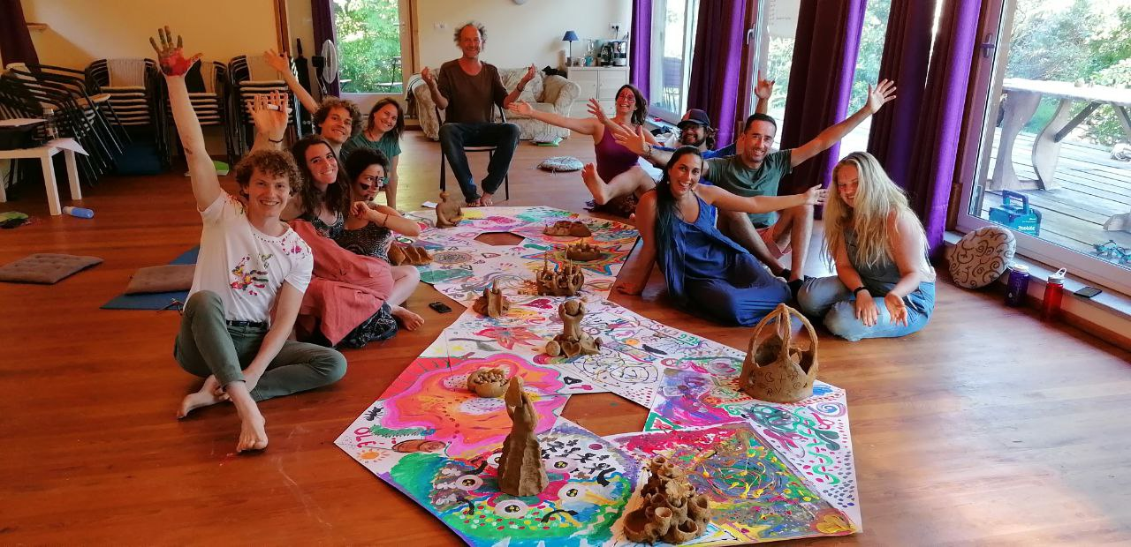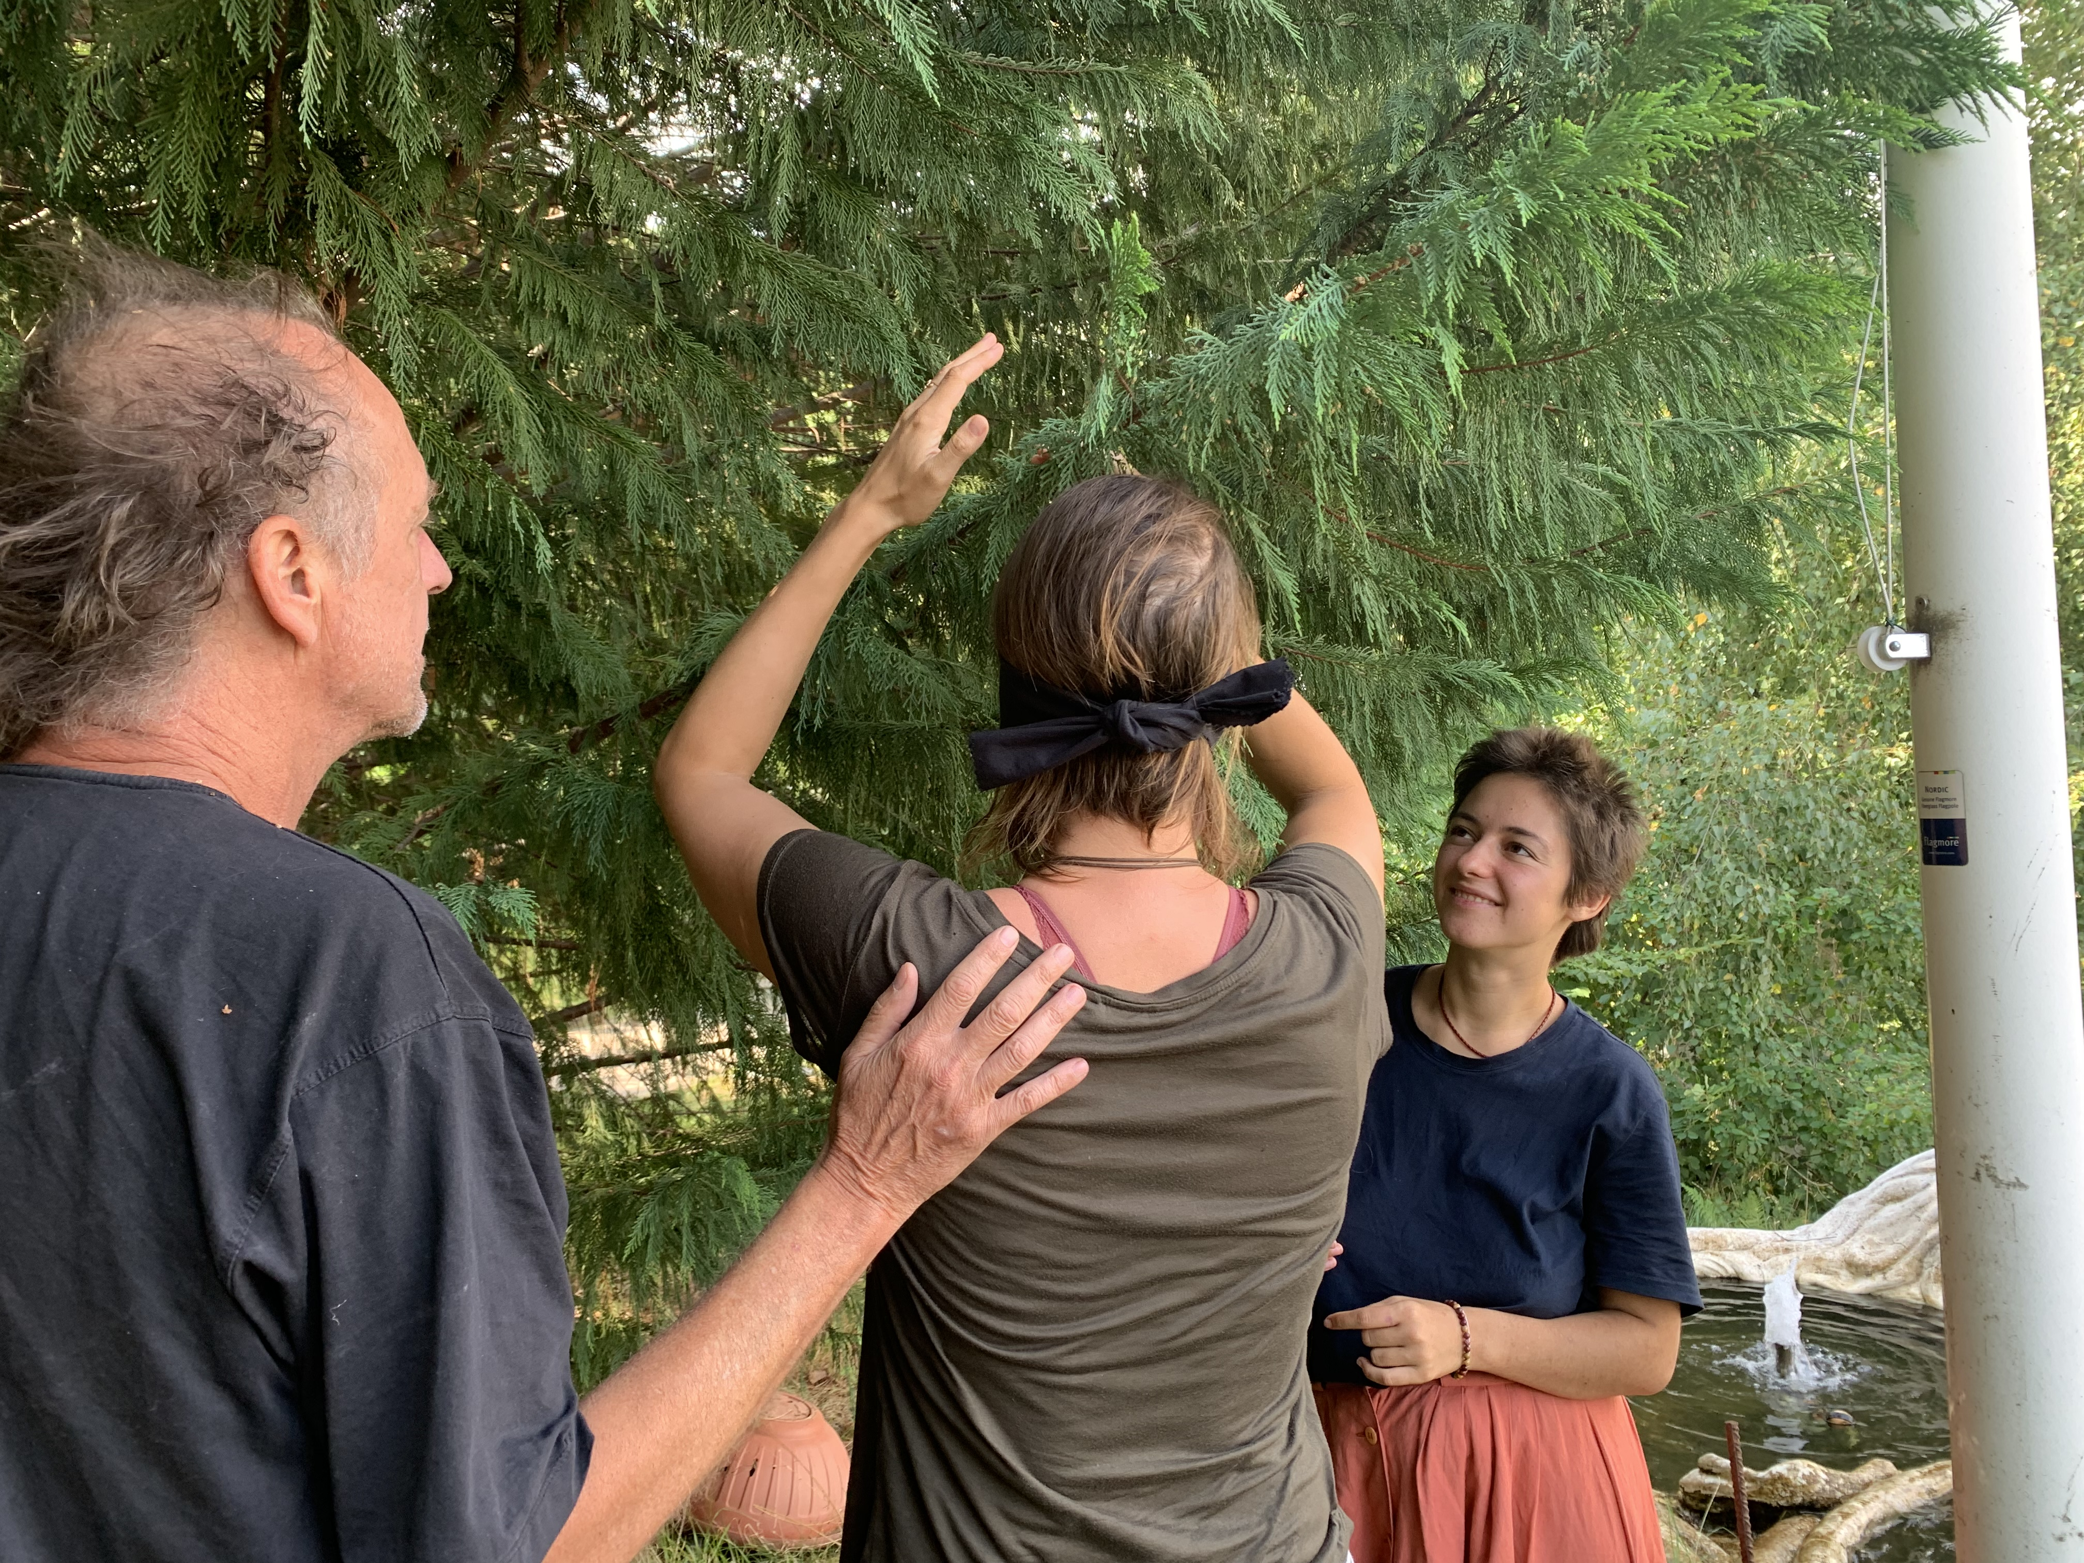
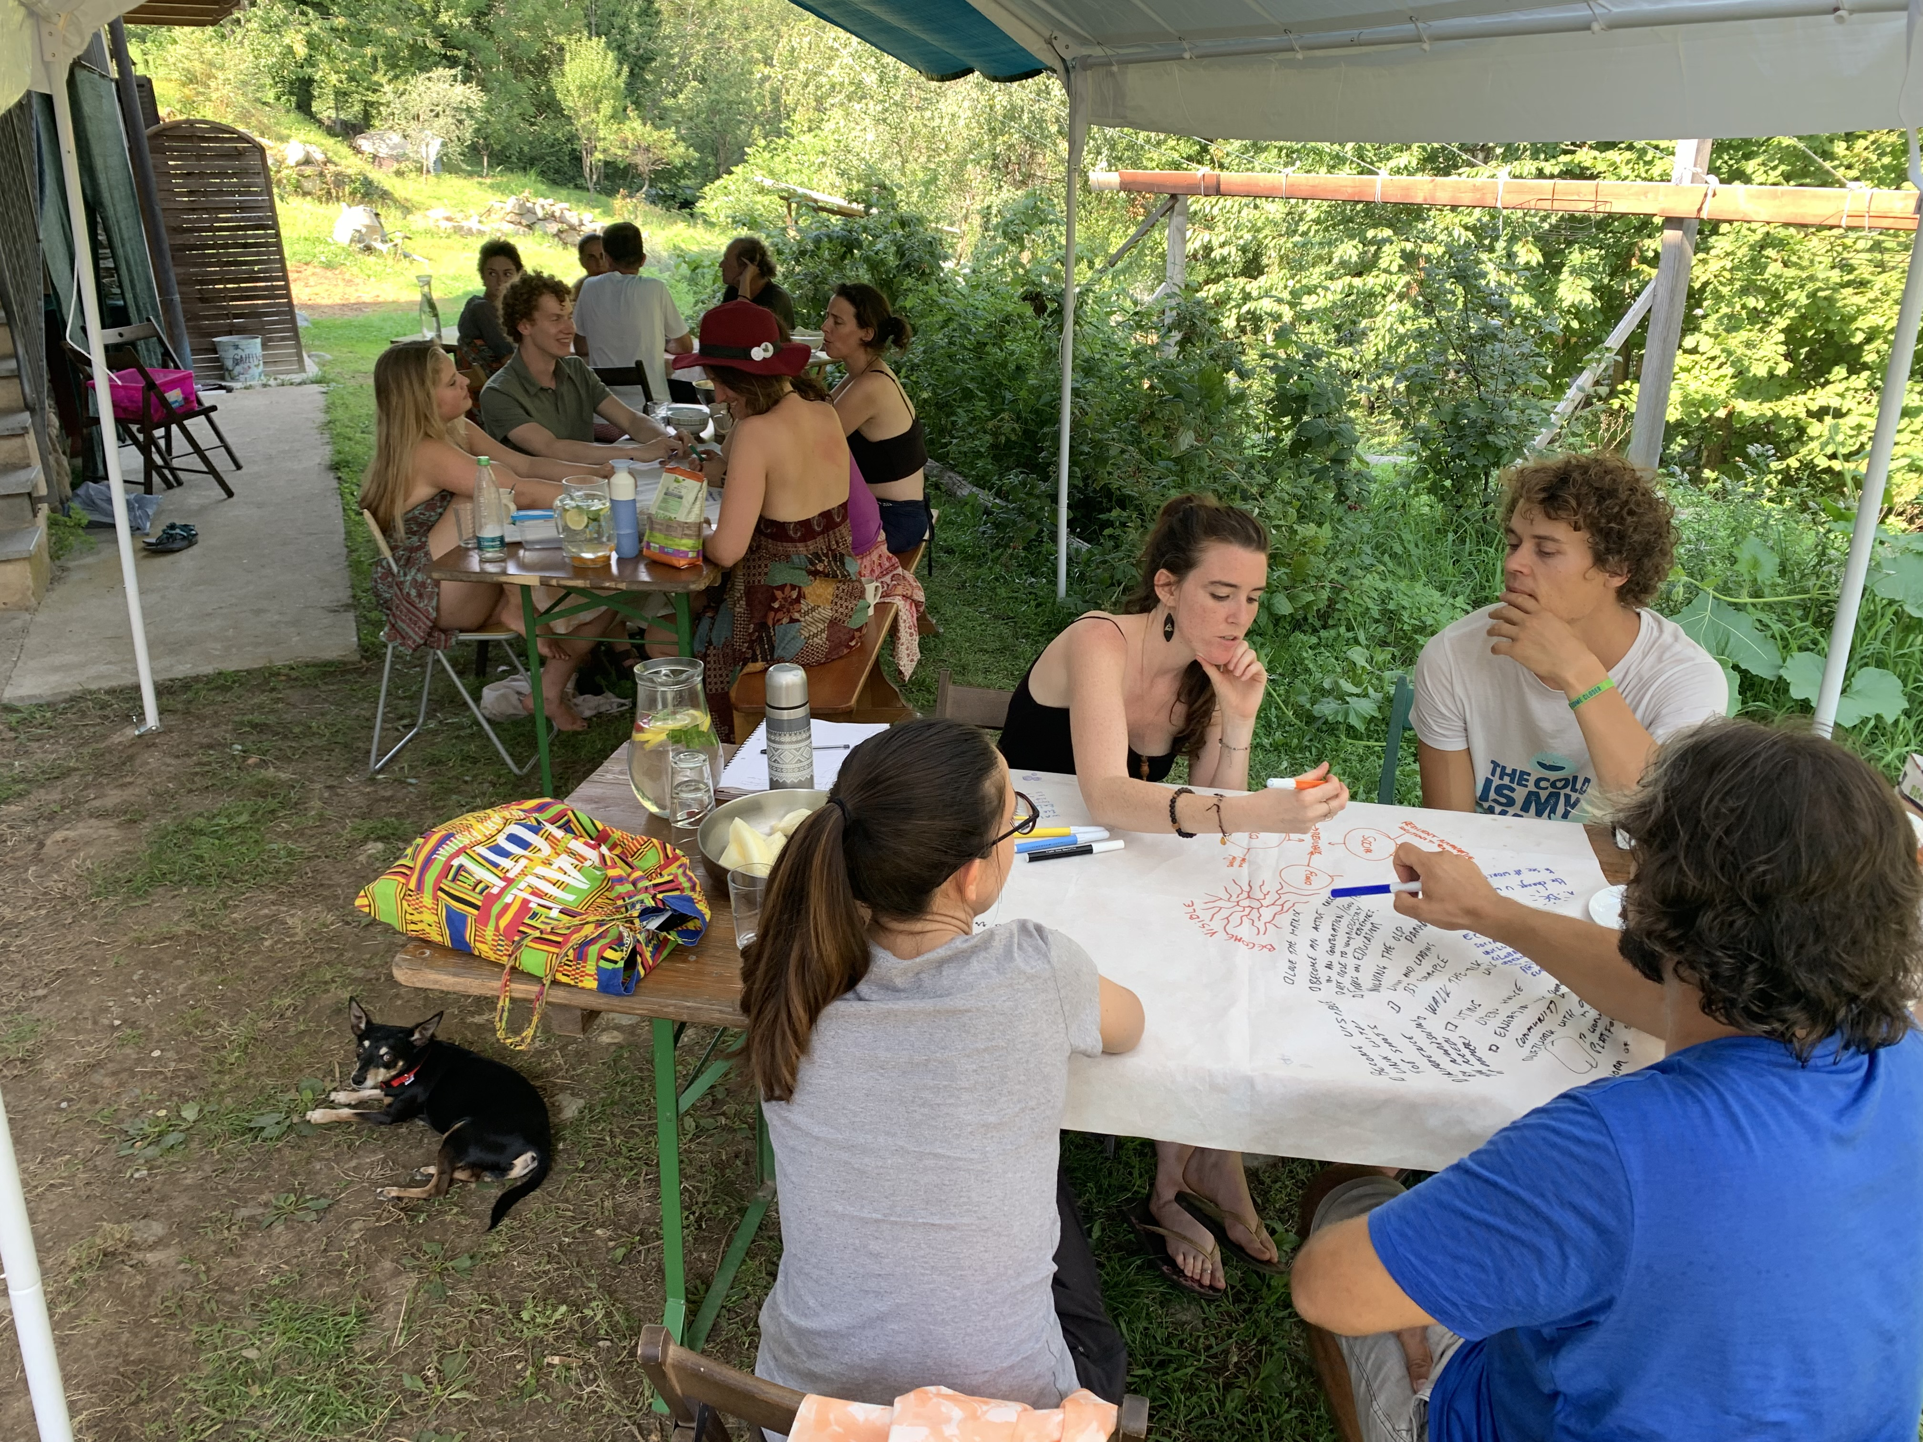

Design (150 - 250 words): What happened in this dimension? What were the highlights? What topics were covered? What practical activities were performed? 2-3 participant quotes from the Gaia Education Evaluations or other sources. A sentence on each core faculty/facilitator. Any other information that you consider relevant.
The Design Dimension applied different designing methods. Through a Dragon Dreaming process three projects were created. During the whole course the participants were weaving the theoretical information they received from the different sessions into their projects. Over the years we have experienced, that doing Design in this way, allows the knowledge the participants receive to become alive, to be stratified, and it stays with them, because of the direct application into the project, learning by doing. Real projects are created, that can become reality.
The Design groups are the platform where the practical learning takes place and where all the knowledge from social tools like leadership, conflict solving etc, as well as the tools from the other dimensions can be experienced and applied directly.
The three projects that were created during the course have the potential to be realized, all were about creating ecovillages combined with learning and healing centers, with different approaches and accents. The participants were very identified with their projects and especially one of the projects is already in the phase of being implemented.

Quotes:
” Working in teams on a concrete group project through the four dimensions was a powerful experience. We applied what we learned in each of the dimension, from designing how to form, build and maintain a community; to how to design the natural and living spaces in ecological ways, to designing systems for economic sustainability and income generation, as well as collective practices, rituals and artforms for a shared worldview. During the process we also learned to work with each other in a small community, resolve conflicts, communicate about the project effectively and were guided by the feedback of experts.”
“Applying the lessons learned in all dimensions to the project was an important tool to anchor our knowledge in something tangible. And, what started as a project just for the EDE, turned out to be a project that continued to exist beyond the course.”
“There are so many important points to think of in how to design the eco village! It was great to get help to realise a more concrete plan. Also the group process helped a lot to explain our ideas and get feedback.”
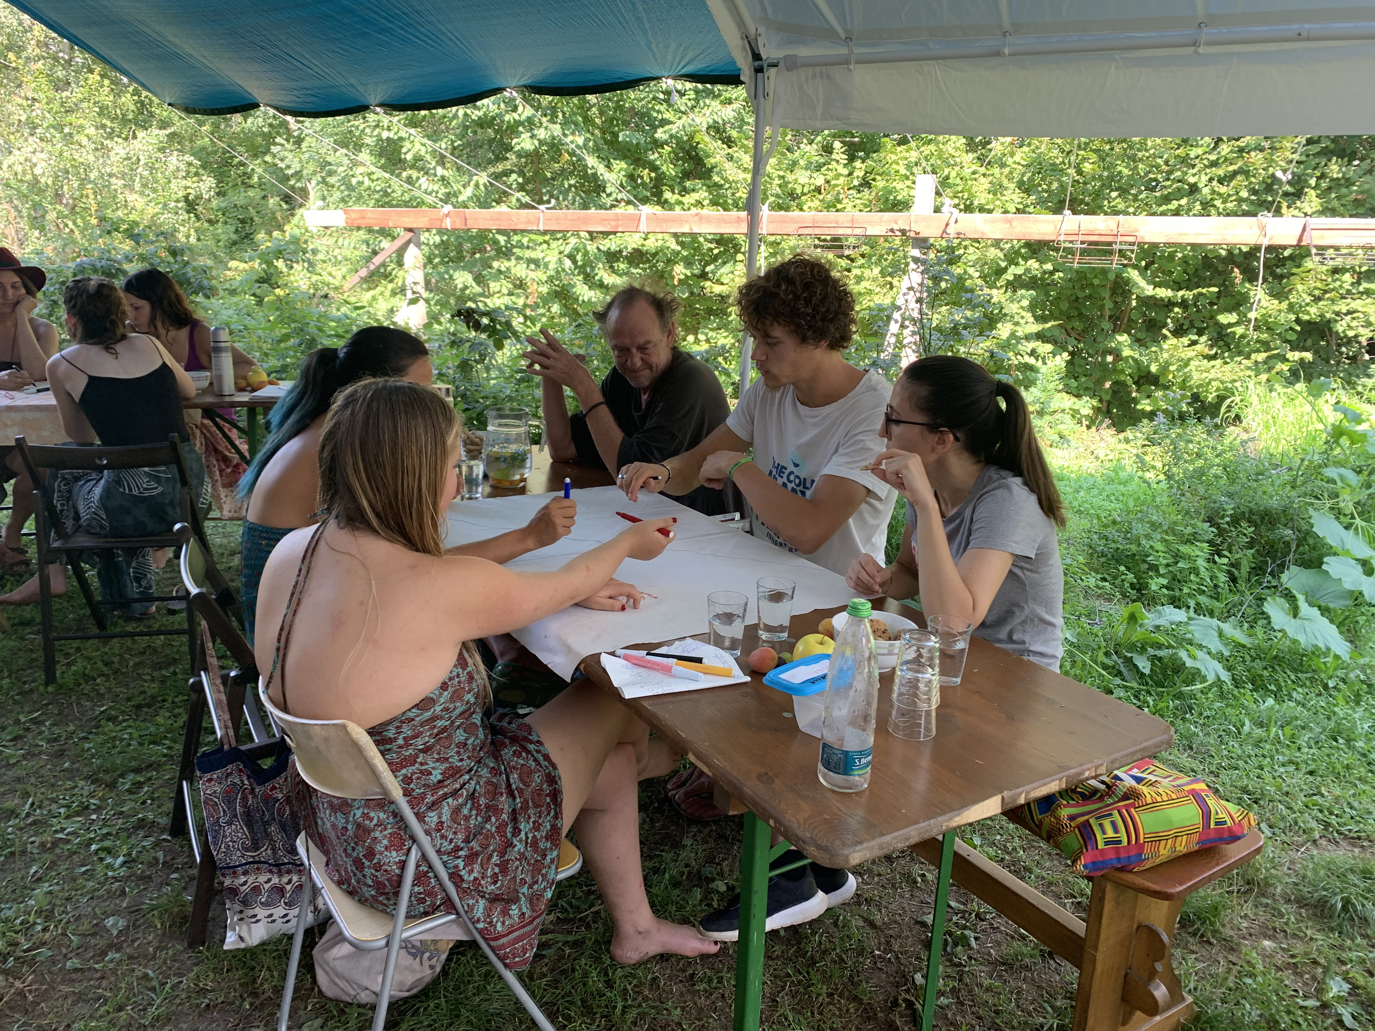
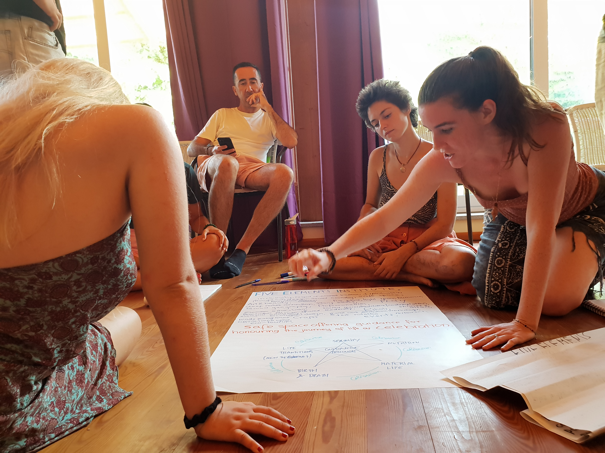

Include 2-3 pictures. If showing a design project photo, please acknowledge the names of the designers. NOTE: The pictures are in the presentations.

Design Studio Case Studies: Brief description of the case studies developed during the programme if applicable.
PROJECT 1. THE FIVE ELEMENTS INSTITUTE: Guided transformative journeys to a whole life.
Group members: Ana Catarina Miranda, Carlos Risso, Guna Faja
https://drive.google.com/drive/u/0/folders/1LxWNZehN6eh2rblh2DBa8onNq4sc0HyF

Summary: This project aims to create a safe space offering guidance for honouring the journey of sustainable life as a celebration. The Institute would offer services related the five elements (Water, Wood, Fire, Earth and Metal) inspired by Chinese traditional medicine. Water would refer to services for physical, emotional and spiritual support in birth and end-of-life. Wood for trauma healing and preparation for new beginnings. Fire for trauma healing and learning opportunities in feminine and masculine sexuality. Earth for learning opportunities around nutrition and regenerative farming. Metal for connecting spirituality and matter using mind as a tool.
The design of the institute would combine the social, worldview, economic and ecological dimension. Social as it will be a gathering center to learn, share ideas and collective rituals. Worldview as it will be promoting life in the vibration of love. Economy as it shall incentivize a simpler lifestyle and support the emergence of new business activities in the bioregion. Ecology as it will be designed to regenerate the land, protect water, the wildlife, grow food, and with passive buildings.

PROJECT 2. AURORA: The rise of a thousand suns
Group members: Jetske Tuinstra, Tjeerd Buis, Bram van der Burg, Alexandra Pfeifer
https://drive.google.com/drive/u/0/folders/1LxWNZehN6eh2rblh2DBa8onNq4sc0HyF

Summary: Aurora is a multidimensional, spiritual ecovillage with a healing and education center aiming to create a blueprint for the new world - that inspires to wake up humanity to an authentic way of living in harmony with nature and each other. It will promote holistic spiritual and consciousness development empowering people to participate in collective growth.
It will be designed by integration the four dimensions.
Ecological design with eco-contructions, conscious living, permaculture, spiritual connection to nature, regeneration of water cycles. Social design will include the creation of a university of life Consciousness, with educational activities, collective governance and rotation of leadership, celebration of diversity. Worldview design will include spiritual and consciousness development Practices such as ceremonies, sacred arts, plan of life, healing work, feminine and masculine work, mindfulness and body connection. It will promote health and wellbeing with prevention, safe space, cyclical living and healthy eating. It will value culture with ritual and celebrations, music, creating women and men circles, and creating temples. Economic design will include a circular economy with a local currency, communal salary, and the production and sale of goods and services relevant to the bioregion (store). The project will be supported through fundraising and holistic outreach.

PROJECT 3. CIRCLES: Monferrato Ecovillage Association
Group members: Marina Tota, Marco Gallo, Jitka Slanska, Frank Willa
https://drive.google.com/drive/u/0/folders/1LxWNZehN6eh2rblh2DBa8onNq4sc0HyF
Summary: Circles is an ecovillage association in Monferrato, in the Piedmont region of northern Italy created by renovating abandoned houses. Its vision is Living individuality together in harmony with nature, and its mission is creating a sustainable community in collaboration with nature & each other where there is space for authenticity & creativity, rippling out circles of positive change into the world. The association will be registered as an NGO with and initial investments by association members. The social design will aim at engaging people in the association. Social design will include recruiting members and engaging them in the planning process. Once the community is formed there will be community building retreats to do dragon dreaming process. The governance structure will be formed with working groups will to implement different areas of the work. The ecological design will include local food production, collaboration with local farmers, ecological building and renewable energy systems, as well as rainwater collection systems. Zone planning will be used for the design of the space. The culture and worldview design will be focused on growing the community organically by actively engaging people in shaping the vision and mission and contribute to promote activities in nature and creativity. The economic design allow member of the association to exchange money or work as contribution, and to pay housing with monetary contribution or when they renovate the housing by themselves. Income generating sources for the project will be the monthly contribution of Association, rental of music studio for rent, AirBnB model for unused housing and guest rooms, Private RV and Camping spots for rent, Courses and Crafted goods.

-----
LESSONS LEARNED - notes for future benefit (50 - 300 words):
What could help future EDE´s from your experience? What were your biggest learnings? If a re-certified EDE, also list & respond to lessons learnt from your previous EDE.
This year we were better with giving more free time to the participants, so that a whole month of intensive learning processes could also find some space for digestion. Still especially toward the last part of the course some participants were really tired. We don’t know yet how to give the right time to self-reflection without losing content.
The overall organisation was more fluid and the participants themselves were involved in the organisation. That helped the participants to experience leadership and took some weight from the organisers. We think that we will use more volunteers in the future.

The Covid situation was challenging, we asked everyone upon arrival whether vaccinated or not to do an Antigen Test to be sure no one would bring Covid to the group and we were lucky. It is definitely difficult to make sure Live programs can happen with Covid.

It was also not easy to have the main course running while a good number from the Online course did only one week. But we managed to make it happen in harmony. We had some people for the first week and that was easy, as they started all together, and some people in the Ecology week and that was more challenging as the core group was already built. Thanks to the spirit of the EDE that both groups had experienced before it was possible to combine the groups. Maybe we will only offer the first week for the people from the Online EDE next year.

Describe your EDE in terms of the know-how and learning obtained, the stories and inspiration that happen to the participants and the organisers during the EDE or a good summary of a project or activity carried out during the program. Take into consideration that this will be circulated among the Gaia Education´s community, so they wish to learn, get inspired and be empowered by your program and your participant´s experiences. (200 – 400 words) . Include 1 or 2 pictures.
The group was rather small, and the projects were defined easily. The participants were quite identified with their projects. The group was diverse, and they really wanted to have deep learning experiences, so they dared to expose themselves and make themselves vulnerable. This gave the possibility for life changing experiences to happen.
As always conflicts arise at least in one Design group and also this year made no difference, but at the end it all worked out really well and the participants learned very much.
One group has taken the opportunity of an empty house near Damanhur to create their independent project. It was strongly life changing, as several people moved to Italy. The other two groups had deep experiences too and the whole course is still in contact, several have been visiting other participants. All participants appreciated the close community that was built during the EDE and for some people it was their first real intense group experience.
One point that added to the course was that one participant came with his partner and their 3-year-old child who participated in the common meals and some activities. Having a child as part of the experience adds another layer of community and makes people become more careful.
There were many young people with the burning desire to make a difference in the world. For them as well as for the elder ones the tools of the different dimensions that were delivered and experienced created a solid base for their future.

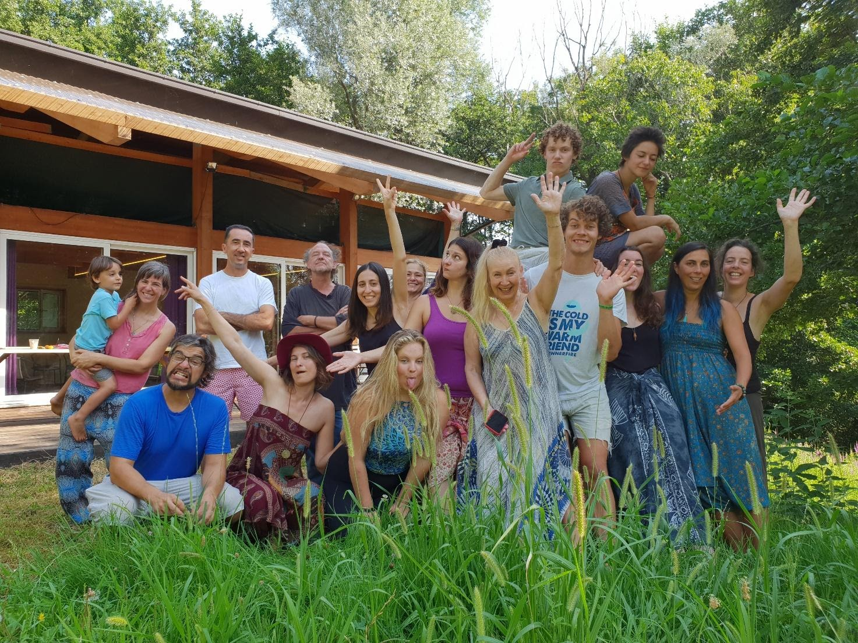
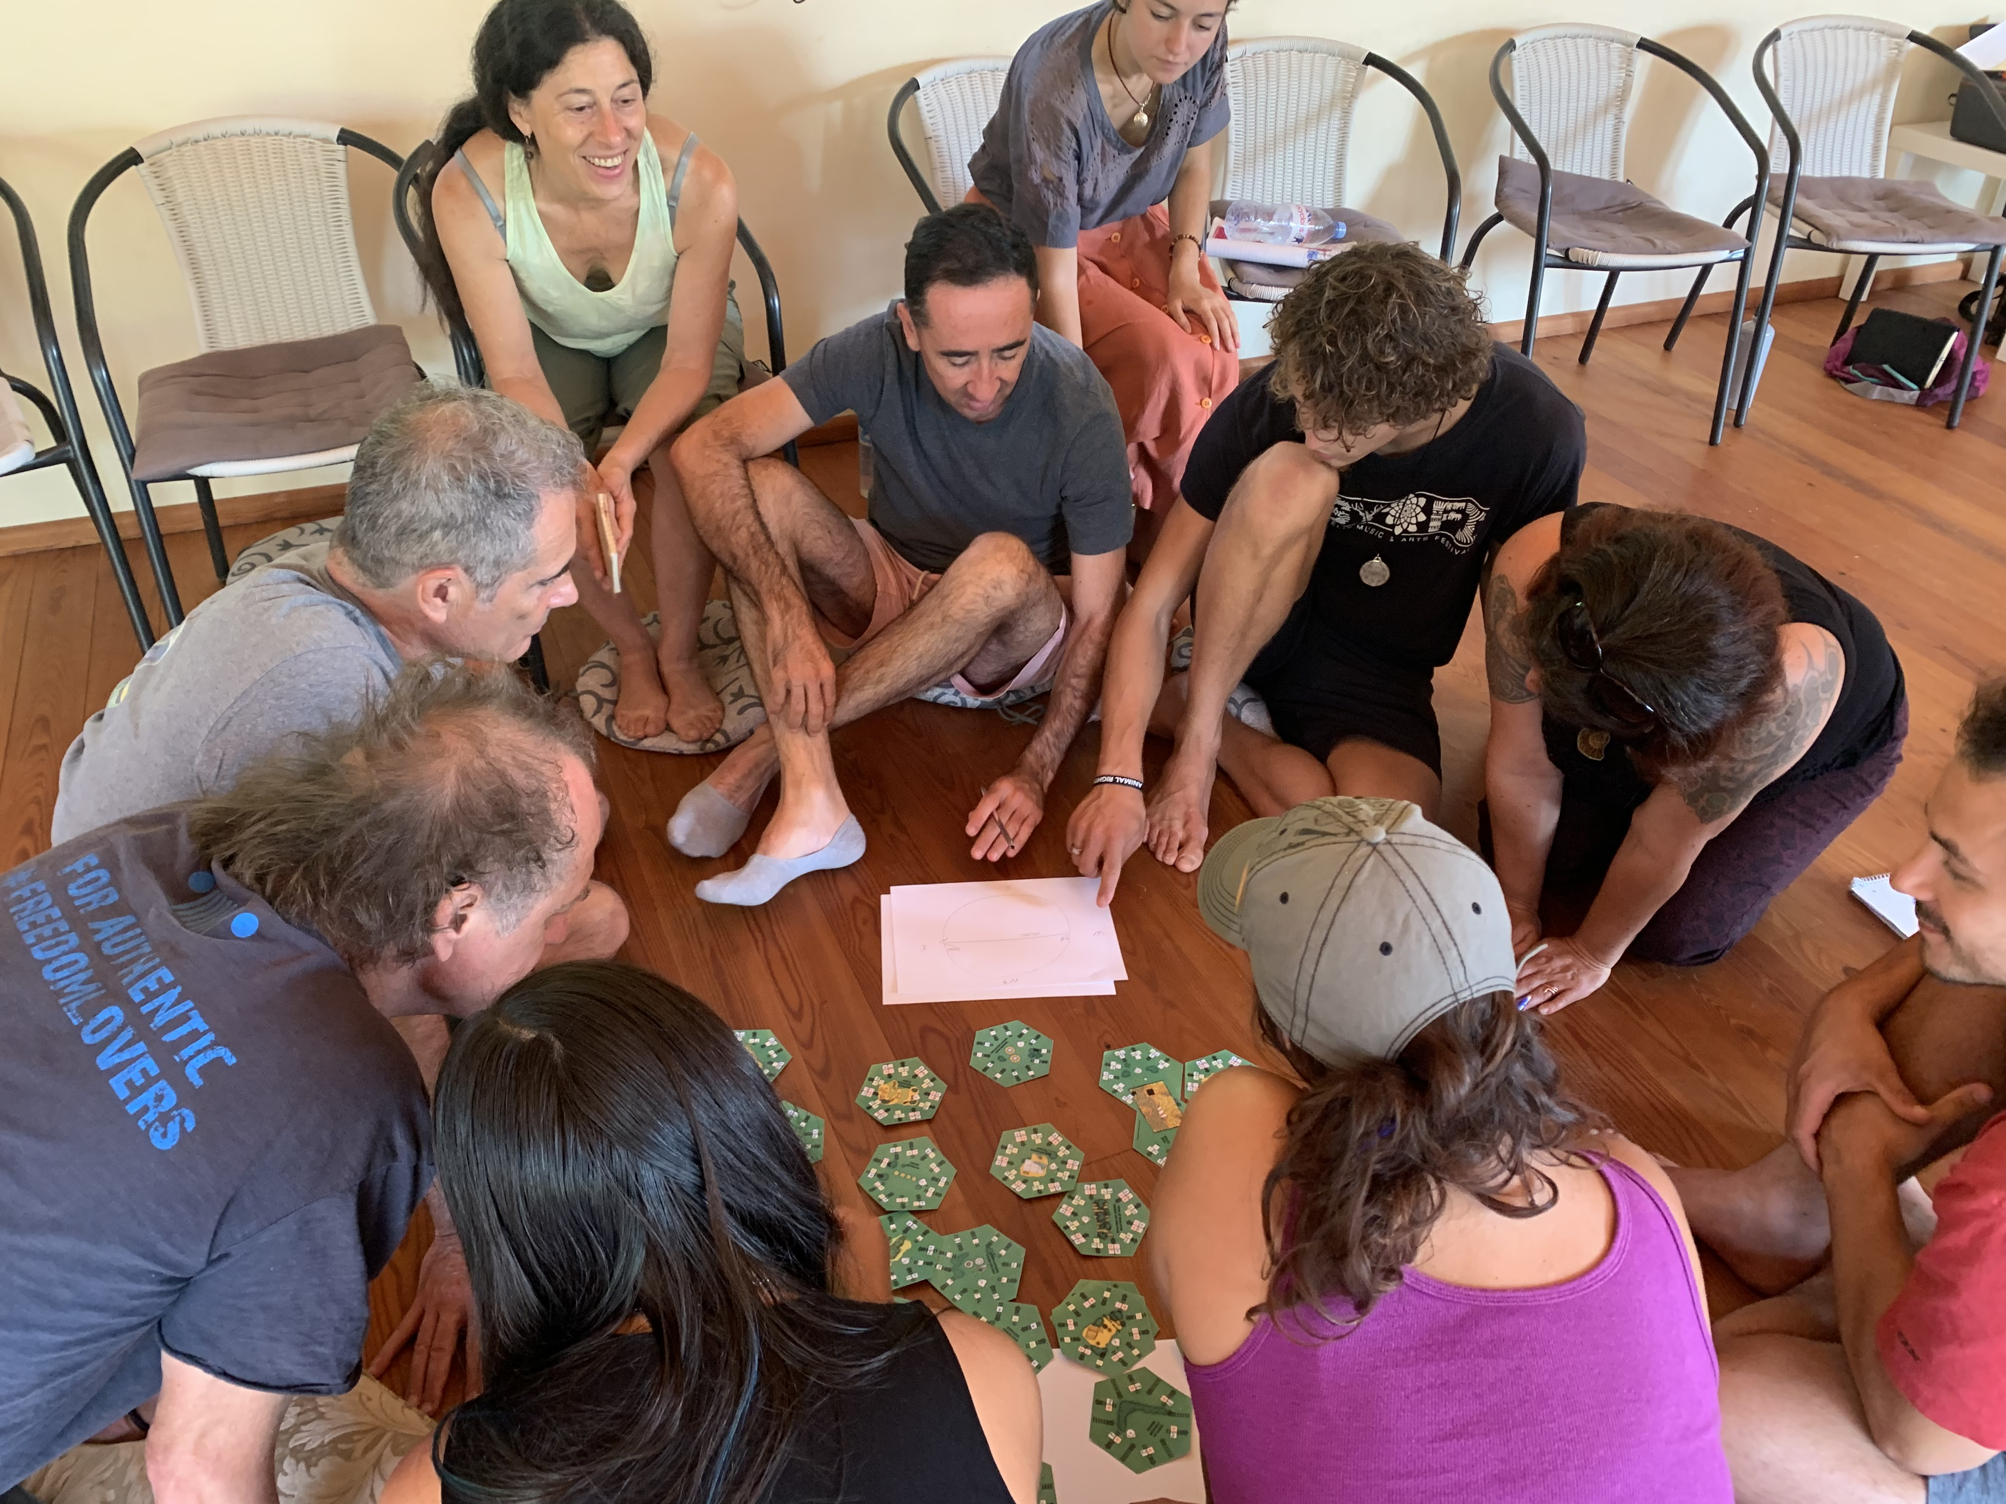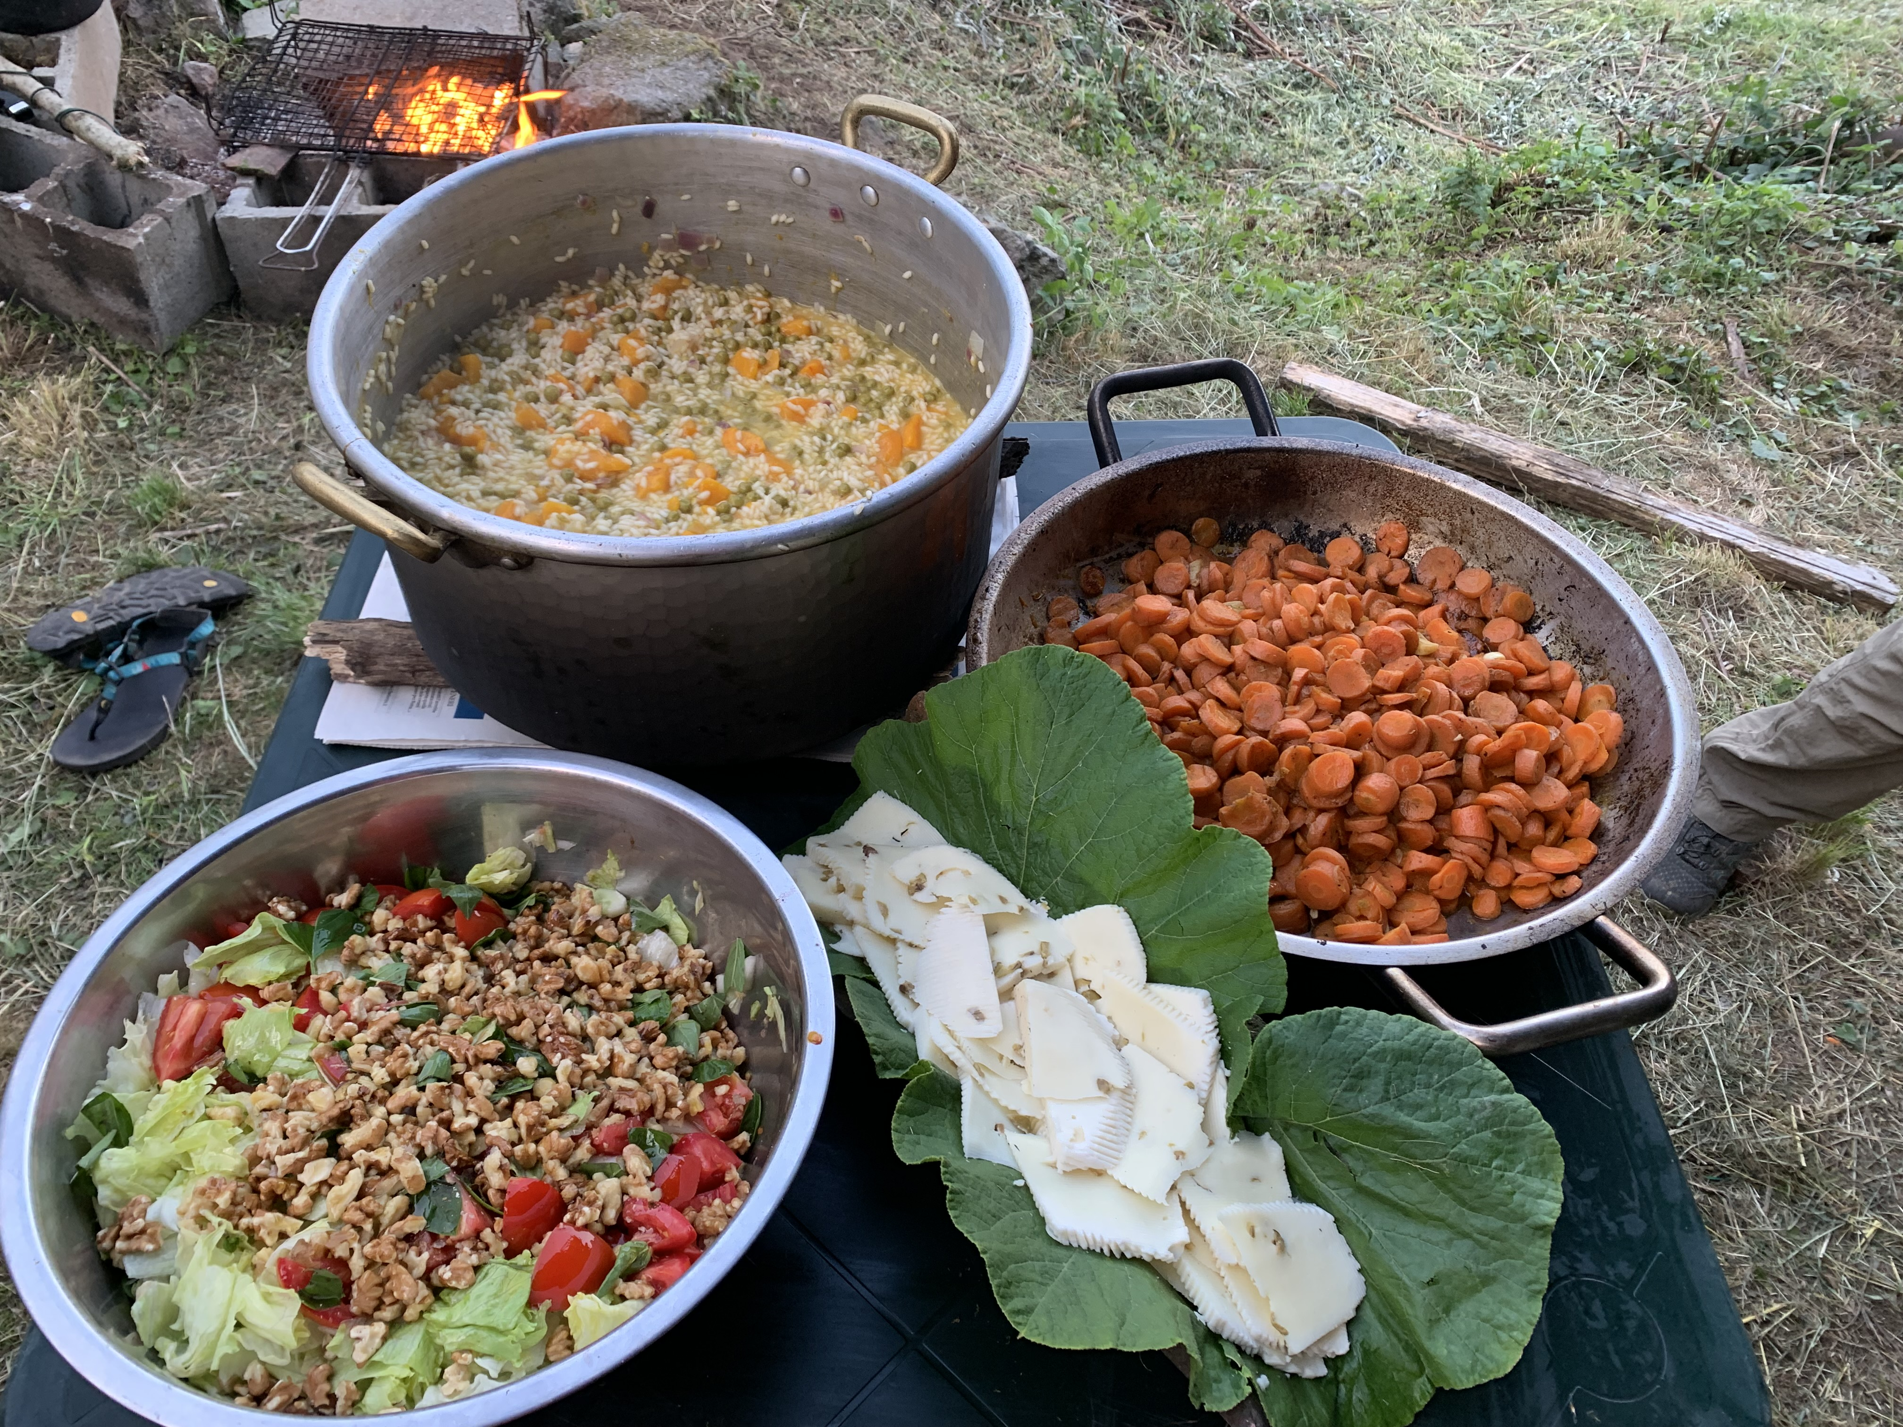
Summary of projects/activities participants intend to engage in, inspired by their attendance in the course (50 - 150 words):
A good number of the participants want to create ecovillages and learning and healing centres. We had a couple from Portugal with experience with elderly homes, that want to create and ecovillage-centre with space for birth and for death. One group is creating an ecovillage already in Italy adding other people that are interested. Also, the third project already has a space and is on its way. Many participants took the ToT with May East right after the EDE and want to join more courses by Gaia Education like the GEDS and some want to become relevant actors in the realm of change-makers in the world. They all want to be active and awaken more people to the urgency our world is facing in these turbulent times.
PARTICIPANT QUOTES: Send 3-4 participant quotes from the Gaia Education Evaluations or other sources, please include names and photos (send the photos as separate .jpeg files and properly captioned/named)
Quotes:
Marina

"Whether you want to design your own ecovillage, contribute to one, or plan a new project, this course will transform your way of thinking, acting and being with participatory sessions, concrete tools, and experiences that will enhance your ability to regenerate communities and ecosystems" (Marina, Italy)

Bram

“This course allowed me the further blossoming of my personal life, community life and left me with an amazing project that has the potential to further change my life.”(Bram, Netherlands)

"My heart, mind and soul expanded. This is not just an ecovillage design course, it's a life changing moment. Macaco is the best"(Catarina, Portugal)

Marco

"The EDE is helping me on my personal journey in building or finding a community. It provided me with helpful tools and knowledge. The group dynamics offer great insights about community life. The course was professionally managed and guided" (Marco, Switzerland)

Jetske

Words can't describe my journey through these weeks. My dream has birthed and collided with others' dreams. Magical. My life has been turned completely around in the most beautiful way. And this is just the start" (Jetske, Netherlands)

Alexandra

"Macaco is a world class teacher and person. It was an honor to learn from her. She gave every part of herself to make this course flow, it was inspiring!" (Alexandra, US)

