EDE Final Report Template

EDE Damanhur 2022
Dates: August 6 – September 3, 2022
Host site: Damanhur

- Course Overview: (150 - 300 words)
Brief explanation of the background of the organisation, host site. Diversity of participants and facilitators. Main highlights, key success factors and other relevant information that would describe what happened during the EDE. This text will appear at Gaia Education´s website to describe your programme.

This year we managed to run the 11th edition of the EDE at Damanhur, organized by the NGO Damanhur Education APS, in partnership with Gaia Education. the Global Ecovillage Network and Arca Tentyris APS, despite the small number of participants.
Founded in 1975 in northern Italy, Damanhur is a resilient Federation of Communities with its own constitution, culture, art, music, currency, schools and utilization of science and technology. It has about 600 full-time residents, plus 500 citizens in the world.
Damanhur is based on the vision of a new model for society based on solidarity, sharing, love and respect for the environment. For over 44 years, Damanhur has developed into a well organized eco-society in continuous change, though staying true to its foundational principles.
Damanhur also became well known in the world because of building the Temples of Humankind, an underground construction, a unique work of art dedicated to universal spirituality.
The EDE at Damanhur dives into the reality of the ecovillage and looks at the many concrete examples and experiences in all four dimensions present in the 48- year old community.
Starting with the Social Dimension in the first week, helps to create the learning community. Many exercises and dynamics build the vessel for the whole course, which is so important, because it creates a red thread and the fundaments on which the other dimensions can unfold at their best. Many powerful exercises allow the participants to get awareness about themselves and the others, starting with sharing life stories. The dynamics are the basis to becoming a life changing experience for many. Some of the highlights of this dimension this year as well as in the former years were the sessions around conflict and leadership.
The Temples of Humankind are always an inspiring experience, hands-on straw-bale building and art sessions bring out the creativity and a community building experiment in the woods is a huge boost for the group, all of them highlights also of the other dimensions.
The Economic Dimension talks about macro and micro economy and uses the example of Damanhur, the hosting community, to demonstrate different economic models, to show aspects of a new economy, as well as how a more just economy can be created. Concrete examples also show the challenges a community has to face and how they can be tackled.
This year our EDE was pretty small, also because of the Visa situation, which did not allow a big group from different countries from Africa to arrive, so we had mainly participants from Europe, the USA and Latin America . There were 11 people from 10 different countries in the group, as some people had multiple backgrounds. People were coming from Holland, Hong Kong, Italy, Usa, Portugal, France, Columbia, Mexico, Germany and Great Britain.
Someone from the EDE Online Live that I held with my dear friend Taisa Mattos on the GEN platform took the chance to also have an in-person experience.
We are living in years of general awakening, so we have observed that every year the participants start already with an always higher level of information and knowledge in the four dimensions of sustainability. With a deep wish to engage, learn and transform themselves the group went really deep, creating the life changing processes, that continue to nourish the participants also after the course when they go back to their everyday life.
Most of the facilitators were from Damanhur, and all were experienced EDE teachers with many years of expertise.

- Participants: (50 - 150 words)
(Basic stats including numbers of participants, age range, gender ratio, countries, ethnicities and backgrounds)
This year our EDE was pretty small, also because of the Visa situation, which did not allow a big group from different countries from Africa to arrive, so we had mainly participants from Europe, the USA and Latin America . There were 11 people from 10 different countries in the group, as some people had multiple backgrounds. People were coming from Holland, Hong Kong, Italy, Usa, Portugal, France, Columbia, Mexico, Germany and Great Britain.

Someone from the EDE Online Live that I held with my dear friend Taisa Mattos on the GEN platform took the chance to also have an in-person experience.

The gender balance was 7 women and 3 men, the ages ranged from 24 to 72, and many participants were under 30 or between 30 and 40 years of age.

We are living in years of general awakening, so we have observed that every year the participants start already with an always higher level of information and knowledge in the four dimensions of sustainability before hand. With a deep wish to engage, learn and transform themselves the group went really deep, creating the life changing processes, that continue to nourish the participants also after the course when they go back to their everyday life.

- Course rhythms: (50 - 150 words):
(A description of the times of daily activities, sessions, free time, social time, interaction with hosts, rest; how many hours in lectures & practical sessions,etc.)
In the morning before breakfast, yoga and meditation sessions were offered by the participants, followed by breakfast from 8:00 - 9:00.
The morning session was from 9.15 - 12:30, lunch at 13:00, break until 15:00.
The afternoon session was from 15:00 - 18:00, dinner at 18:30, break until 20:00. The evening program was from 20:00 - 21:30.
The program varies a lot, but there are some basic patterns. Usually the morning begins with some kind of sharing, followed by a theoretical part. After the theoretical part, there is often the design part, which continues throughout the entire course. The weeks of the four dimensions are different, as the ecological part also has hands-on sessions. There is art in the worldview dimension, and a community building experiment for the social dimension. There are several moments to contact the hosting community, in addition to the initial visit, such as a dinner in a Damanhurian nucleo community and hanging out the Damanhur Crea, the central place of Damanhur, where the community members meet. There are several free evenings, every week at least one free afternoon and one completely free day.

- Highlights & challenges of each dimension:

Social (150 - 250 words): What happened in this dimension? What were the highlights? What subjects were covered? 1-2 participant quotes from the Gaia Education Evaluations or other sources. A sentence on each core faculty/facilitator.
The Social Dimension takes place in the first week of our EDE. The first week creates community and a very high frequency for the whole course. Through the many exercises and processes experienced in this week a really strong community feeling is created since the beginning. Most participants had life changing experiences during the Social Dimension. The highlights were similar to the previous years: the sessions about leadership presence, conflict resolution, governance and decision making and most of all the community building experiment in the woods. These intensive processes mixed with lot’s of fun helped the participants to learn so much about themselves and how they are part of creating the group.
The community building experience in the woods was particularly pleasant and allowed the participants to experience leadership and decision making, to work on personal growth, and to understand what it means to think as a group even in a different environment.
The contact with the hosting community is also very important, because the participants get a taste of community life. The participants are invited to have dinner in a nucleo (smaller communities from 12-25 people) and to hang out at the Damanhur Crea to meet with the Damanhurian community.
Macaco Tamerice facilitated the Social and Worldview Dimensions, and she co-facilitated the Ecological and Economic Dimensions. She has 29 years of expertise in community living and her ability to guiding groups and group processes lead the group through intense personal and group processes and games.
Formica Coriandolo co-facilitated the Worldview Dimension using art as a tool to self-exploration and bringing energy and warmth. Formica has 39 years of community expertise and is one of Damanhur’s artists.
Quotes: “My favorite dimension was the Social dimension! I am more ready than ever to step into collaboration on regenerative projects now that I have tools for communication, governance and conflict resolution”
“I love the social dimension, all that involves art, non violent communication, empathy, conflict resolution.”
“The commitment to collaborative governance, communication, and conflict resolution is key”

Include 2-3 pictures.
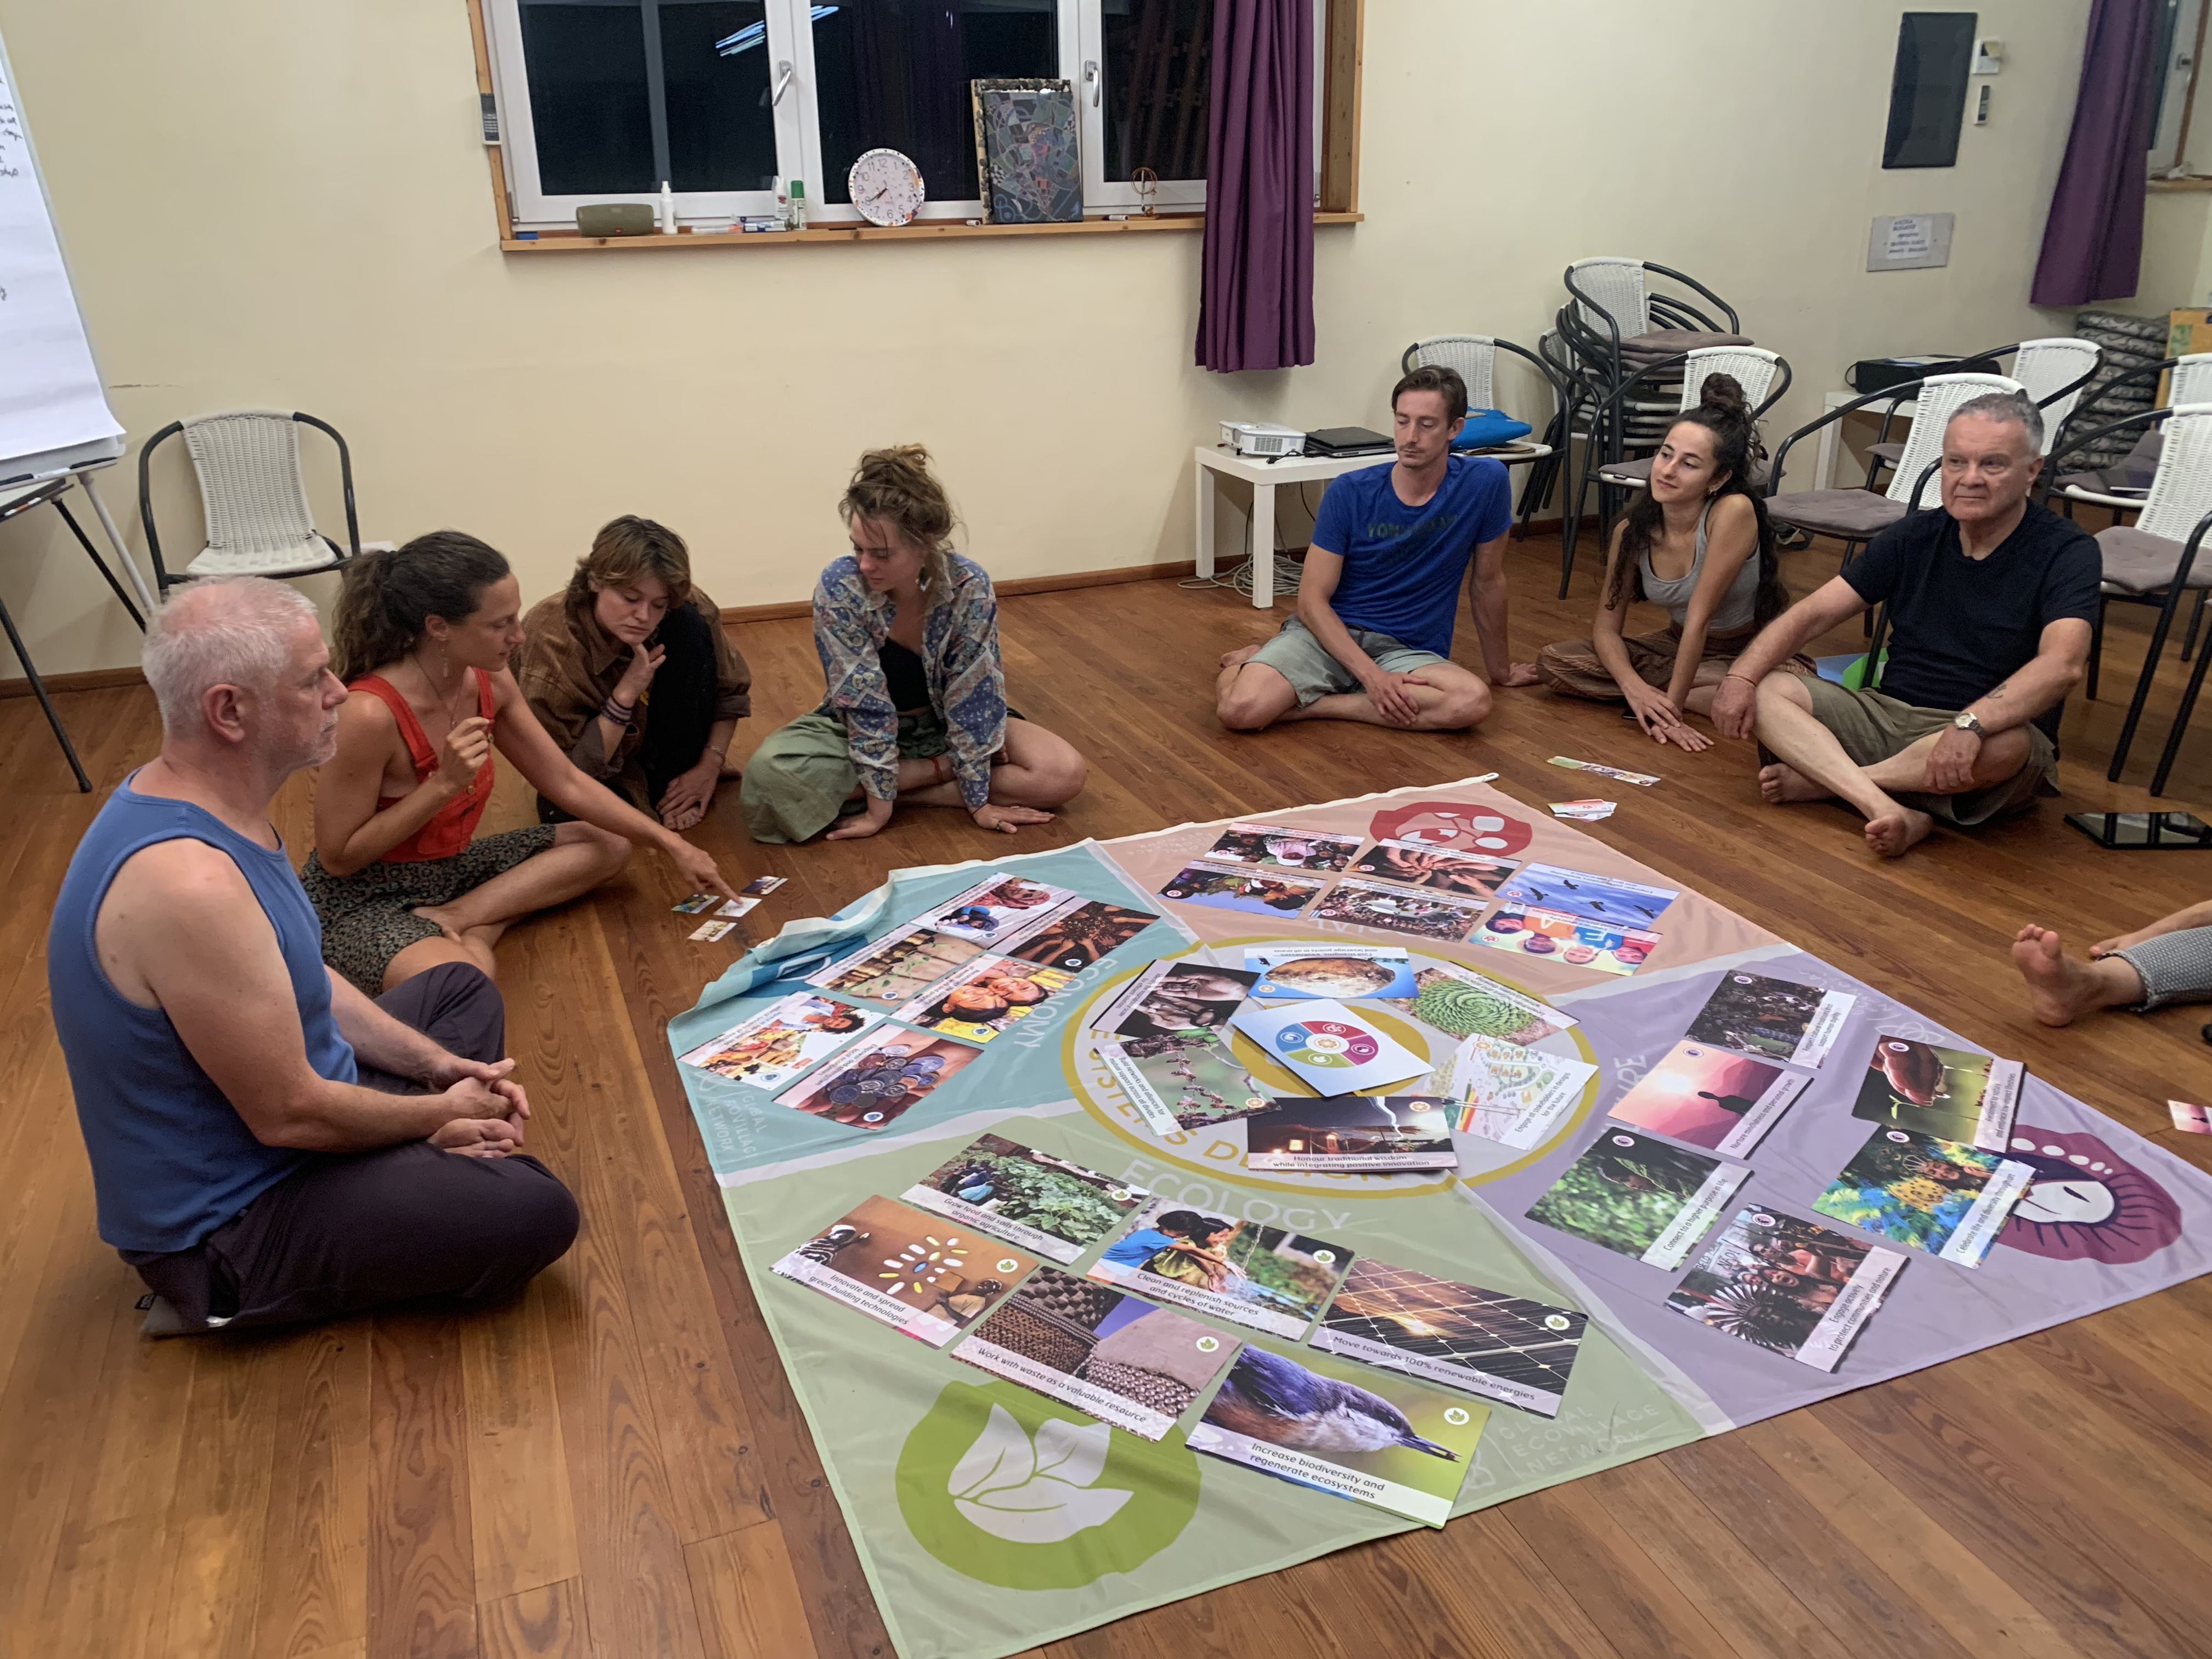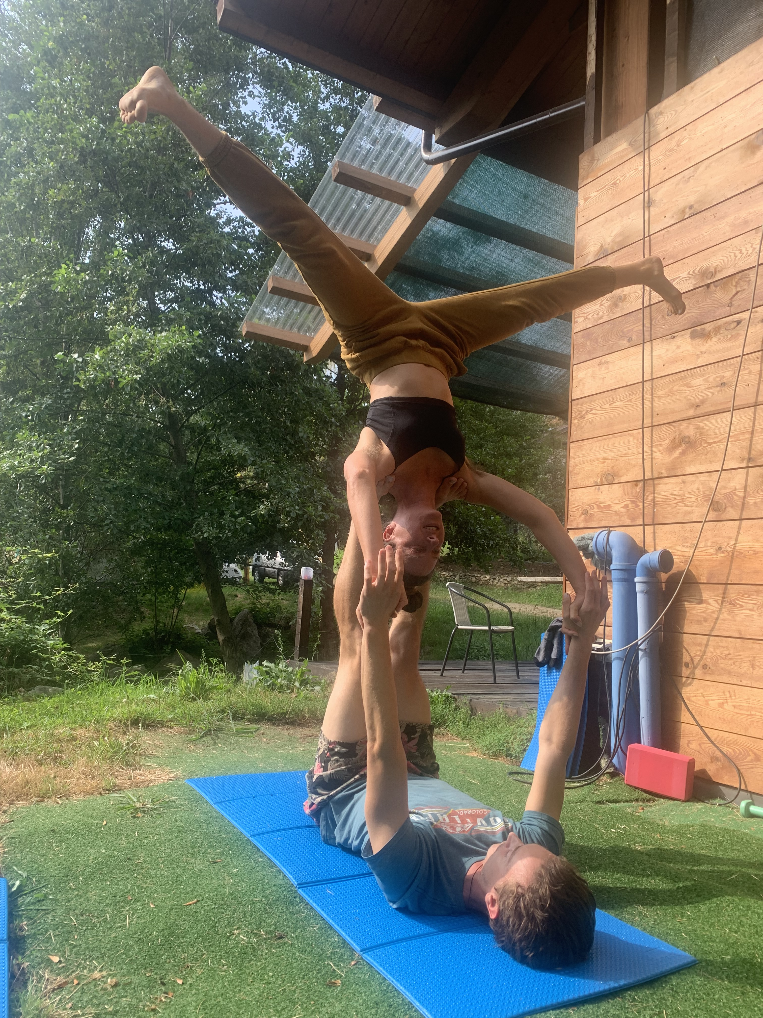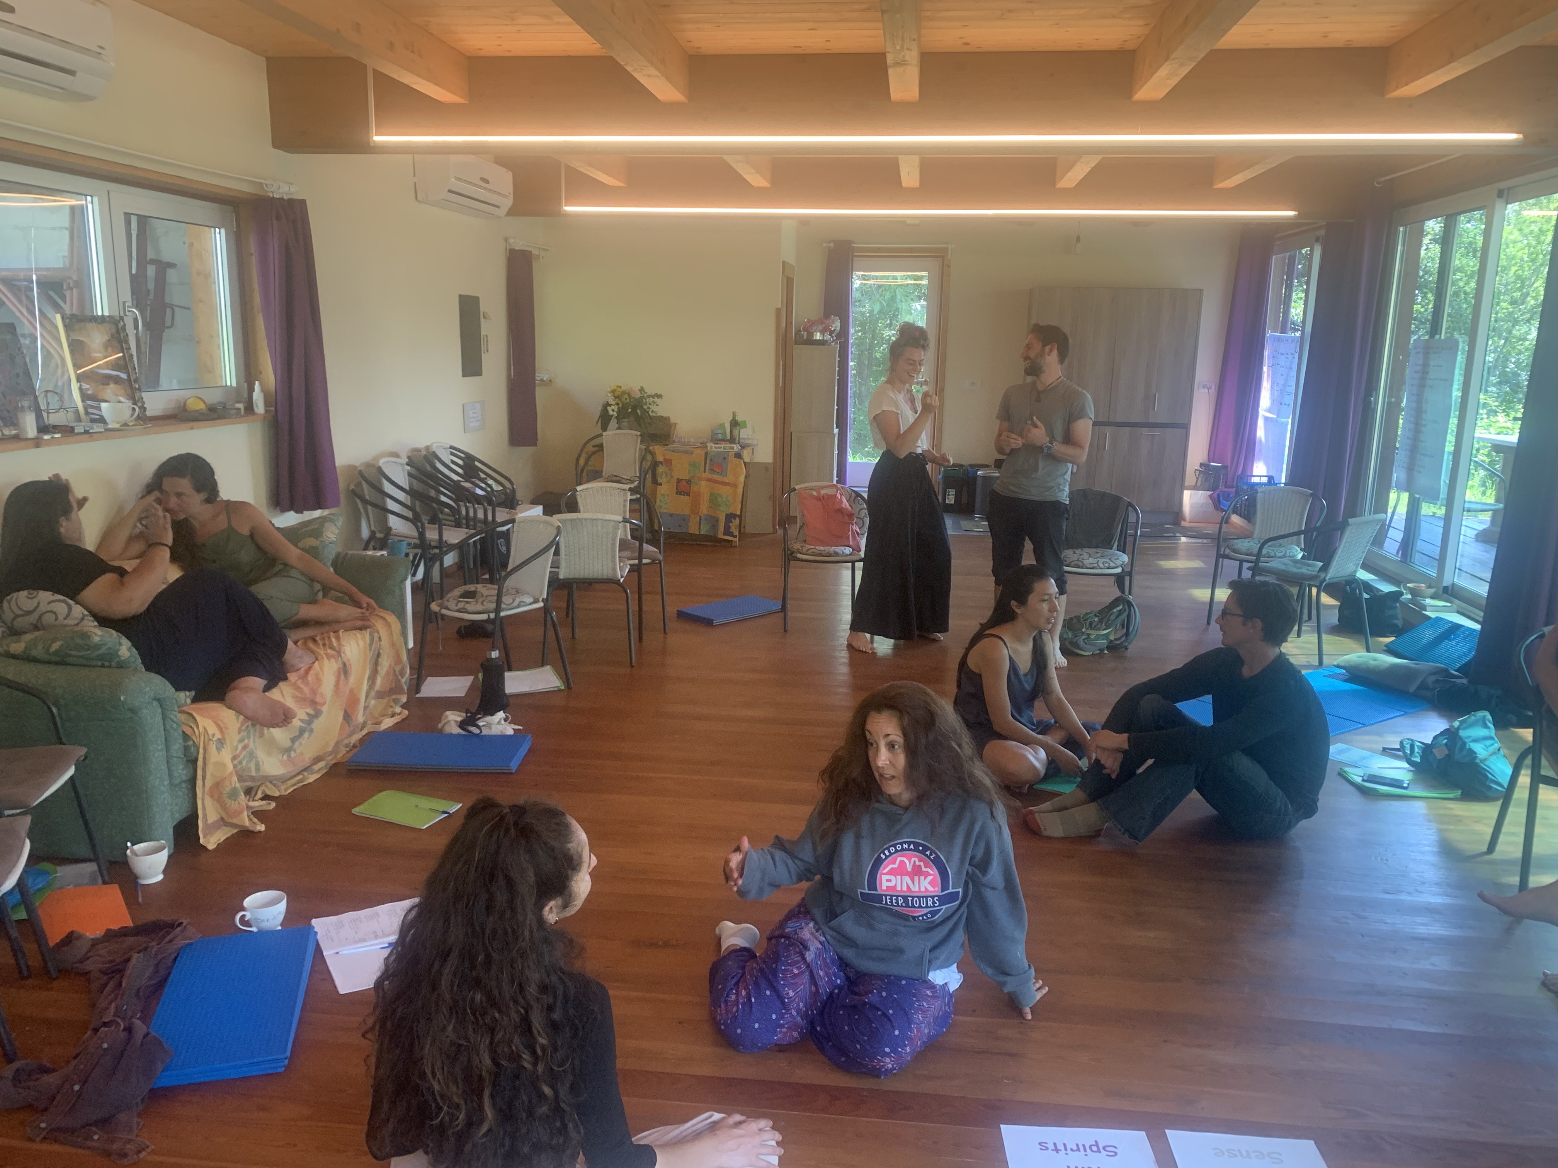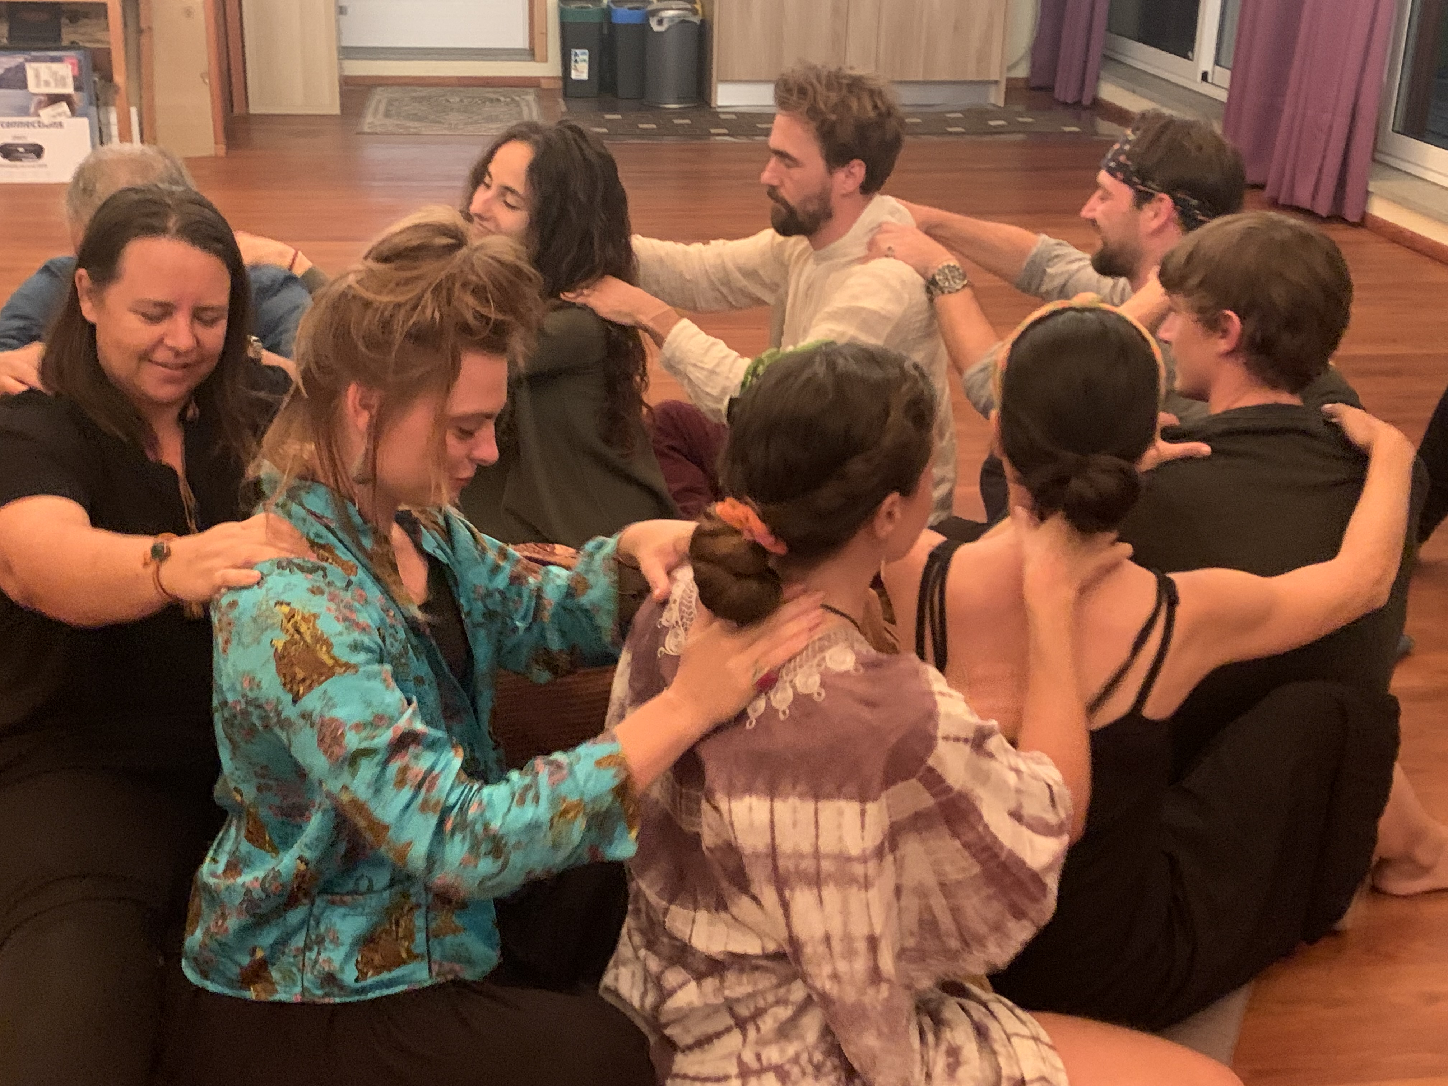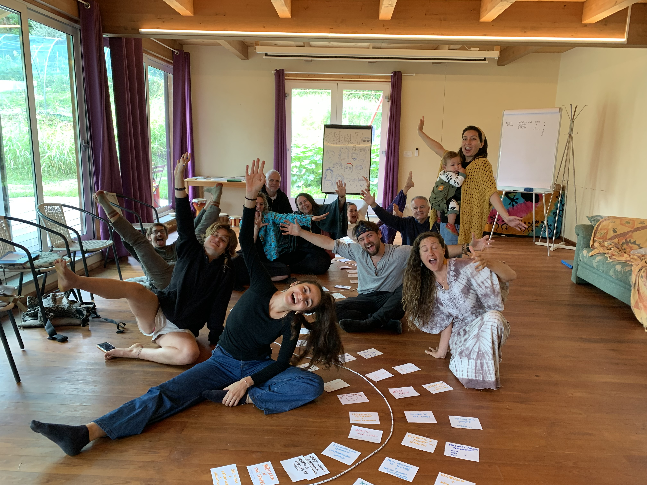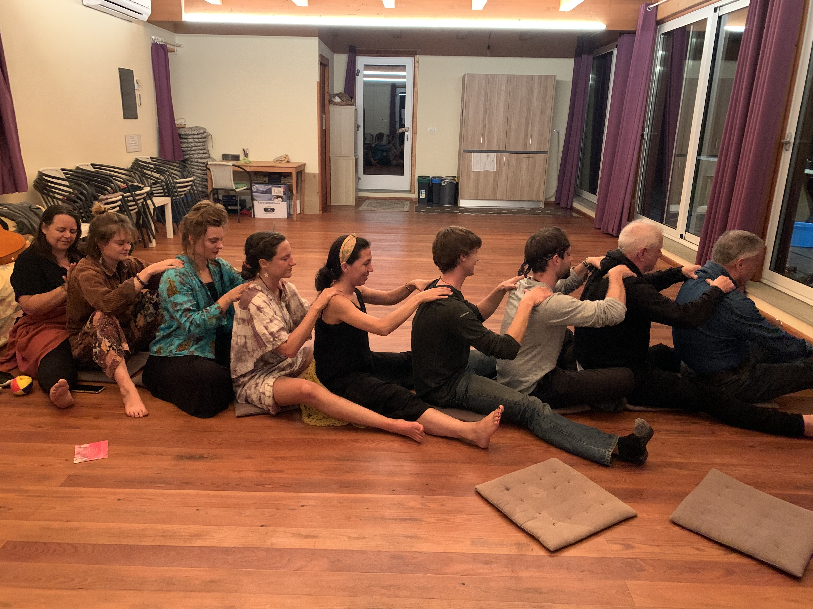

Economic (150 - 250 words): What happened in this dimension? What were the highlights? What topics were covered? What practical activities were performed? 2-3 participant quotes from the Gaia Education Evaluations or other sources. A sentence on each core faculty/facilitator. Any other information that you consider relevant.
The Economic Dimension explained about the ownership of money, macro-micro economy and helped the participants explore possible alternatives to an unfair economic system. It also looked at new models through concrete examples. This Dimension explored complementary currencies and local economy and looked at how these aspects are related to a new way of looking at economy. Solidarity as one of the key elements for a regenerative future helped understanding, that if you want to measure richness there are many more forms of richness than just money.
Damanhur, as the hosting community, demonstrated concrete alternatives and many different aspects of a new economy, and how a more just economy can be created in a community inspired by solidarity. Some very concrete economic tools like the balance point and a business plan were explored too.
Lemming Cactus was the main facilitator of the Economic Dimension which he lead with professional expertise and know-how.

Quotes:
“ I learned that there is the possibility to create your own economic world and that it is possible to leave the system in a more free way”
“I really enjoyed meditating on how much we can personally contribute to our dream projects and using that info in our group project”
“So good to learn how to make a budget and where the money are coming from”

Include 2-3 pictures.
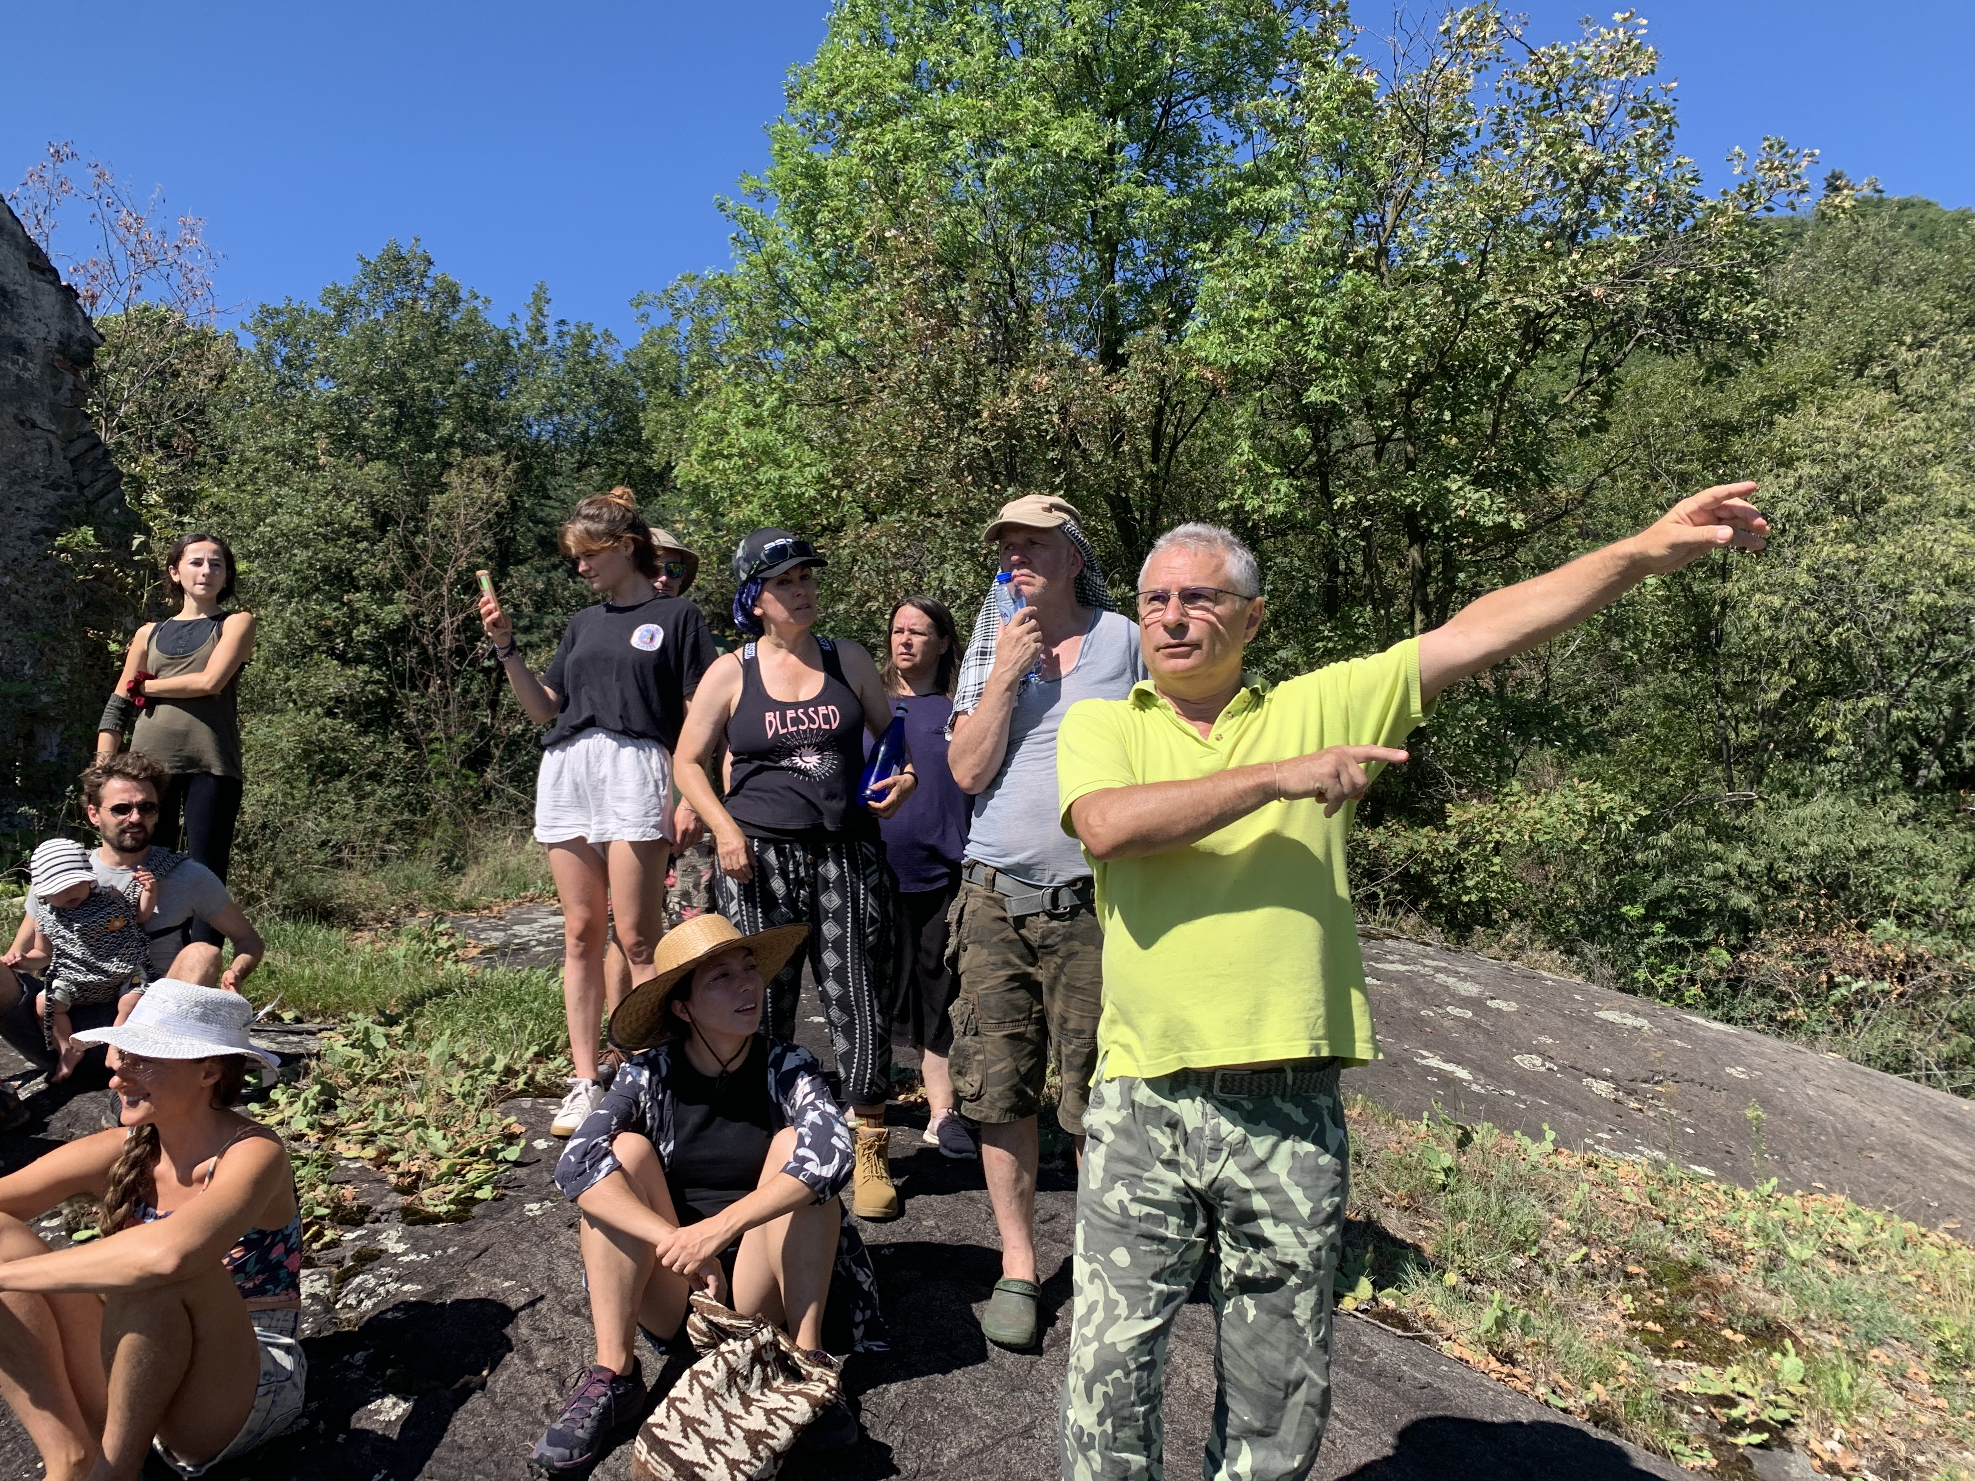
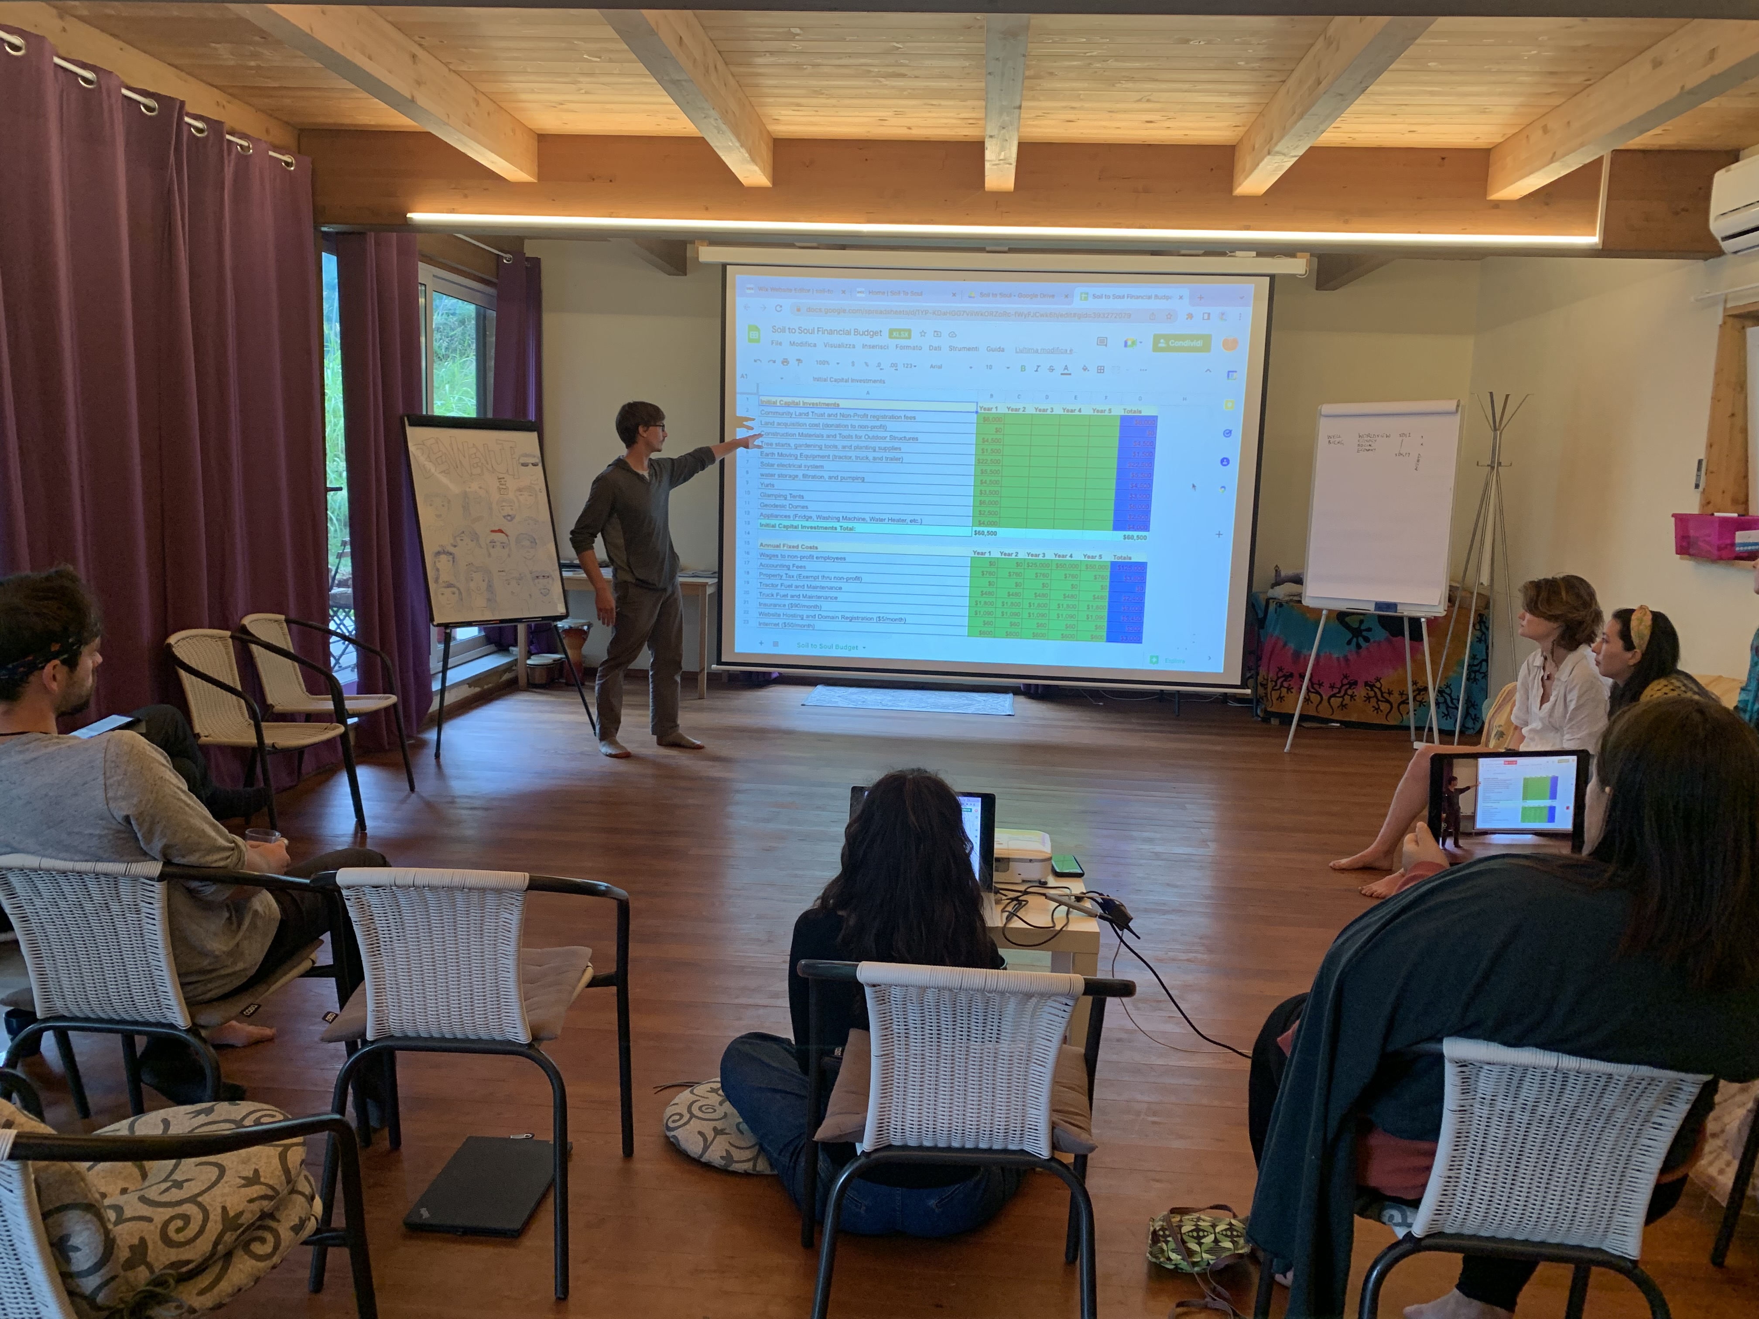
Ecological (150 - 250 words): What happened in this dimension? What were the highlights? What topics were covered? What practical activities were performed? 2-3 participant quotes from the Gaia Education Evaluations or other sources. A sentence on each core faculty/facilitator. Any other information that you consider relevant.
In the Ecological Dimension, the participants had several sessions to get to know permaculture design. They also learned about growing organic food, water and wastewater treatments, green building and retrofitting, alternative energy and about appropriate technology.
Our Ecology Dimension has a big part of hand’s-on and the highlight of this session was the experience of straw-bale building and the creating of a warm bed in one of the nucleos. The introduction to permaculture and designing with permaculture principles gave good insights to different design methods. Also, visiting places in the hosting community where various technologies had already been successfully implemented showed the practical application of the theory.
The participants had lots of fun with strawbale building and enjoyed applying the permaculture principles directly. Also, the visit to the damanhurian organic farm that produces food for the whole community and the community’s organic shop was highly appreciated.
Marco Aicardi facilitated the permaculture program, awakening an interest in permaculture design and best practices.
Inti China led the sessions about alternative building and the hands-on straw-bale building, showing how to use different tools and methods.
Quotes:
“We had fun working in the field with straw bales, cob, gardening tools, and the other hands-on learning aspects”
“ We learned about Huglculture, strawbale building, renewable energy, so much knowledge!”
“Exciting to experiment and understand the possibilities of bioconstruction”
Include 2-3 pictures. 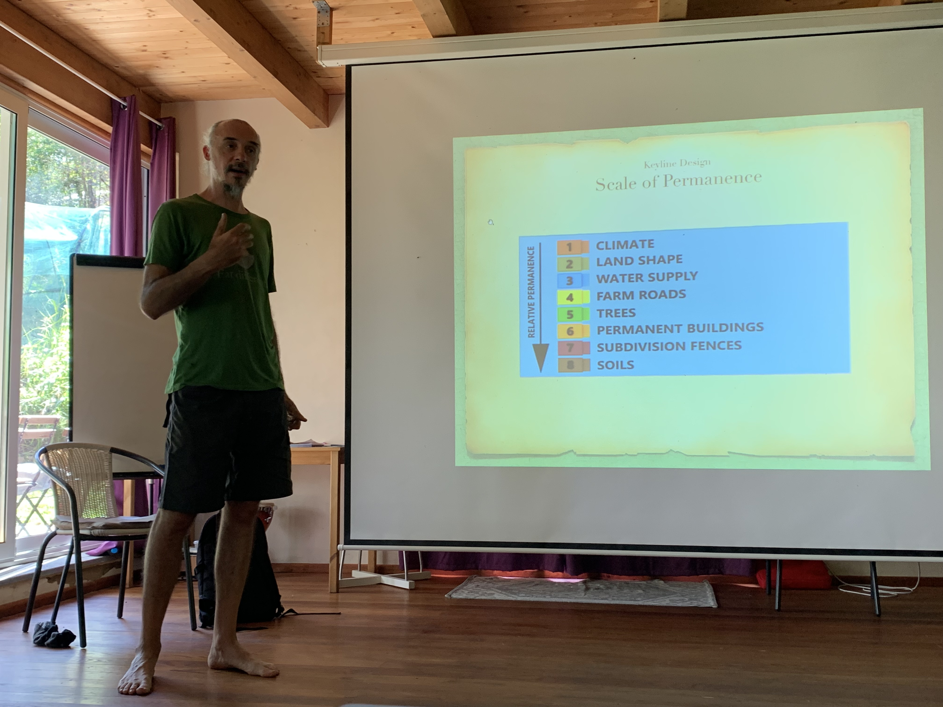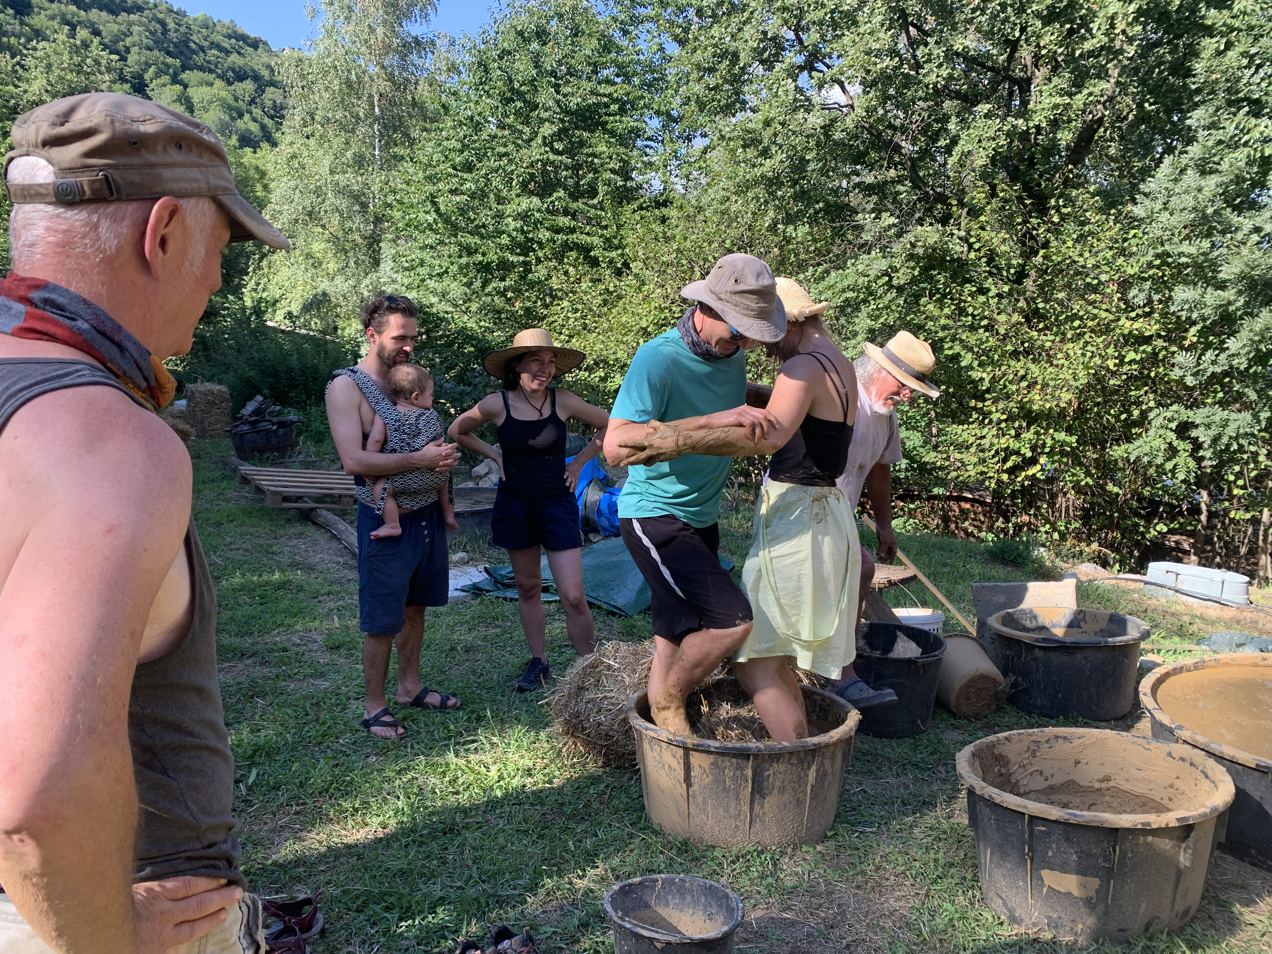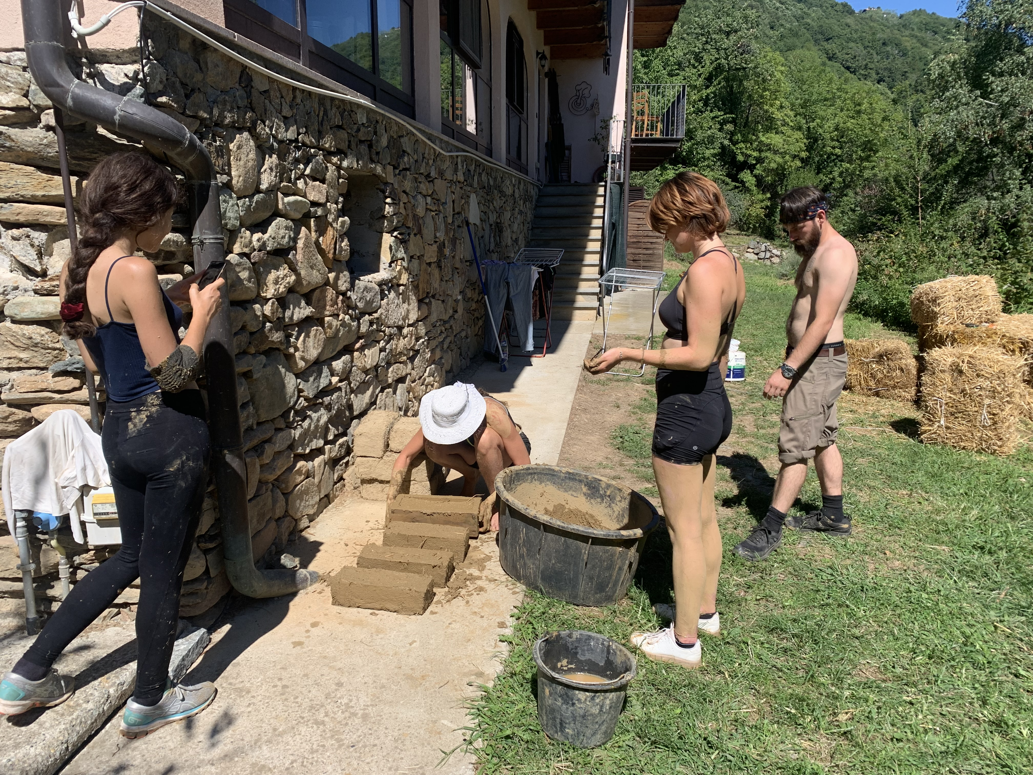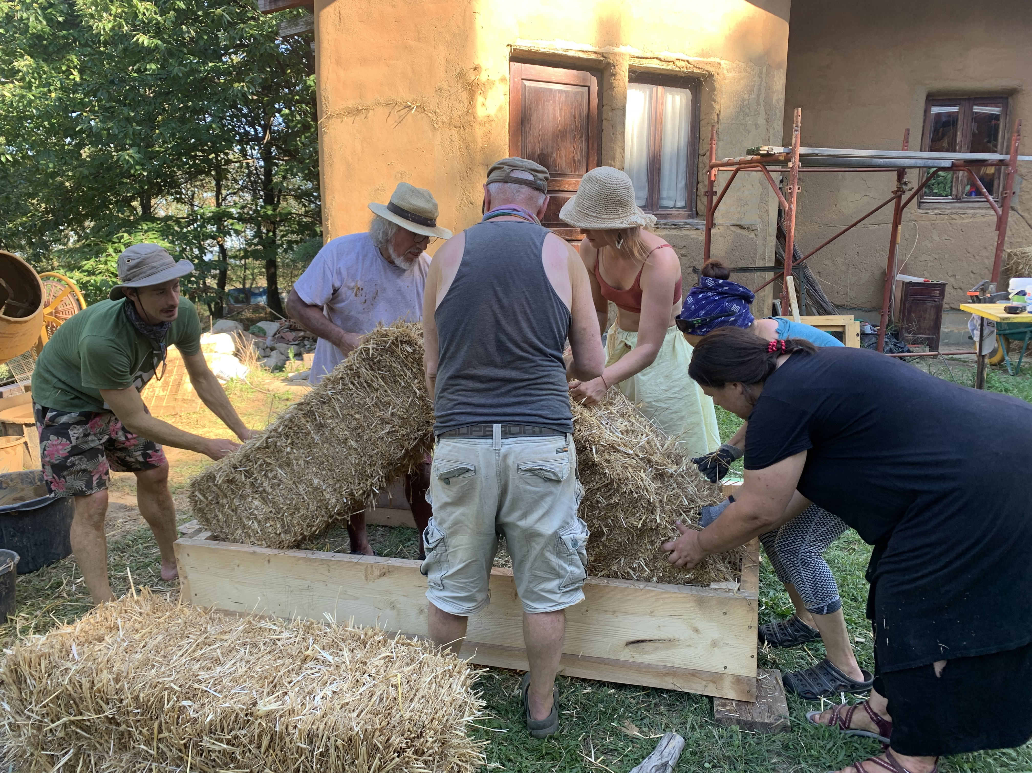
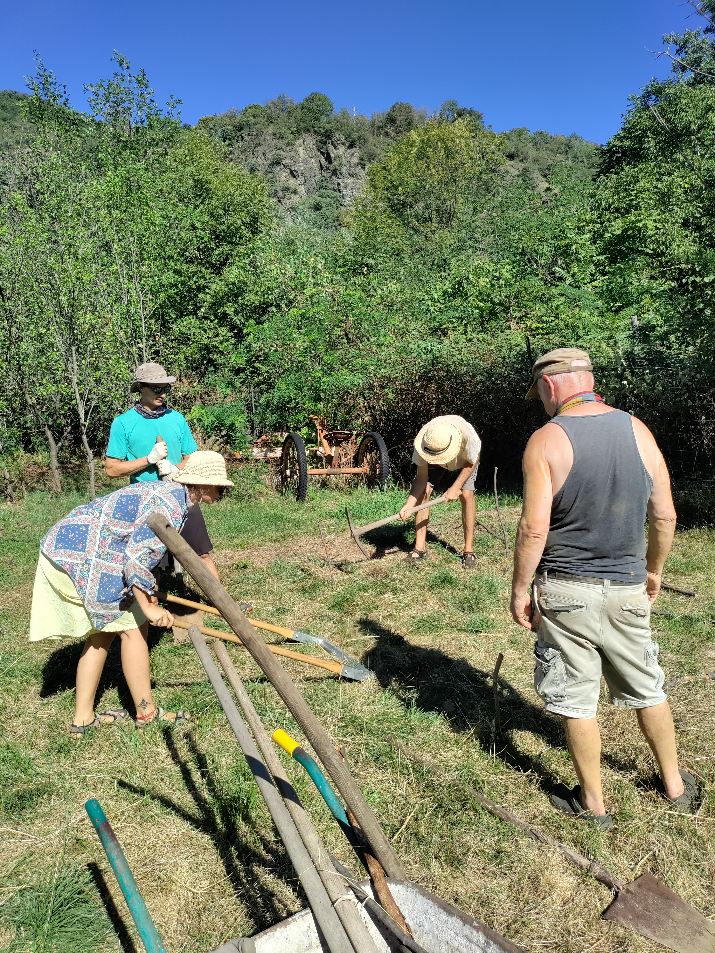

Worldview (150 - 250 words): What happened in this dimension? What were the highlights? What topics were covered? What practical activities were performed? 2-3 participant quotes from the Gaia Education Evaluations or other sources. A sentence on each core faculty/facilitator. Any other information that you consider relevant.
The Worldview Dimension is another really touching part of the EDE. It allowed the participants to experience their artistic and expressive abilities, to connect deeply to nature and to visit the Temples of Humankind. They also participated in a meditation in the Temples, which also this year was a highlight of this Dimension. The participants had an introduction to Spiral Dynamics with some exercises, to understand about human evolutionary steps inside ourselves and as a society. A beautiful sharing about worldviews was enriching for all. A detailed introduction to Sociocracy with some exercises gave inputs about more inclusive ways of governance.
A session about health helped understand how different approaches to health can happily coexist and be applied in a community.
Connecting to Nature is always a particularly appreciated session. There are exercises from Deep Ecology and from Damanhur and the session was perceived as an important highlight of this Dimension. The experience the participants made during this session created a deep connection with nature and with ourselves as being part of nature.
Macaco Tamerice led the Worldview sessions from Spiral Dynamics, personal transformation and connection with nature, to moving toward an understanding of collective intelligence.
Formica Coriandolo held the art workshop with sensitivity and support, bringing out the artist that lies in everyone and understanding the meaning of creating art together.
Quotes:
“I love the world view, the spiritual side and higher purpose. Interbeing and the connection between all the dimensions.”
“I’m so impressed by connecting with nature and larger social/societal patterns (frameworks)”
“ It’s so important to understand how diverse we see the world and yet can create a common vision and goal”
Include 2-3 pictures.
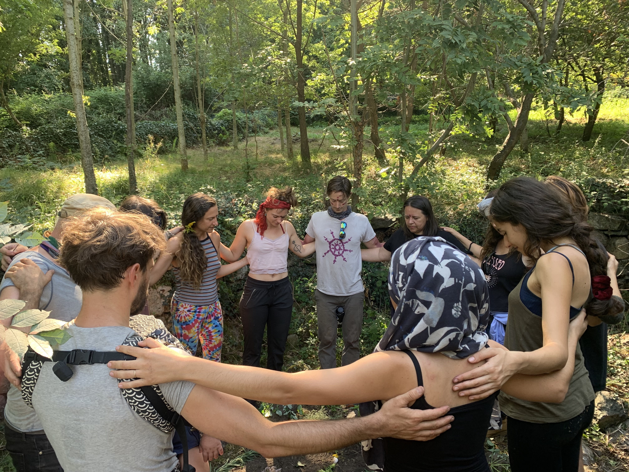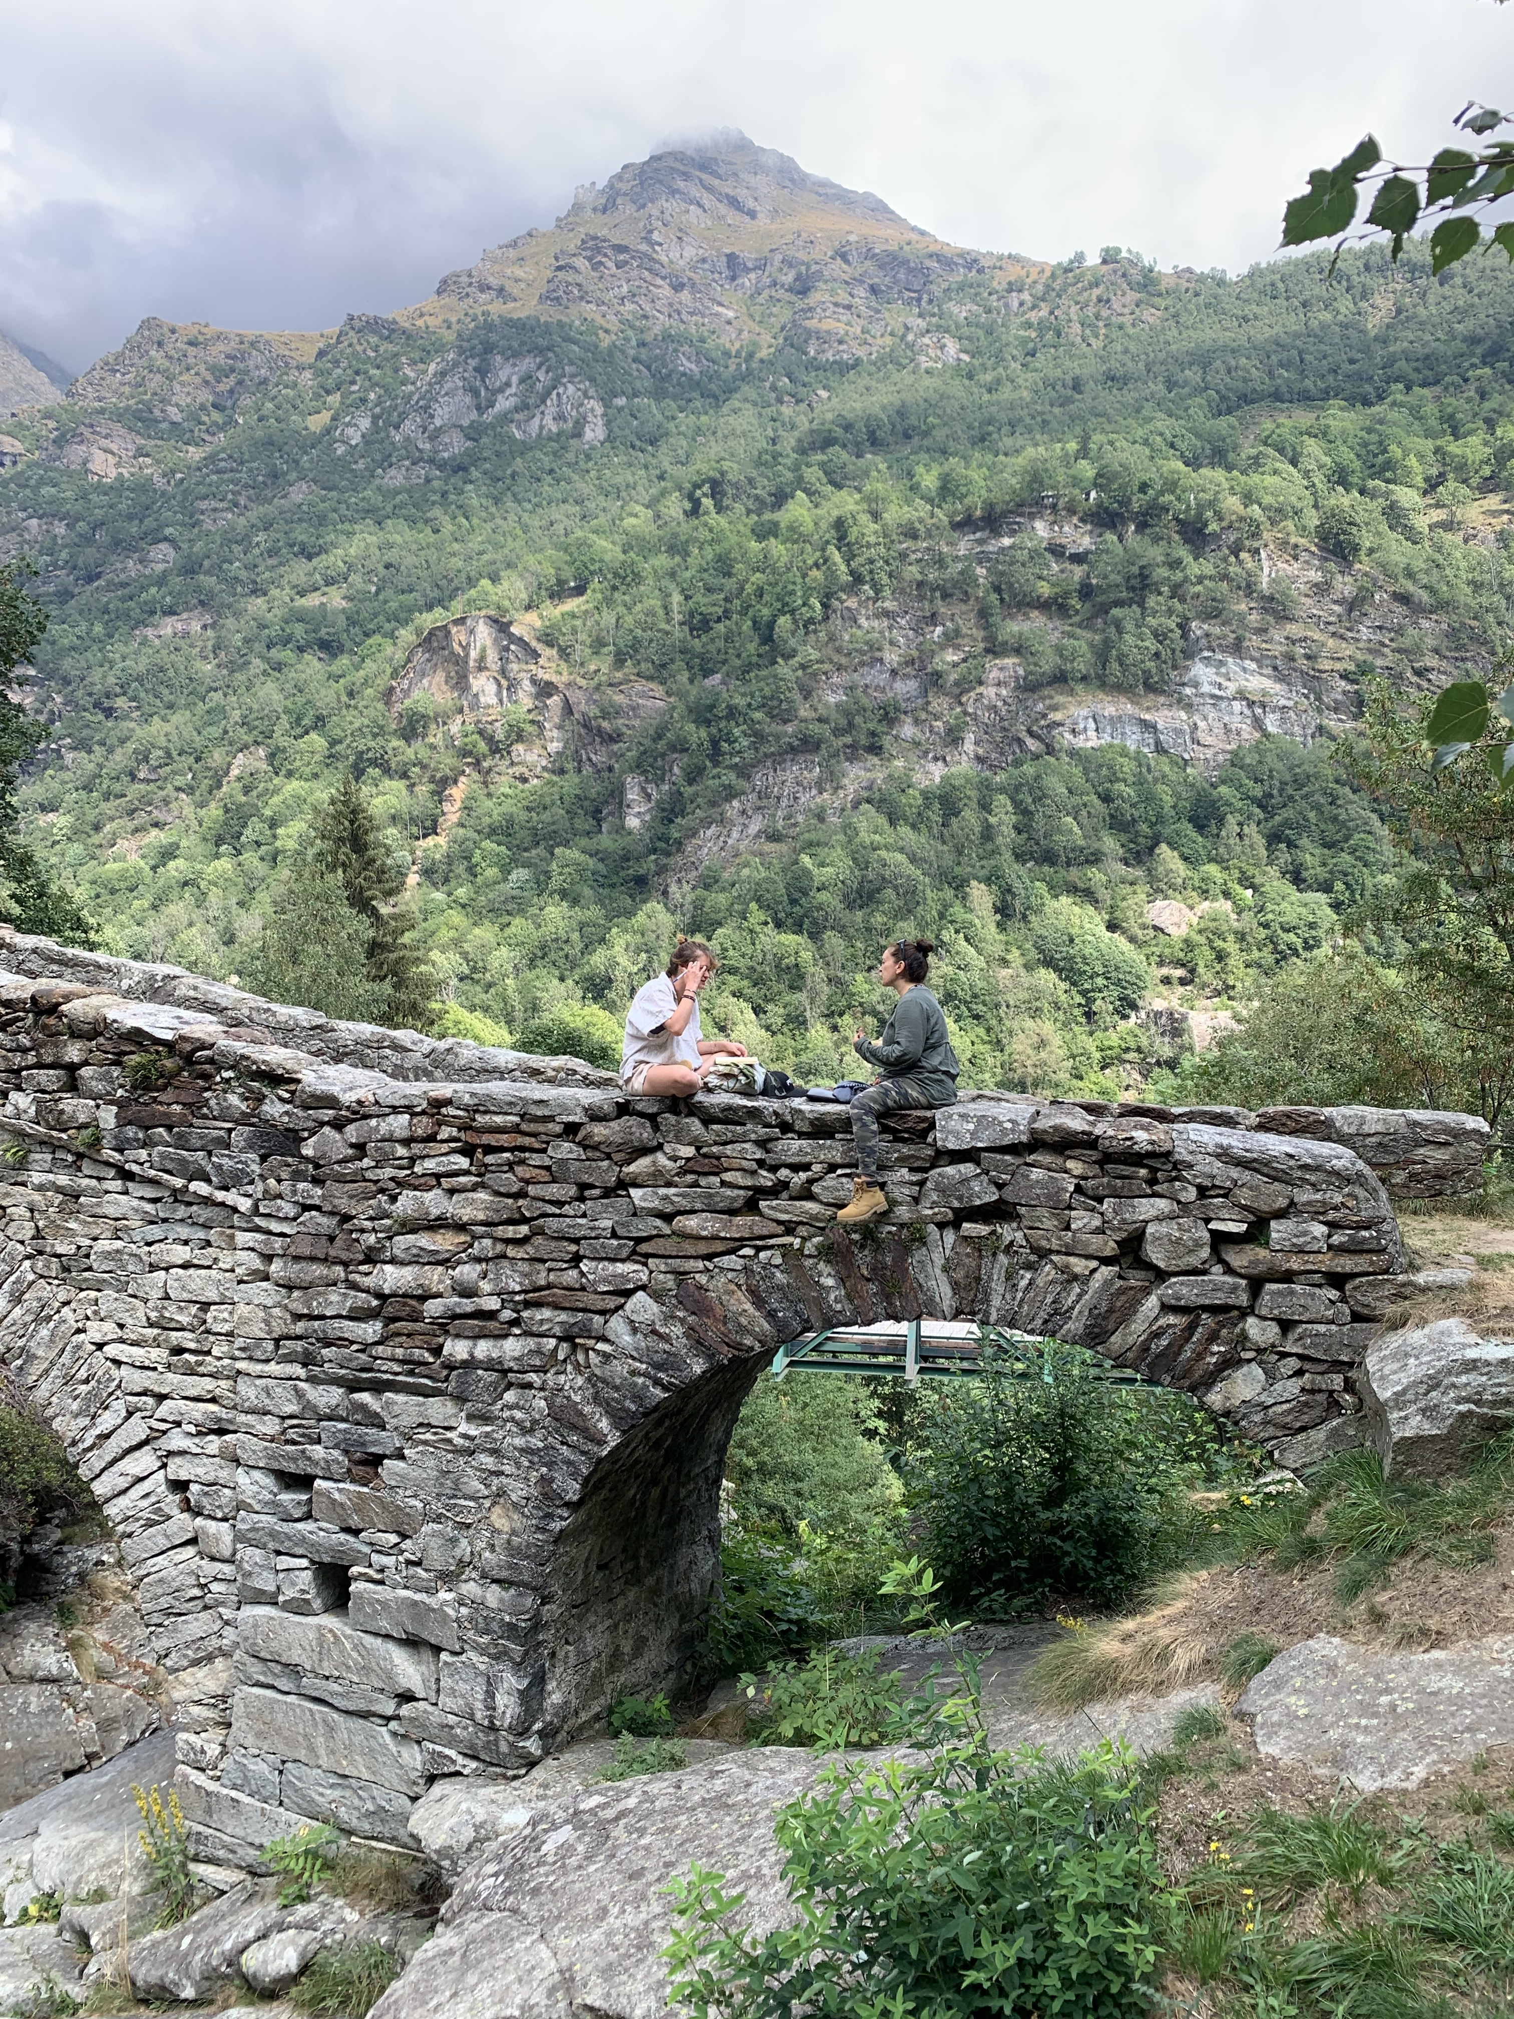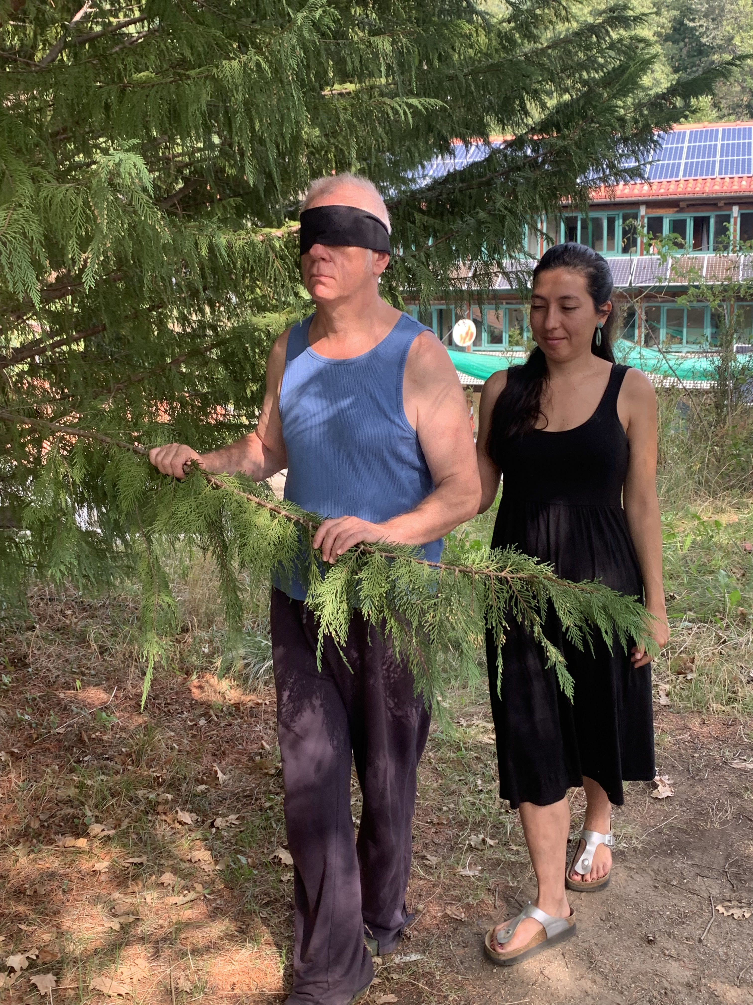
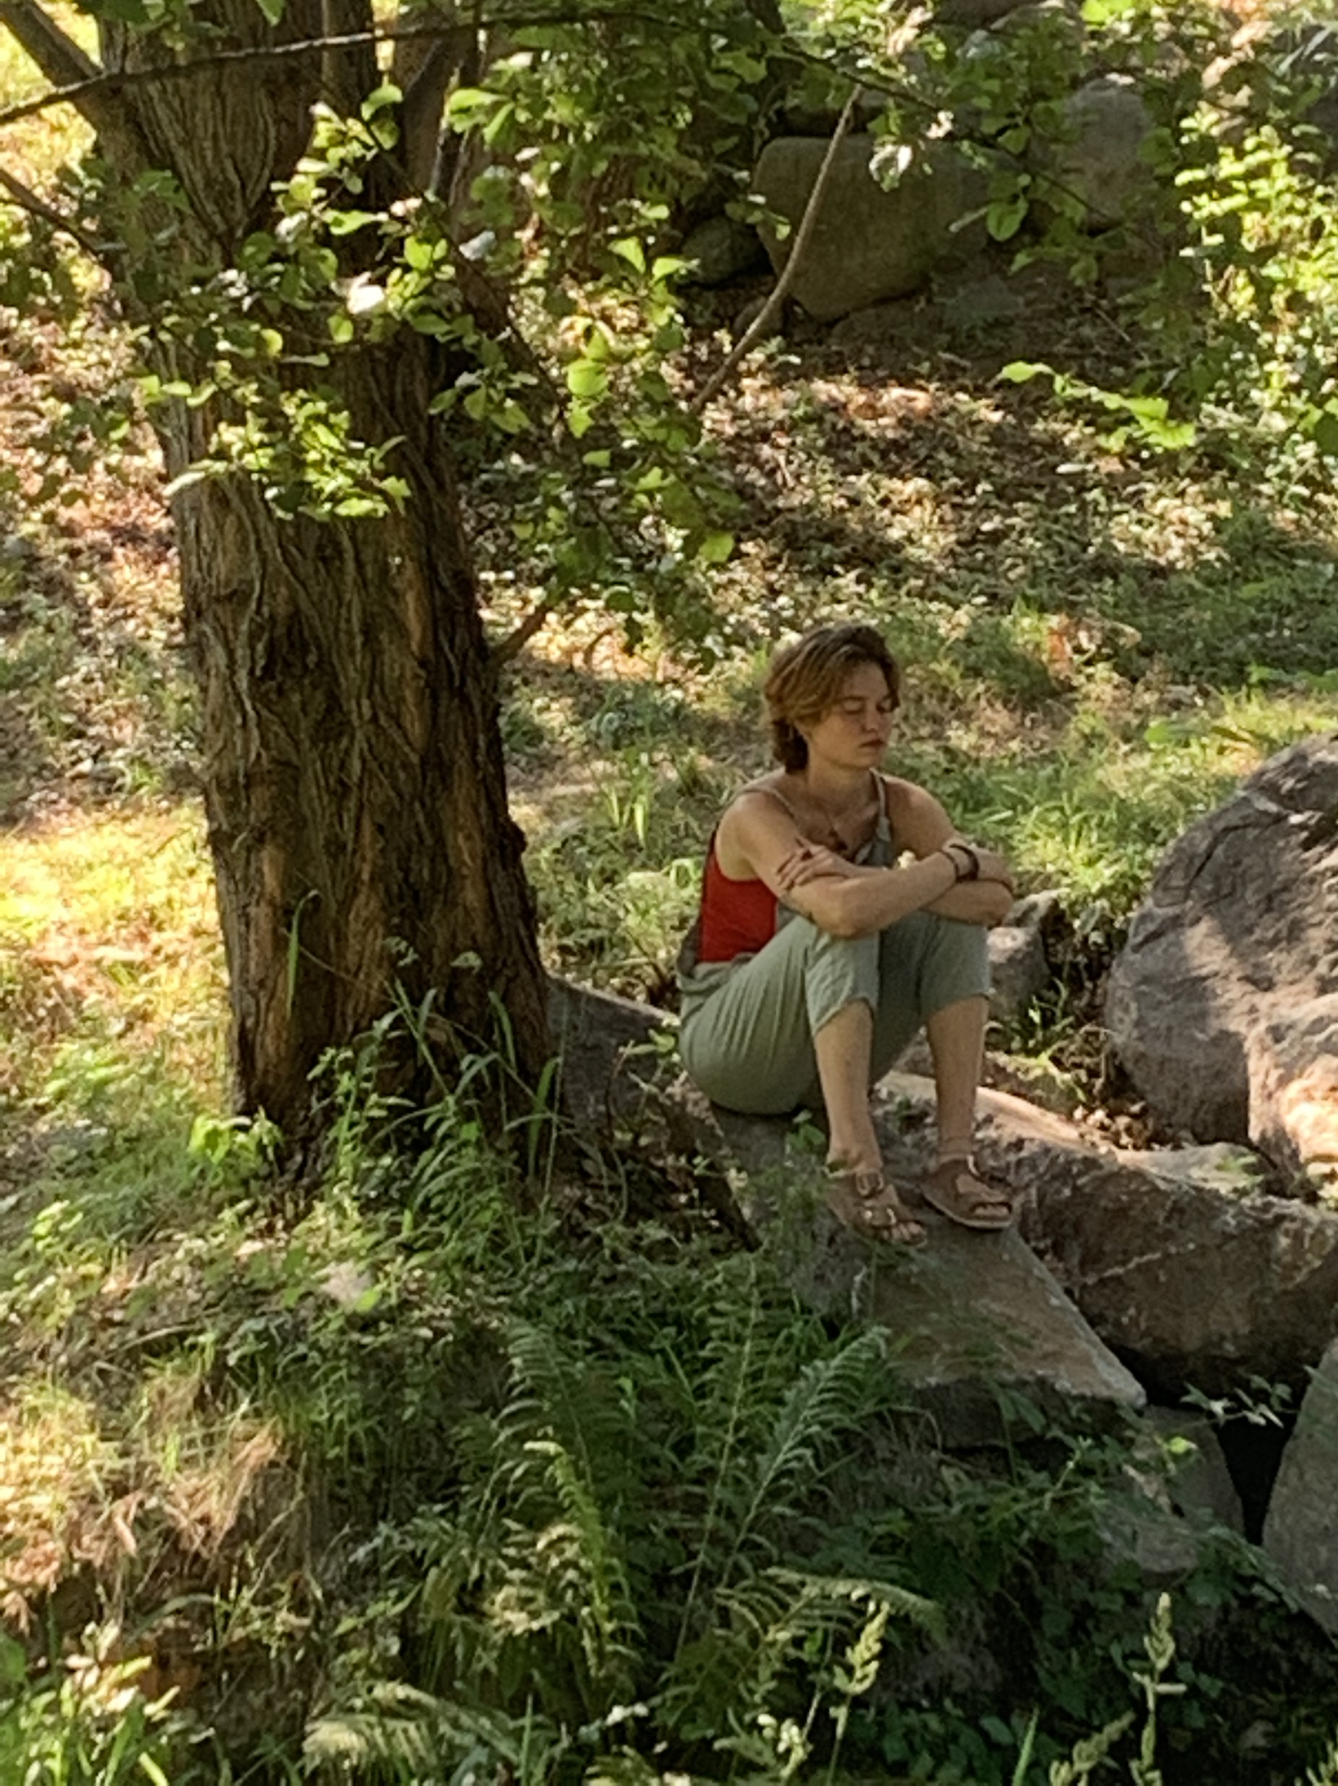

Design (150 - 250 words): What happened in this dimension? What were the highlights? What topics were covered? What practical activities were performed? 2-3 participant quotes from the Gaia Education Evaluations or other sources. A sentence on each core faculty/facilitator. Any other information that you consider relevant.
The Design Dimension applied different designing methods. Through a Dragon Dreaming process two projects were created. During the whole course the participants were weaving the theoretical information they received from the different sessions into their projects. Over the years we have experienced, that doing Design in this way, allows the knowledge the participants receive to become alive, to be stratified, and it stays with them, because of the direct application into the project, learning by doing. Real projects are created, that can become reality.
The Design groups are the platform where the practical learning takes place and where all the knowledge from social tools like leadership, conflict solving etc, as well as the tools from the other dimensions can be experienced and applied directly.
One of the two projects that were created during the course is already being implemented, one was about creating ecovillages combined with permaculture, the second about a community venue for holistic, collaborative programming of immersive experiences that empower people to find well-being. The participants were very identified with their projects and especially one of the projects is already in the phase of being implemented.

Quotes:
“Design Group project brings it all together!”
“ It’s mind-blowing to be able to build a project and implement it.”
“ An amazing opportunity of self-development and big design for a greater world”
Include 2-3 pictures. If showing a design project photo, please acknowledge the names of the designers. NOTE: The pictures are in the presentations.
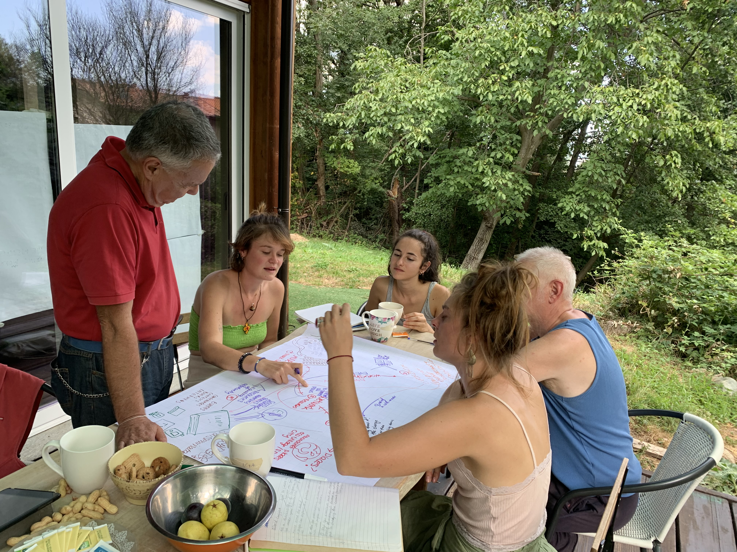
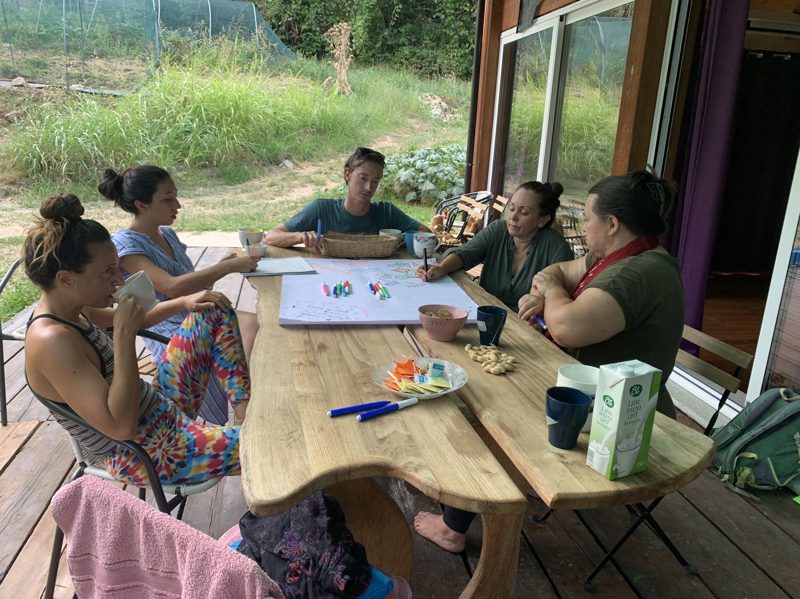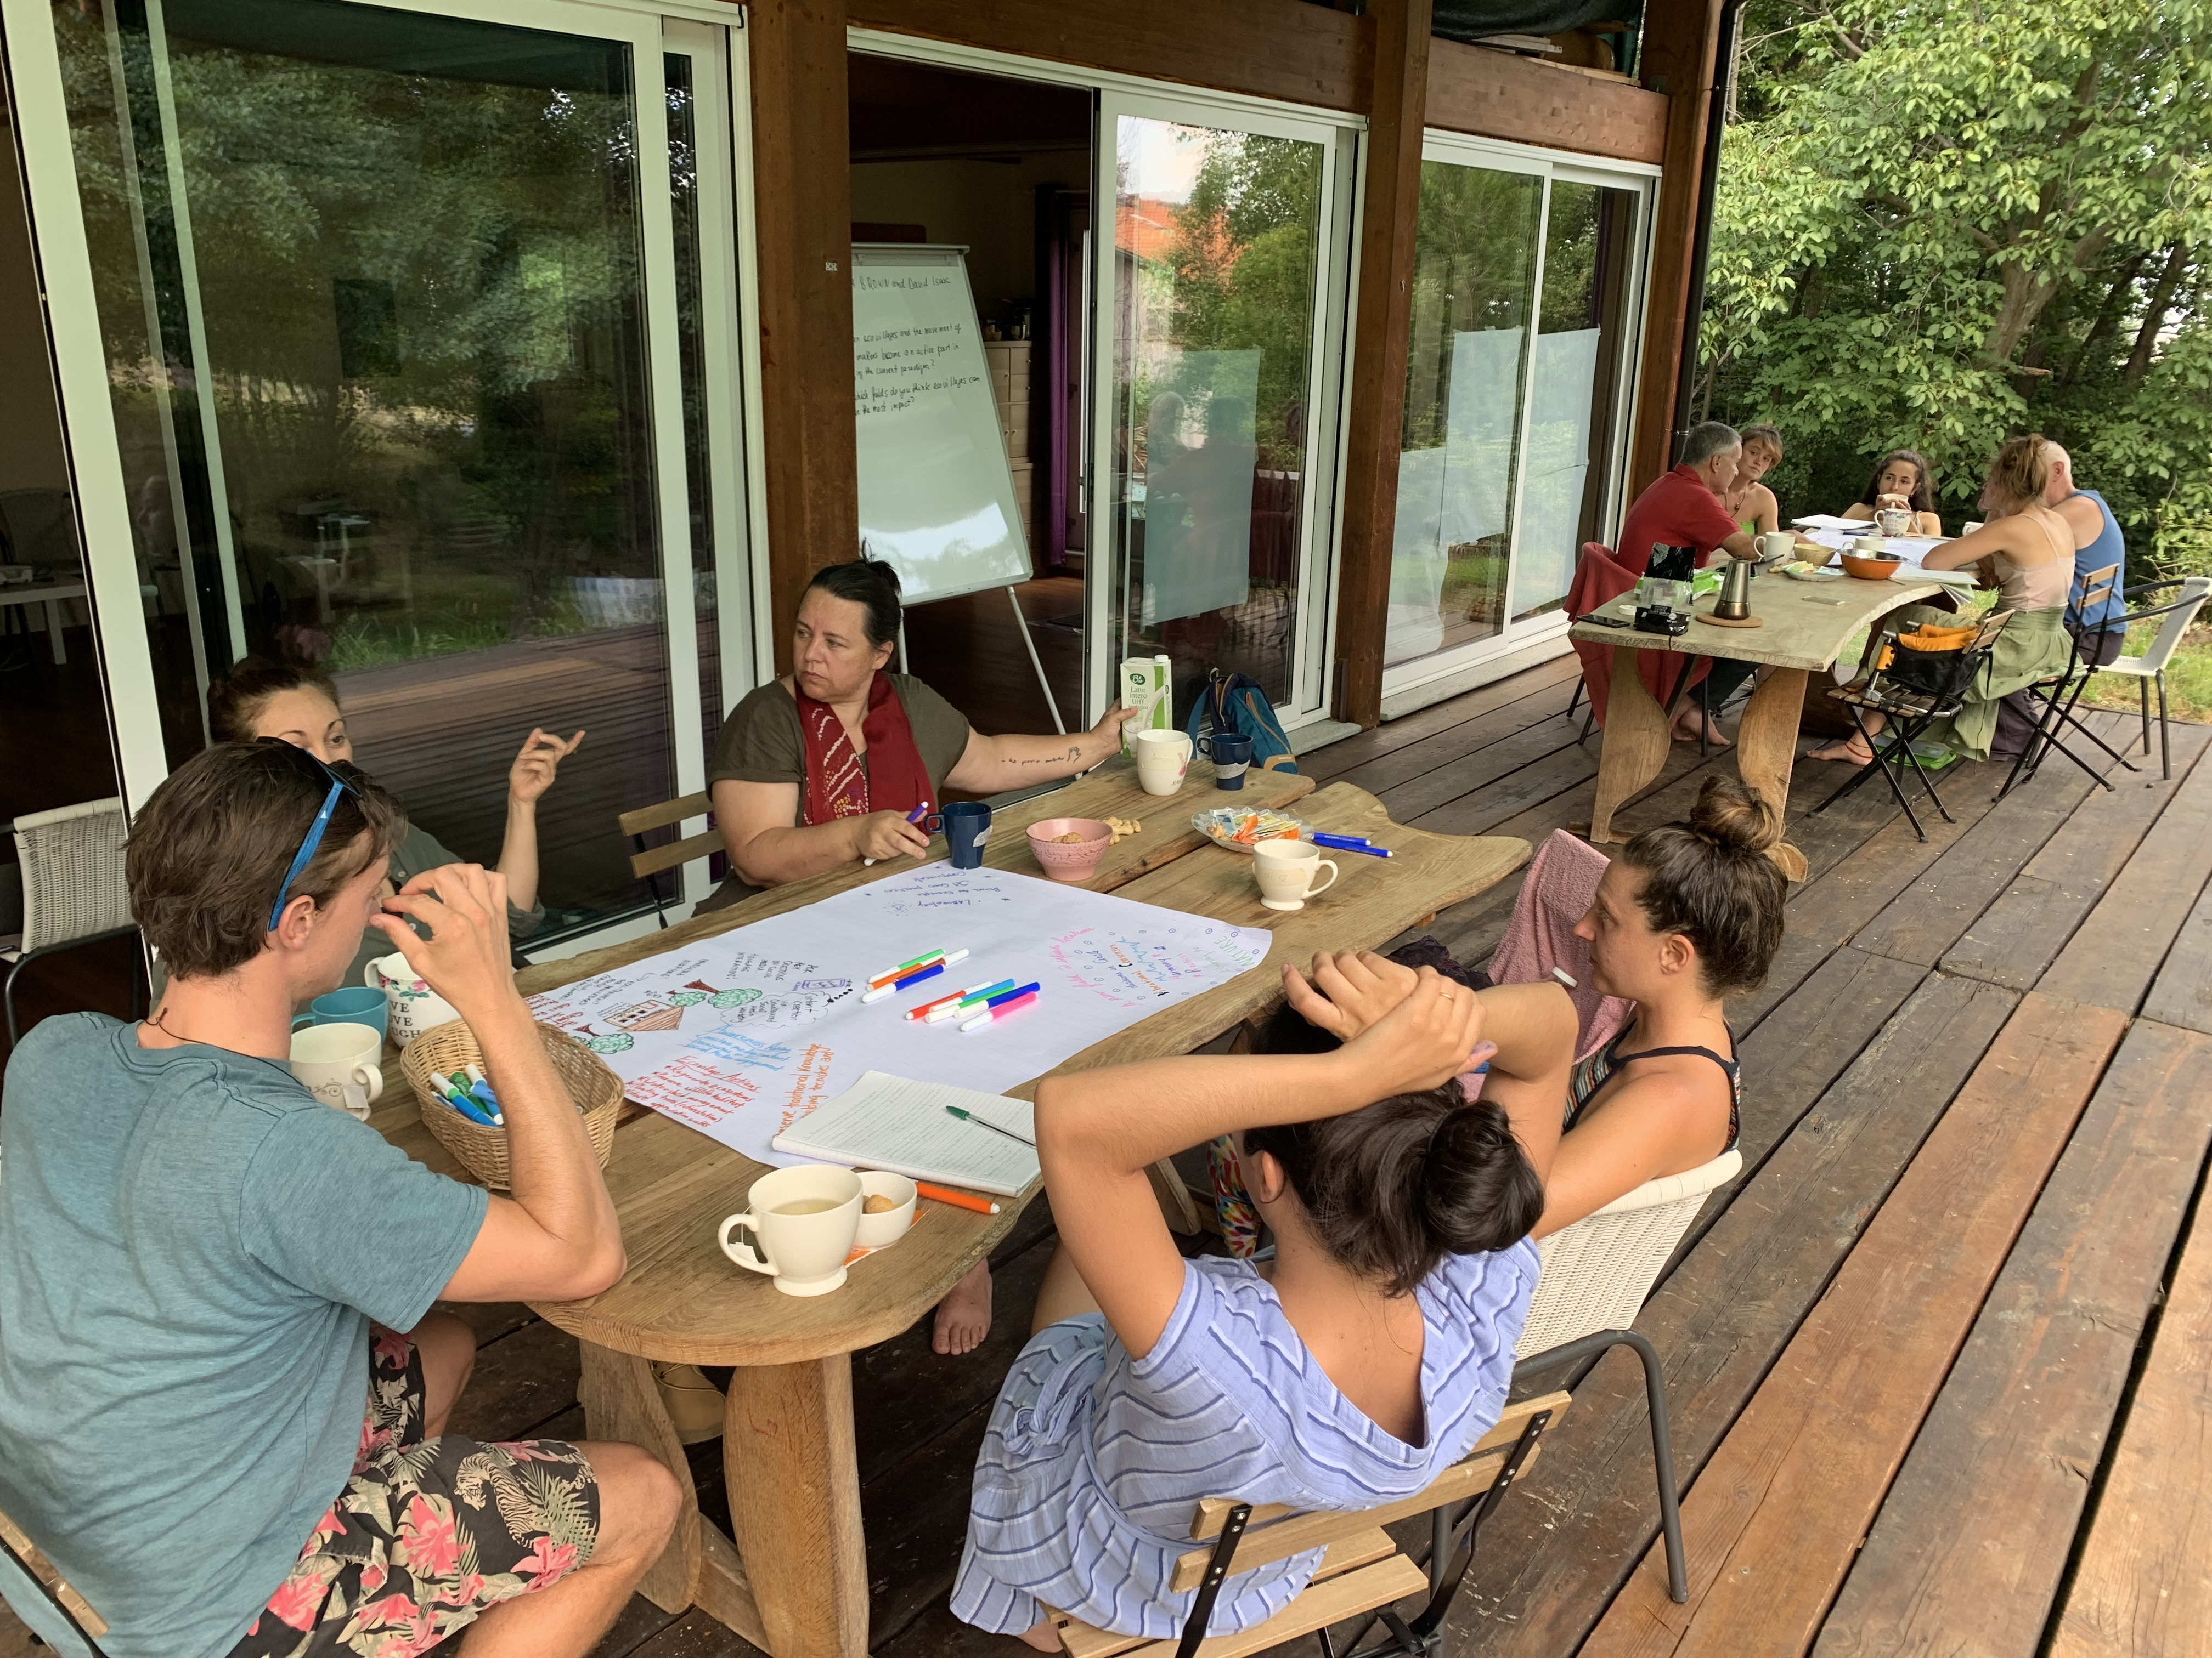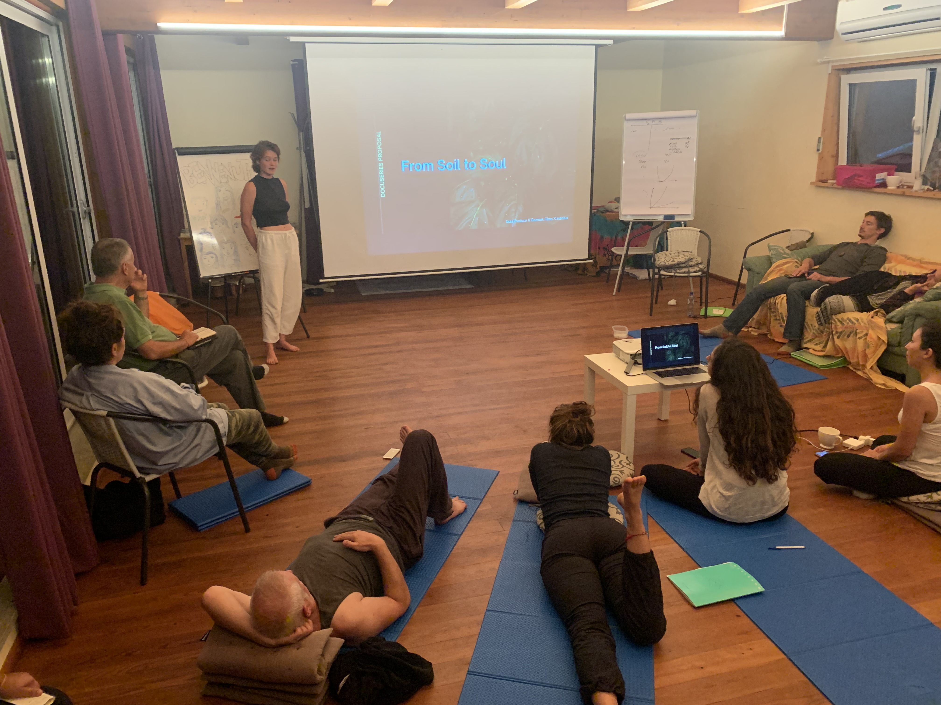
Design Studio Case Studies: Brief description of the case studies developed during the programme if applicable. https://docs.google.com/document/d/1ZdAf_pemzrwYetdfMUEYLsdptWkjrL3_sd2m5mSovCo/edit
. "Soil to Soul" was inspired by the spiritual connection we feel with the earth and all its inhabitants. We seek to live in harmony with nature and each other as we work to heal the degraded ecosystem and nourish the collective soul.
We are a diverse group of permaculture designers drawn together by an audacious goal to create a thriving community and re-green the desert on a remote piece of land in California. Hailing from the USA, Colombia, Italy, Germany, and the Netherlands, the five of us met at the 2022 EDE in northern Italy. Over the course of four weeks, we lived as a temporary Eco-village community within the larger Damanhur community.
Our experience living and learning together gave us the knowledge and tools to start our own Eco-village with the limited funds we raised through our network of friends and family. We were given the opportunity to steward a remote desert property for the purpose of showing what is possible using regenerative practices.

“Nature Wisdom”
https://drive.google.com/drive/u/0/folders/1vagTsROWrDTrOIXNyxgahI3ANUej_lUn

Nature Wisdom functions as a community venue for holistic, collaborative
programming of immersive experiences that empower people to find
well-being. One of our core collaborators is The Art of Sustainability from
Wales, UK who will bring a major framework through their Wellness of Being
Programme that covers SDG goals and connects us with a larger Worldview.

-----
LESSONS LEARNED - notes for future benefit (50 - 300 words):
What could help future EDE´s from your experience? What were your biggest learnings? If a re-certified EDE, also list & respond to lessons learnt from your previous EDE.
The balance between course time and free time was definitely improved this year, as the participants were less tired than other years. We started already last year to give more free time. Indeed 4 participants decided to stay on for the ToT right after.
Giving the right inputs in the beginning for self-organisation is core to create a sense of responsibility for the common spaces as far as order and cleaning is concerned.
The Covid situation is still challenging, we asked everyone upon arrival whether vaccinated or not to do an Antigen Test to be sure no one would bring Covid to the group and we were lucky. It is still definitely difficult to make sure Live programs can happen after Covid.

Describe your EDE in terms of the know-how and learning obtained, the stories and inspiration that happen to the participants and the organisers during the EDE or a good summary of a project or activity carried out during the program. Take into consideration that this will be circulated among the Gaia Education´s community, so they wish to learn, get inspired and be empowered by your program and your participant´s experiences. (200 – 400 words) . Include 1 or 2 pictures.
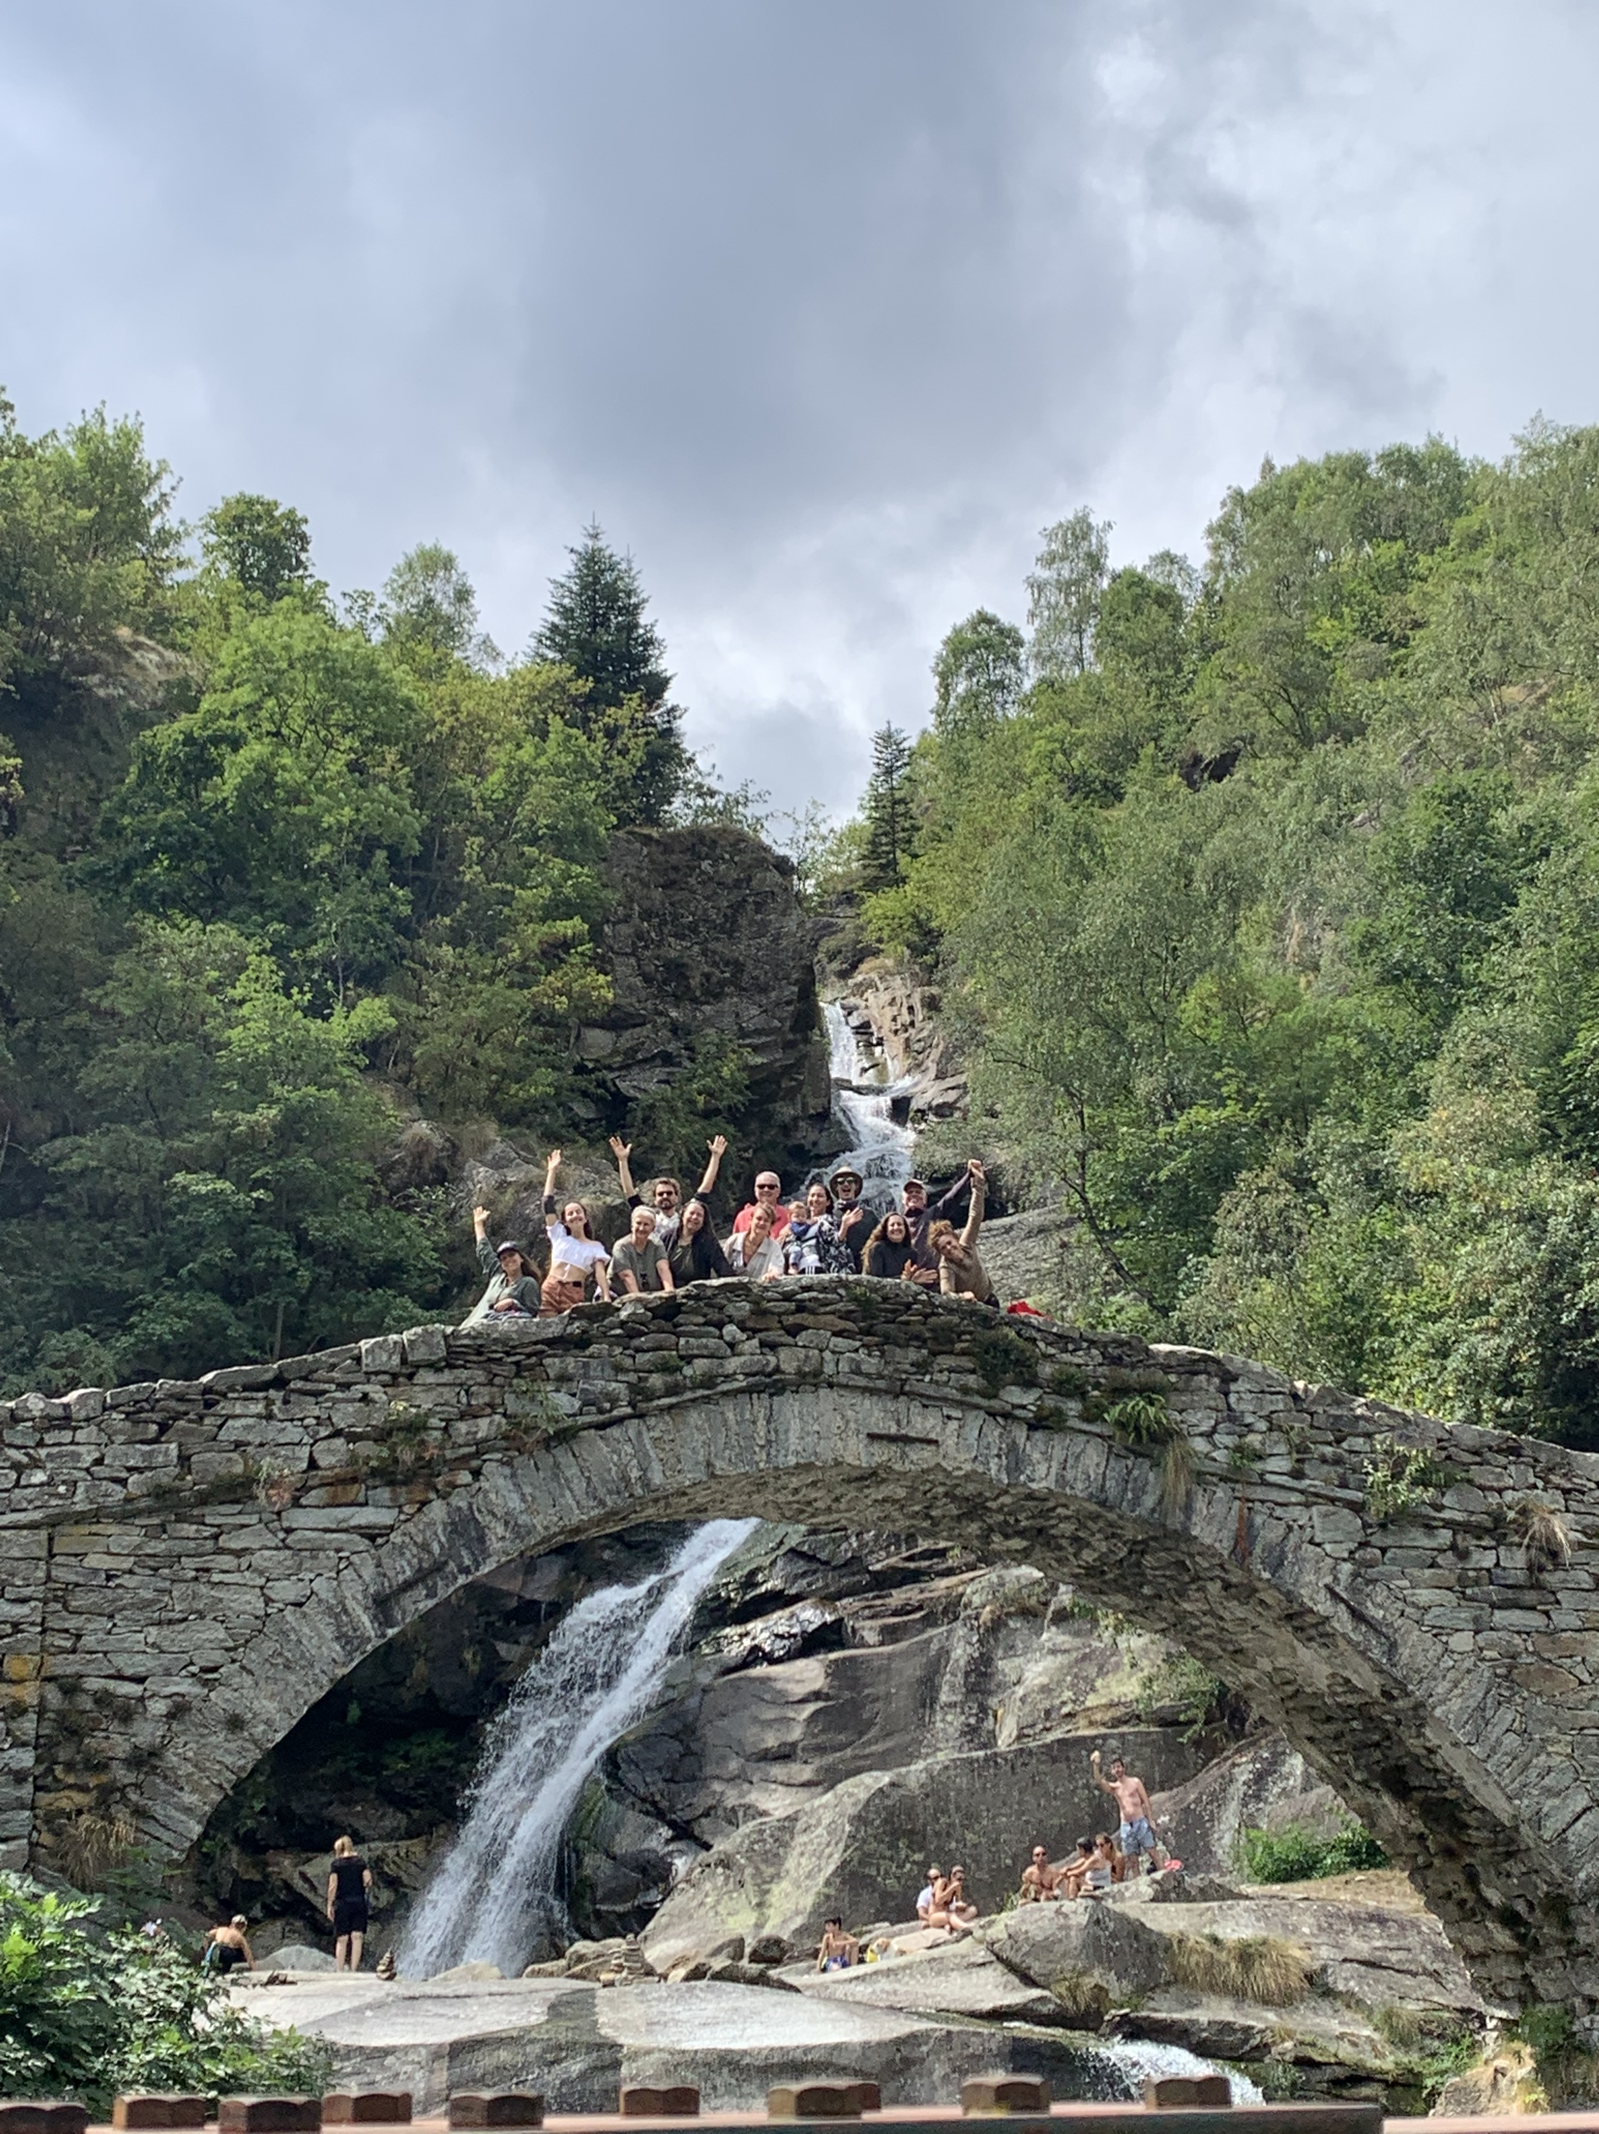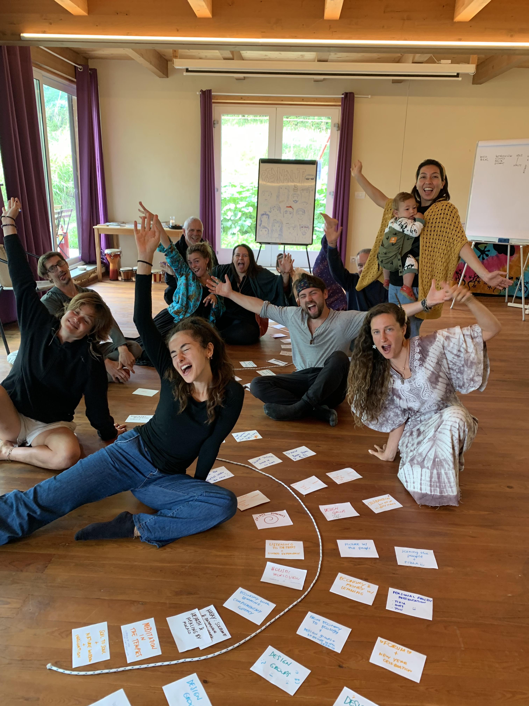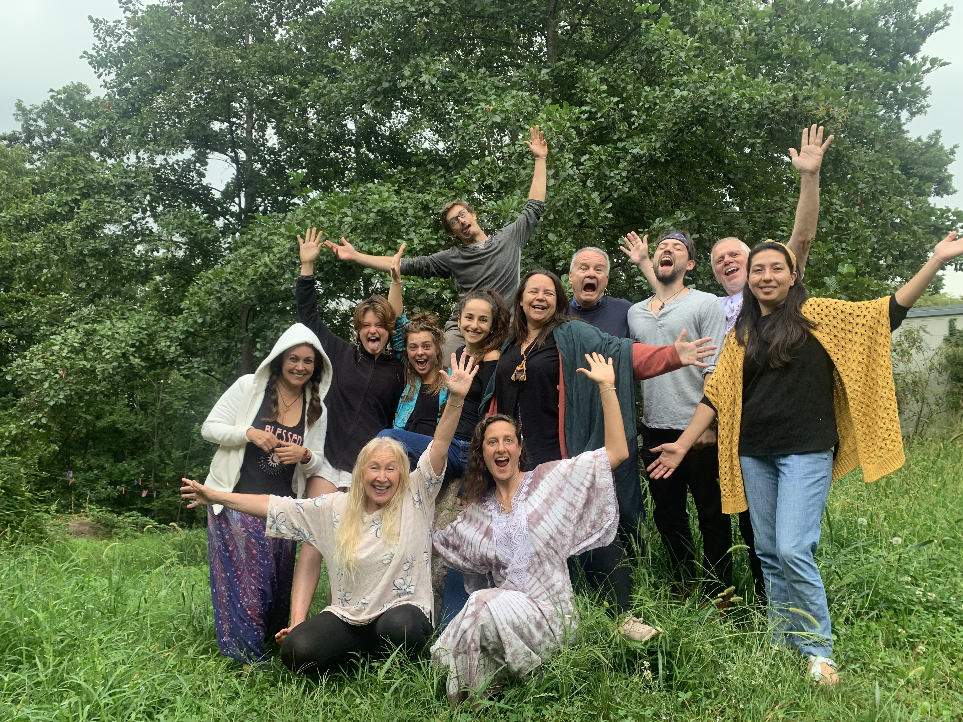
This year the group was so small that we were considering cancelling, but at the end we decided to go ahead and that was really a good decision. For most participants it was one of the most important experiences of their lives and that’s a good reason to go ahead even if you don’t break even.
The group became really strong right from the start, which allowed each individual to go through transformational processes and grow, while having an intense community experience.
One of the design projects was to develop a vision for an already existing community project and it came out with a fully fledged project ready to implement, which created important trust in being able to tackle any kind of project. This led to many new projects and indeed a new EDE in Ibiza with a strong accent on local projects is already on it’s way.
On of the strongest community experiences every year is the community building experiment in the woods, which is a community game that allows the participants to face and overcome their personal blocks and limits. This year it was very special because there was also a toddler in the experience and that adds a level of reality and care taking that is special.

Summary of projects/activities participants intend to engage in, inspired by their attendance in the course (50 - 150 words):
All of the participants want to engage in creating a change in the world. Some are involved in a community in California, other in creating courses for children where to bring in the knowledge, to create an EDE in Ibiza, bring the contents of the course into university, creating a new ecovillage.
5 people signed up for the Social Dimension of the GEDS, 4 stayed on for the ToT taking place right after the EDE.
They all want to be an active part in creating a regenerative new reality.

PARTICIPANT QUOTES: Send 3-4 participant quotes from the Gaia Education Evaluations or other sources, please include names and photos (send the photos as separate .jpeg files and properly captioned/named)
Quotes: Cole, USA:
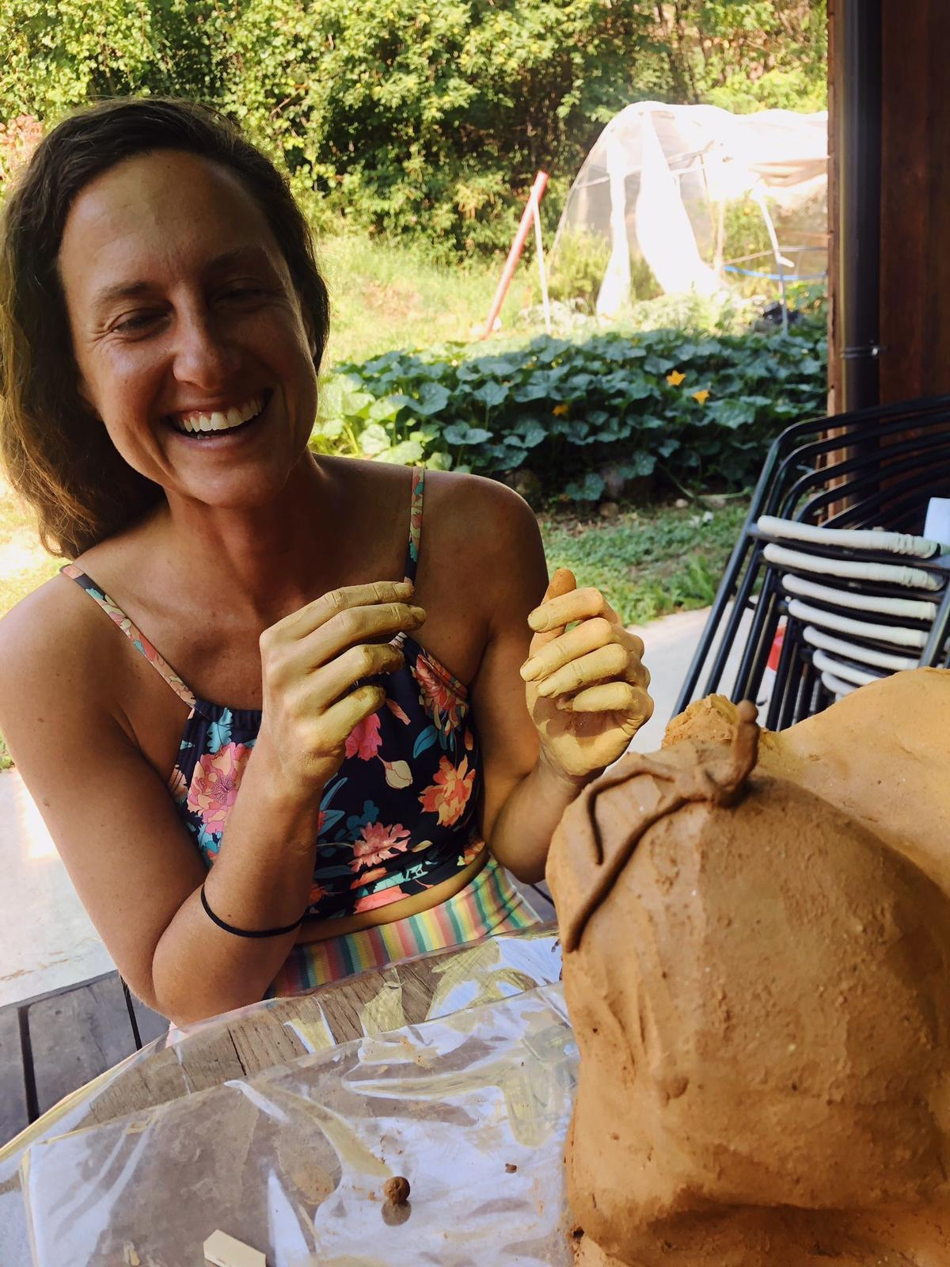
“The EDE at Damanhur is a magical dream come true! The modalities of connection and embodiment paired with the knowledge and wisdom of the facilitators brought me into a whole new level of confidence around eco-village creation. I feel so lucky to have learned from this amazingly structured course all the while enjoying an immersive experience in such a beautiful and successful eco-Village at Damanhur!”

Ines
It's a 10 out of 10 course, with its location, teachers and leader. Macaco, her experience and amazing way of leading the group. It would have not been the same with another group leader.
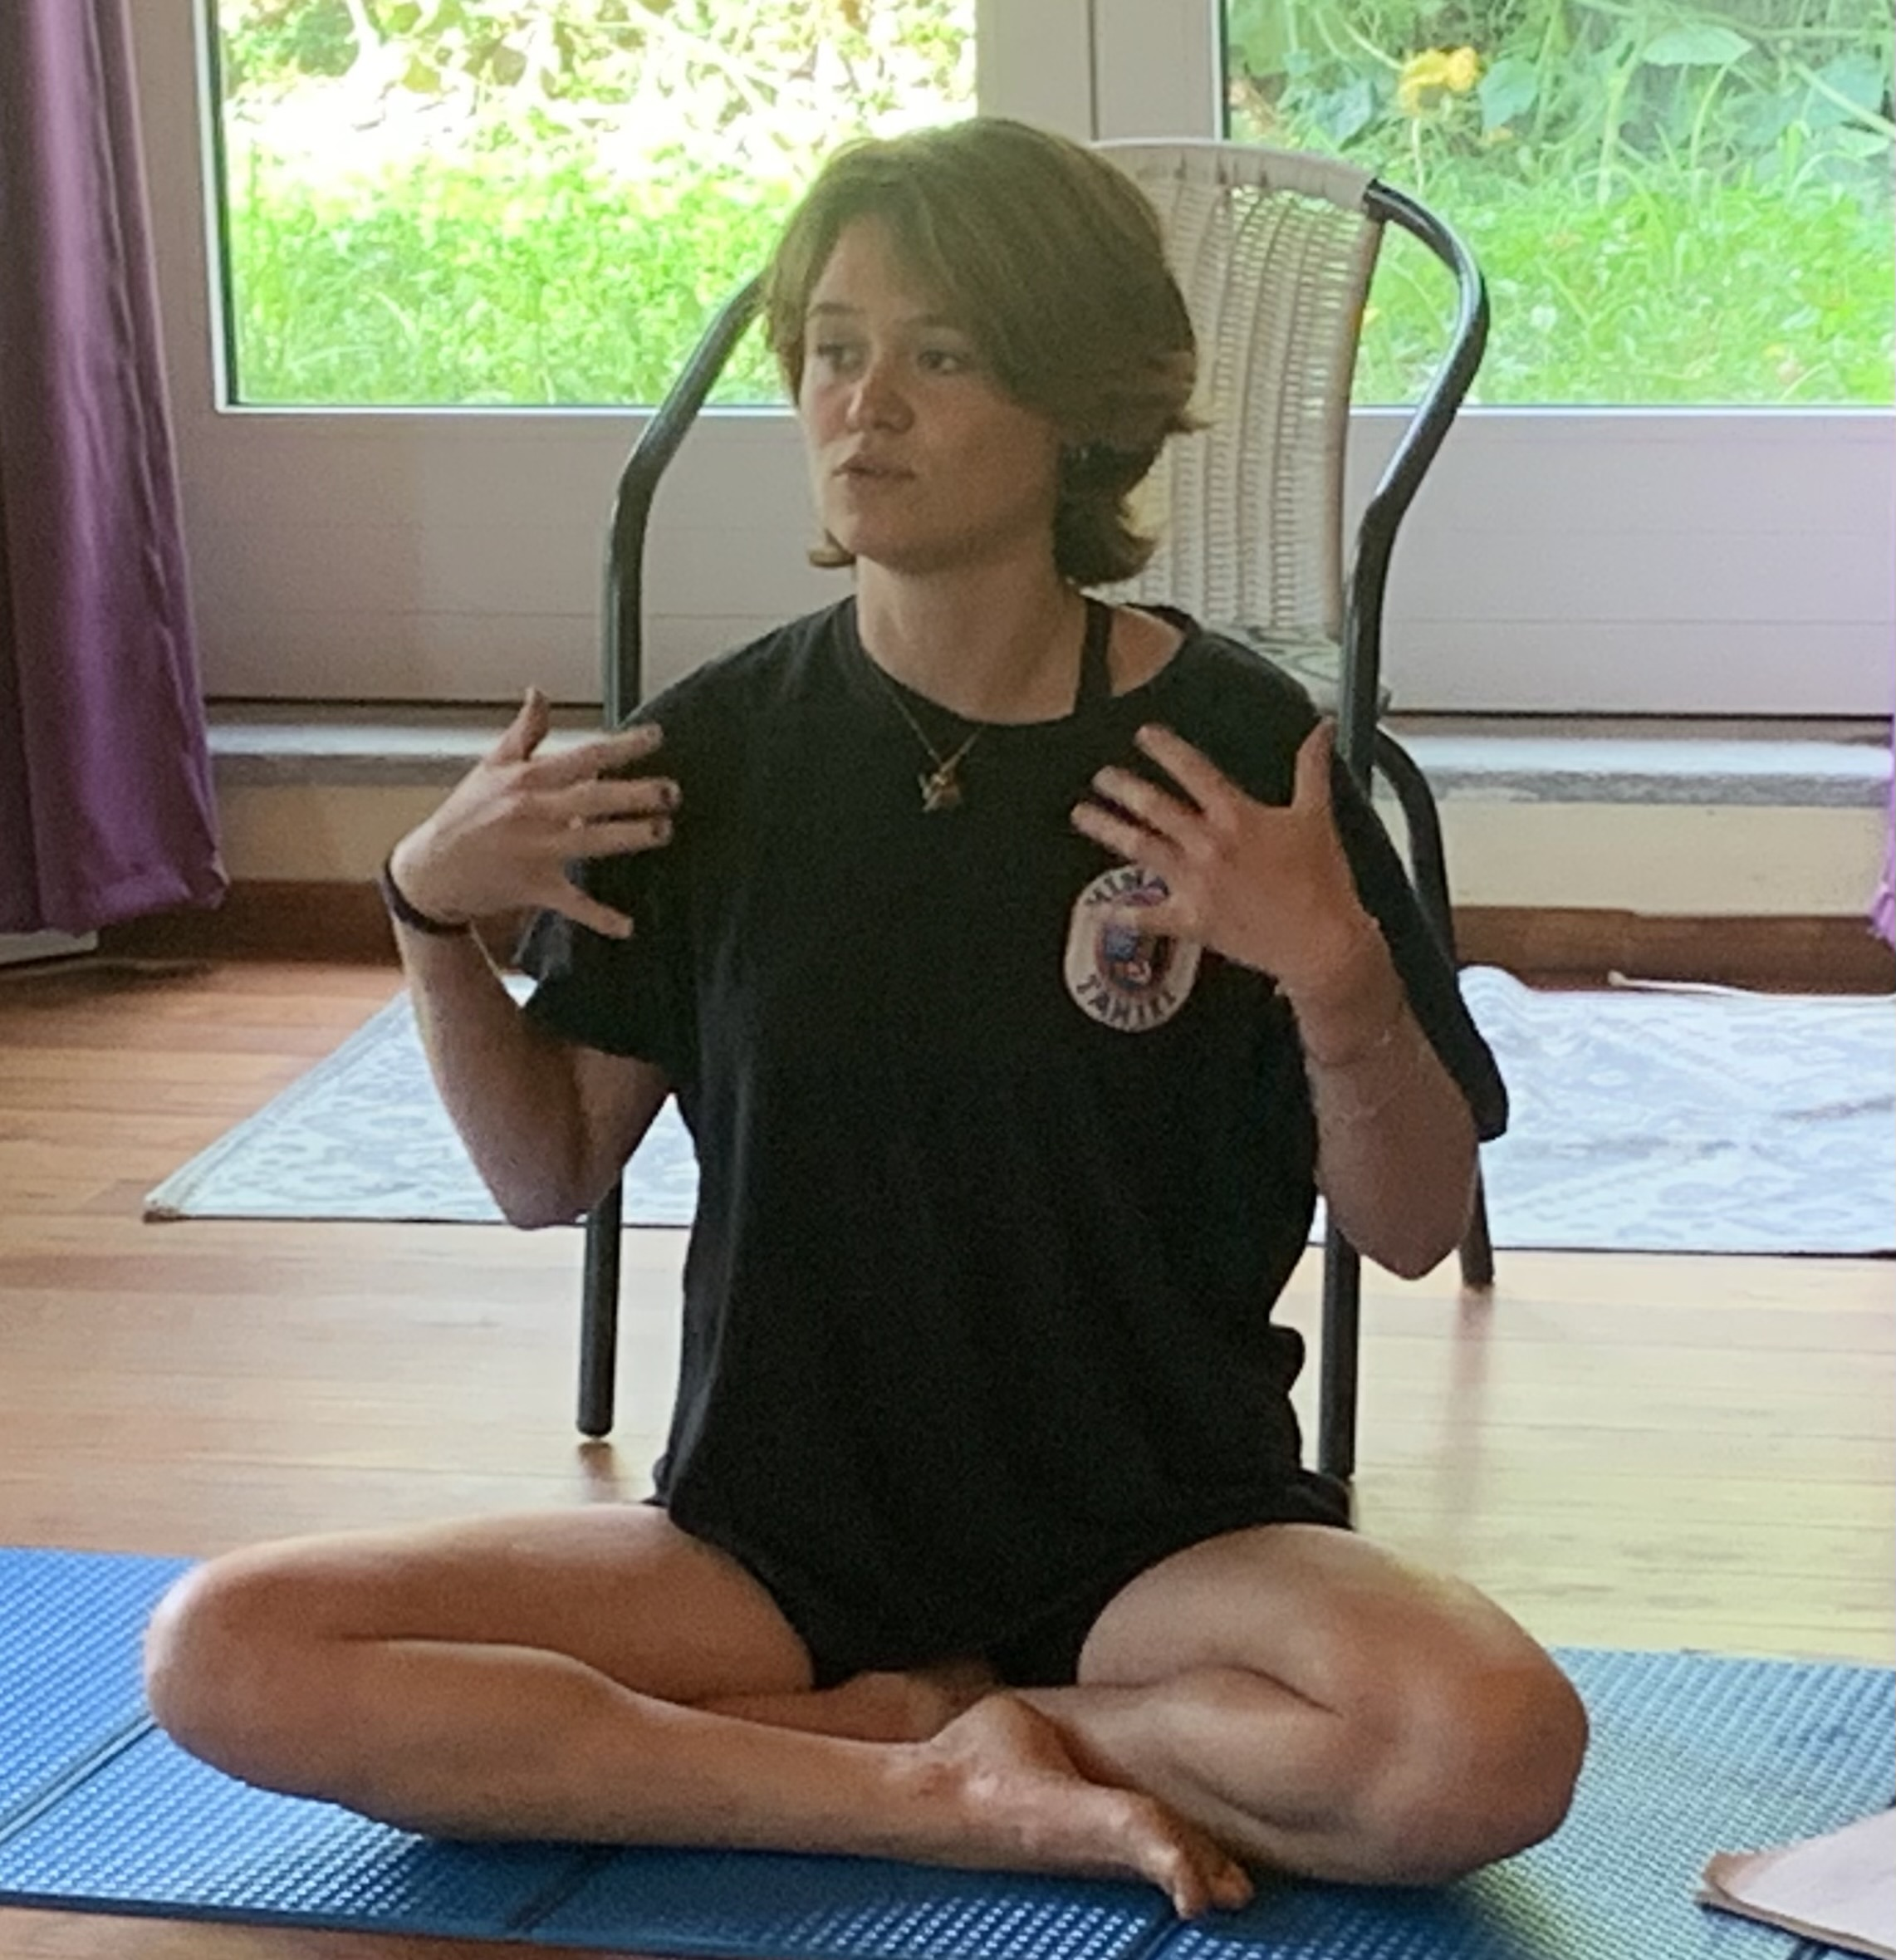

Patty:
Overall one of the best times of my life. I am feeling the impact and looking forward to helping spread this education to help nature and people deal with Climate Change disruptions. EDE is a school of Life and Self Mastery. It is where you go to evolve as a human being and find purpose in co-existing with the Planet. It is where I have found the "family I choose" and Kindred Spirits.
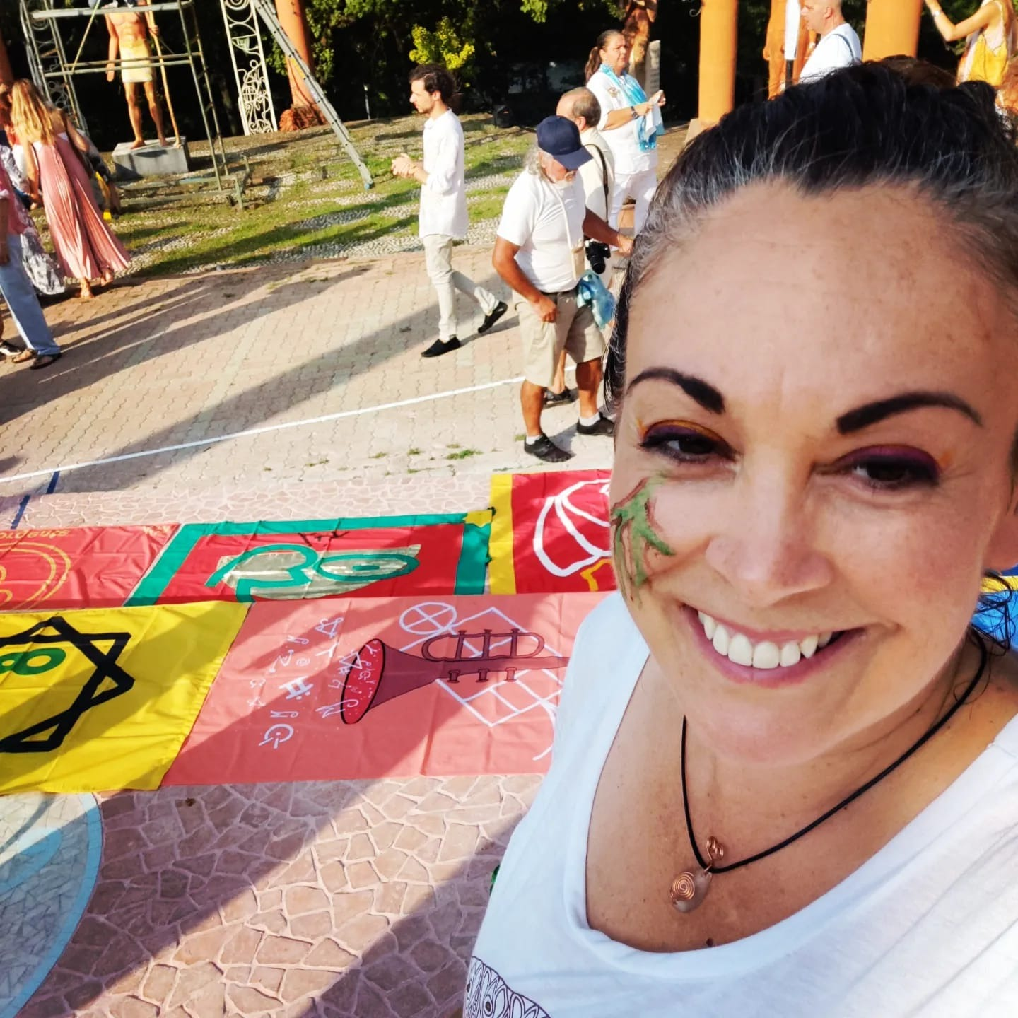
Niya
EdE 2022 in Damenuhr was an incredible journey where I learned a lot about my inner landscape- how many creative tools there are to create an honest, holistic transformative relationship on the outside with other fellow human beings and with myself.
It gave me the opportunity and most importantly the safe space to experiment, grow and learn- experiencing my own power to lead, create, plan and present, alone as well as working in a group towards a project, blossomed in me.
The Ede inspired me to the TOT, Social GEDS and much that is yet to come.
Gratitude, self esteem and the power of community for the future was laid during the course.
